- Block diagram
- MCU output 10KHz PWM signal to drive the LED.
- Photo diode transfer the 10KHz opto to current signal and the first LMV722 change the current to voltage.
- The second LMV722 using as voltage amplifier.
- The third LMV722 is for band pass filter. We met issue at the third LMV722.

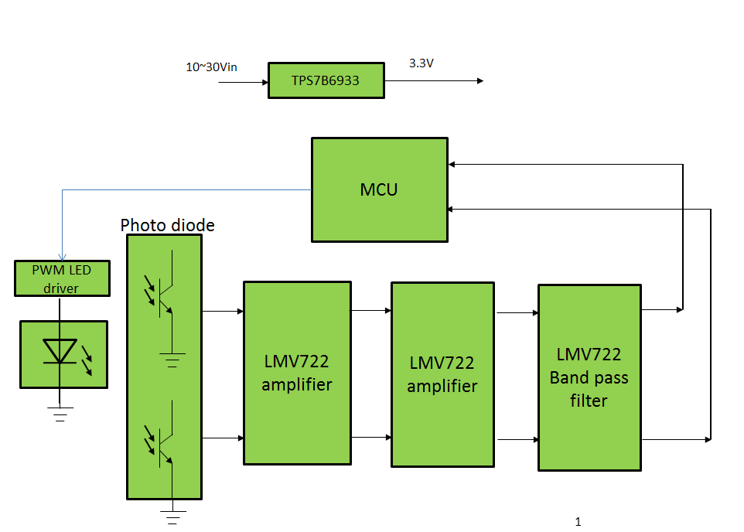
- Sch
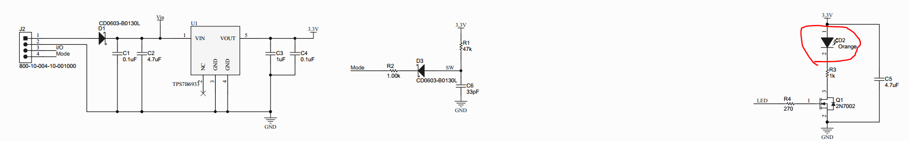
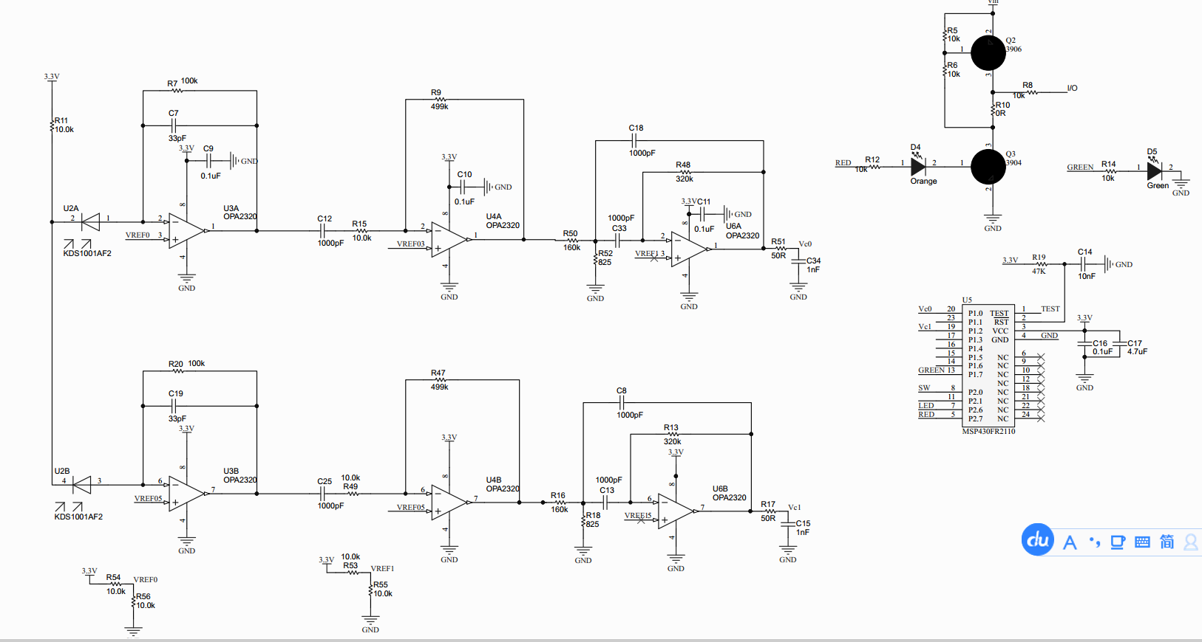
- Issue:
  - During test, we found 10KHz 100mV signal output at the VC0 and VC1 even the first and the second LMV722’s outputs are the same as what we designed.
  - We shorted the D2 which means no opto signal be sensed so that their will only 1.65V DC voltage at VC0 and VC1. But we found VC0 voltage has 100mV peak, 10KHz sin waves. We also test the U4A and U4B’s output, no AC signal actually. So something wrong with the third LMV722.
  - We shorted the MCU’s PWM signal, means not only no opto output but also no 10KHZ current path at LED circuit. If that, the third LMV722 has no AC output.

- Now we have no idea why the LED current will impact the Bandpass filter but will not affect the first and the second LMV722. Do you have any ideas?
Thanks.

