Calculation of 5A and -5A level detector circuit

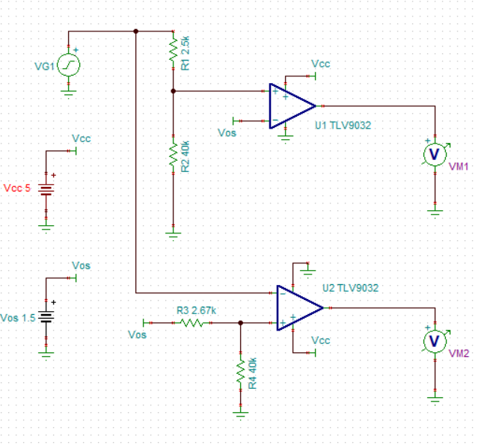

Signal VG1 has following Values

|  |  |
| --- | --- |
| **Input Current (A)** | **Sensed Voltage (V)** |
| 40 | 2.25 |
| 5 | 1.594 |
| -5 | 1.406 |
| -40 | 0.75 |

The goal of level detection circuit is to sense +5A level and -5A level

**Note: Following calculations are carried out assuming ideal OPAMPS**

1. Calculation of R1 and R2 for +5A detection (level 1.594 V)

Voltage at positive pin of OPAMP (U1) should be more than +1.5V for output to be +5V

Choose **R2=40 kΩ**

Hence,

To detect level 1.594 V (+5A input current), R1 will be calculated as below:-

$$1.5=1.594*\frac{R2}{R1+R2}$$

**R1=2.5 kΩ**

1. Calculation of R3 and R4 for -5A detection (level 1.406 V)

Voltage at negative pin of OPAMAP (U2) should be less than 1.406 for output to be +5V

Choose **R4=40 kΩ**

Hence, to detect 1.406 V level (-5A input current), R3 will be calculated as below:-

$$1.406=1.5*\frac{R4}{R3+R4}$$

**R2=2.67** **kΩ**

**TINA Output:**

