Matched input impedance FDA single to diff.

Your original circuit looked like a gain of 8.4 - there will be a -6dB matching loss, so you can increase that gain if you want - if you run out of BW with the THS4541, the next big step up is the LMH5401.

With an Rt to ground, you can pick whatever for the Feedback R - it just needs to be large enough to give a solution.

Here I picked a 402ohm where my spreadsheet tells me the max gain (where Rt goes to infinity)

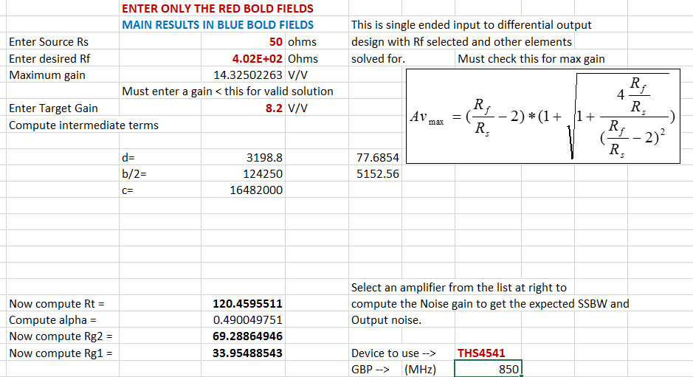Then down below this, I test for the best fit E96 vs the exact solution here,

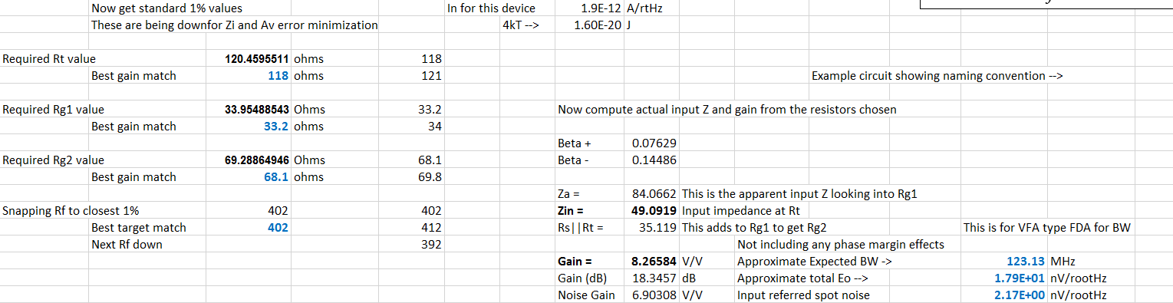

If you want to eliminate Rt, then there is only one unique Rf that will work to set both the input impedance and gain, I found a better more recent set up I did

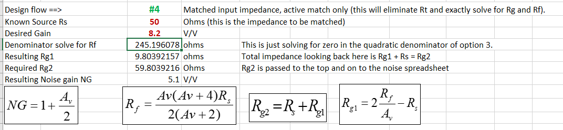

I had a sim file set up for gain of 8, nicer R values and 216MHz F-3dB where this plot includes the 6dB loss.

