Mid Supply driver, using the OPA2810 and BUF634

This is an attempt to use the high output drive of the buffer on a single 24V supply in a closed loop configuration – one of the real unknowns is what the load looks like to the BUF634 mid supply driver

Here is an initial LG sim – showing 16deg phase margin

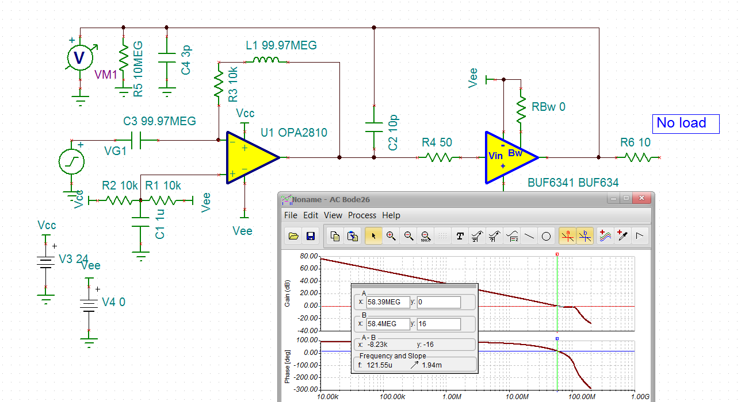

Lets hook that 10ohm load to 12V midsupply – assuming this is all the devices depending this for a pseudo ground. No change really, that cap looks promising.

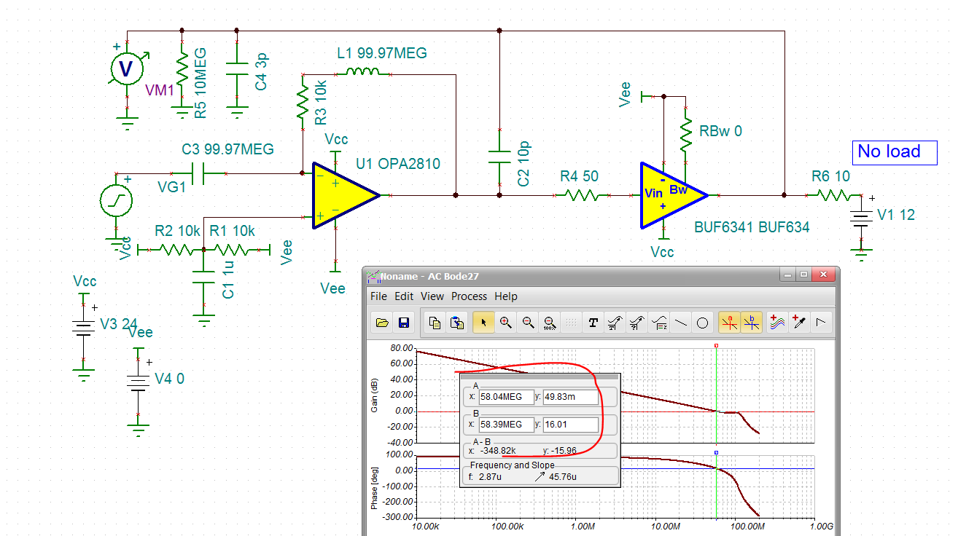

So lets try 100pF there. Nope, that is oscillating for sure.

Lets adapt the dual loop feedback for driving cap loads to this, also described in this article

<https://www.planetanalog.com/author.asp?section_id=3404&doc_id=565077&>

yes, so this moves it up to 35deg phase margin

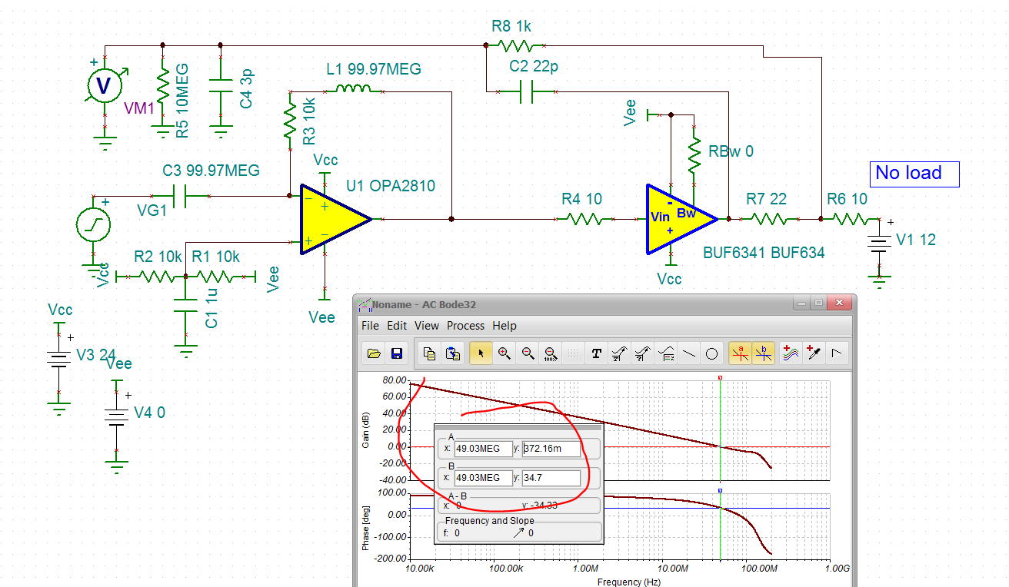

Running closed loop I get about 7dB peaking at 70Mhz.

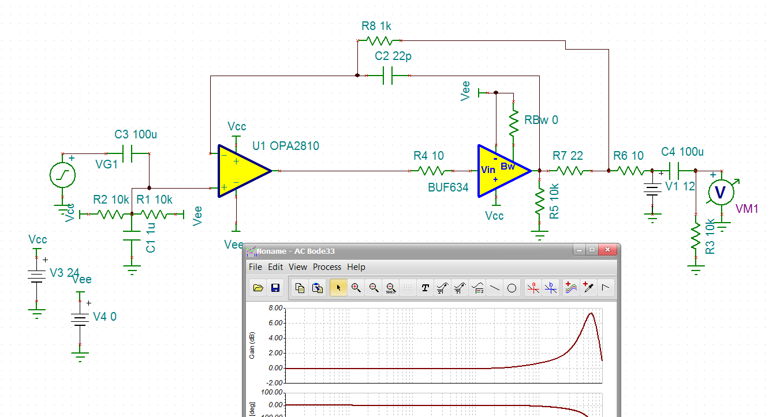

And then looking at the closed loop output impedance,

Ok, actually at this point it looked like I needed a Cload to help broadband Zout,

Adding that in the LG sim, still about 35deg phase margin, I needed the 10kohm for DC convergence.

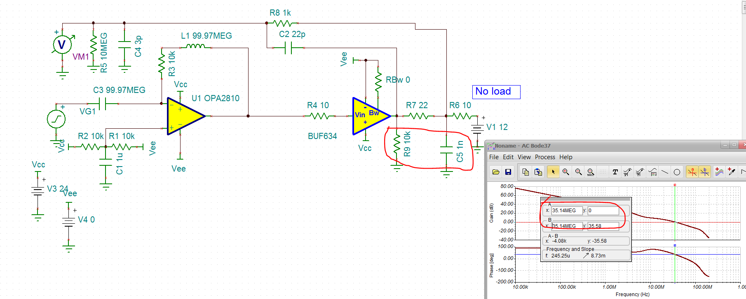

Ok, now back to closed loop zout

That 28dbohm peak is 25ohms max at 7MHz

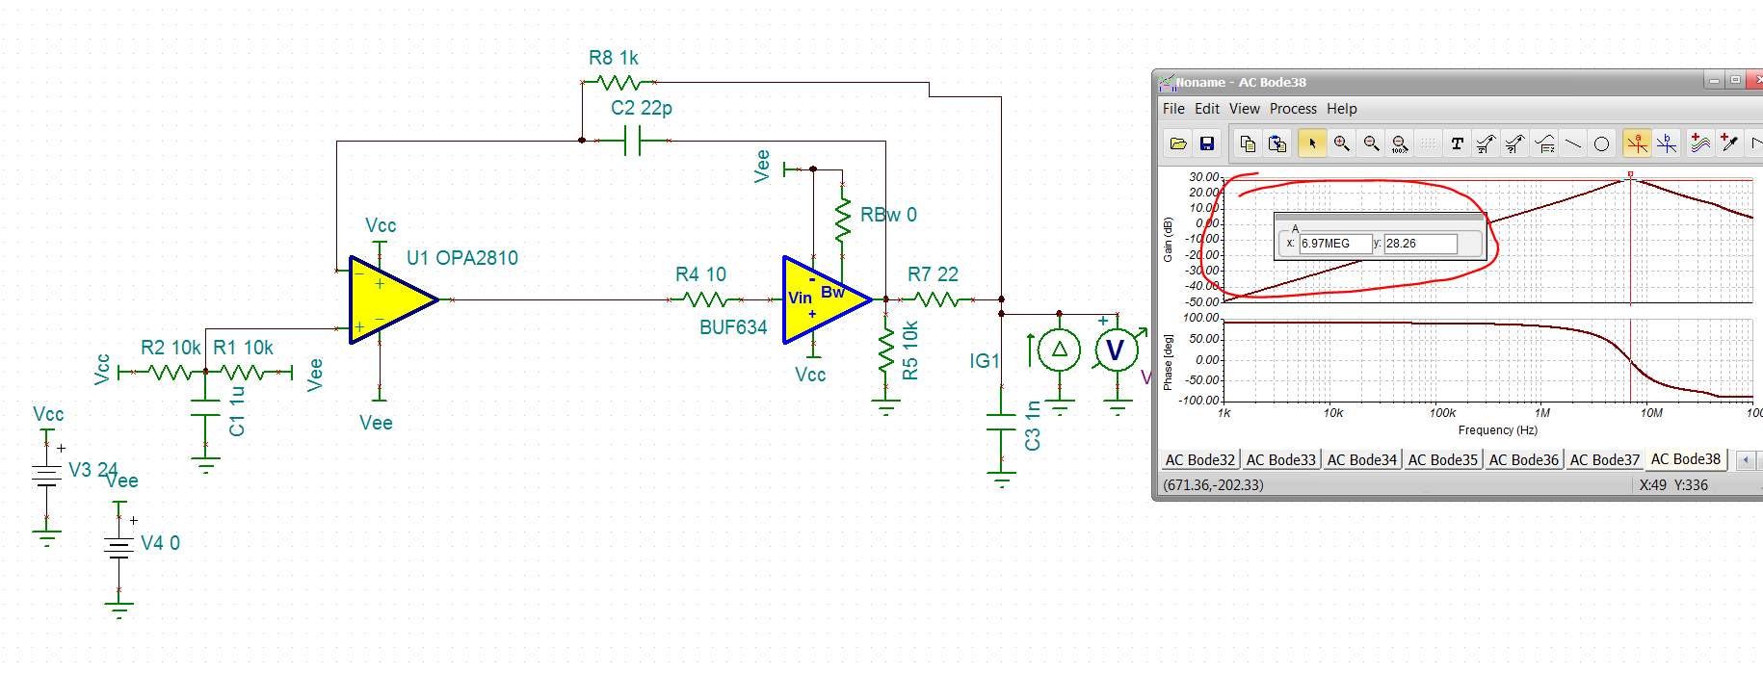

Now try a square wave load current of +/-200mA at 100khz 50nsec ramp. look at Vout. Probably don’t want those big shifts, but this circuit will get you started,

