The current reference design is capatured from BOOSTXL-AFE031 Rev E2 Powerline Communication Analog Front-End, Revised 6/19:
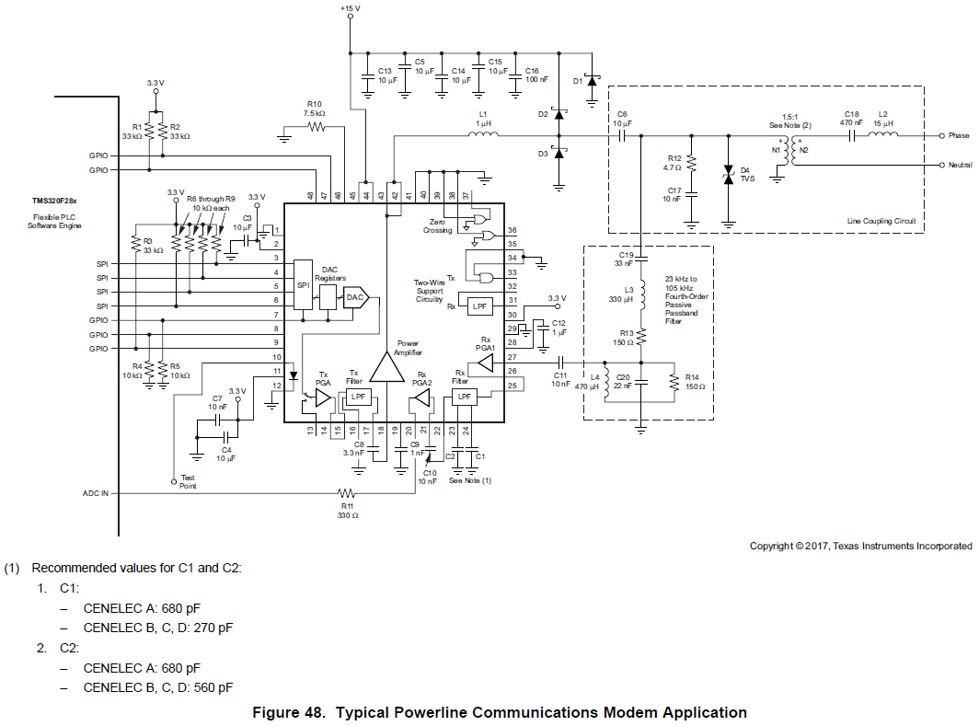
The previous schematic is BOOSTXL-AFE031-DF1, AMPS079 Rev A, circled areas in red are required to be modified.
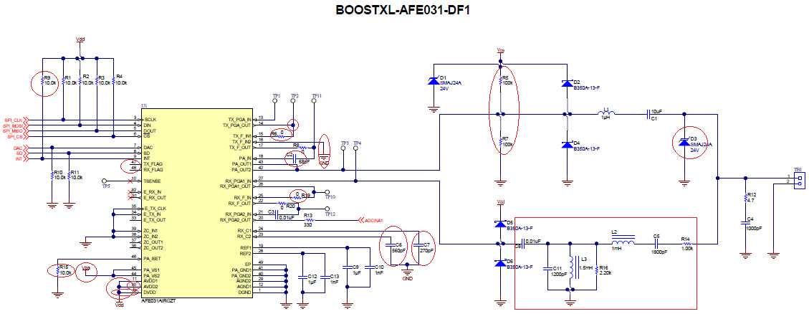
- C6 was 560pf, now it needs to be configured for CENELEC A band at 680pF piggy back 120pf, X7R capacitor on top of C6.
- C7 was 270pf, now it needs to be configured for CENELEC A band at 680pF piggy back 430pf, X7R capacitor on top of C7.
- Remove R7
- Remove R5, replace it with 47uF and 0.1uF (prefer X7R capacitors)
- Passive Bandpass filters: C11, L3, R16, L2, C5 and R14 (You mentioned that you have these component values per your operating frequency interest), see Figure 32 Passive Bandpass Rx Filter.
- TVS at D3, *** TBD ***
- R6 0Ω, *** TBD ***
- R8 0Ω & C2 *** TBD ***
- R19 0Ω, *** TBD ***
- Remove R9. replace it with 33 kΩ.
- Optional: Remove R10, replace it with 7.5 kΩ , Pin 46 is configured for max. output current from Power Amplifier, $I_{LIM}=1.92A$ with 7.5 kΩ. Current Figure is 10 kΩ and $I_{LIM}=1.6A$. See p.38 of SBOS531E Application Note.
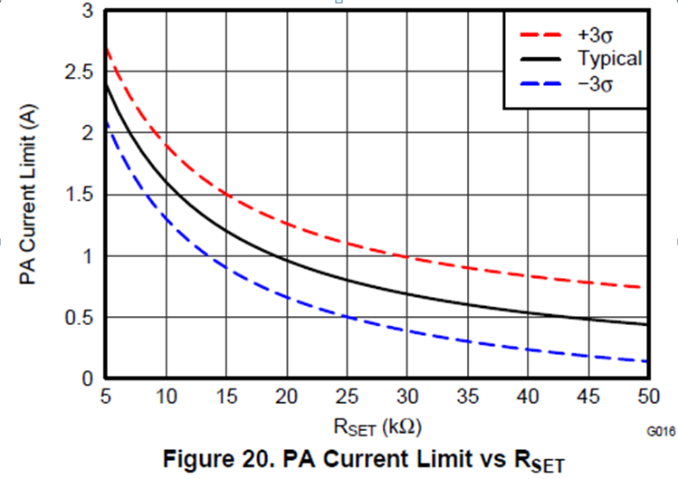
- Pins 2, 10, 11 are unchanged, which are connected to 3.3V at Vdd.

TBD *** Design and Application Requirements ***
- Need to know it is Capacitive (DC power transfer) or Transformer coupling power transfer (AC voltage).
- What is the operating voltage amplitude in AC or DC?
- Is it going to operate in DAC or PWM mode? Require additional RC filter settings.
- If it is in PWM mode, single Tx Filter Input or both Tx Filter input, see Figure 28, 29 and 30
- Rx Filter Configuration: See Table 3, Figure 31,32 & 33. Rx filter is 4th order passive bandpass filter, +40dB/decade to ramp up and -40dB/decade to roll off except the bandpass region, see Table 4 and 5.

The above design information is based on AFE031 Powerline Communications Analog Front-End, SBOS531D Datasheet.

