Problem
NCMR 3508 documents FSC1046 failing ESS Temperature testing. When the unit first turns on at low temperature the output on every tank reads higher than it does 3 minutes later or as the unit warms up.
There is another NCMR documenting another PCBA with the same issue.

Investigation
On 27 Oct 2016, we captured a scope trace of a mis-shaped Probe Excitation during the fail. Just a little bit of noise at the top of the sine wave peak. The theory formed that since the same issue affects all channels, the problem most likely occurs before the 5VAC fans out to each individual channel.
On 9 March 2017, I soldered wires onto 2 resistors in the 5VAC generation circuit.
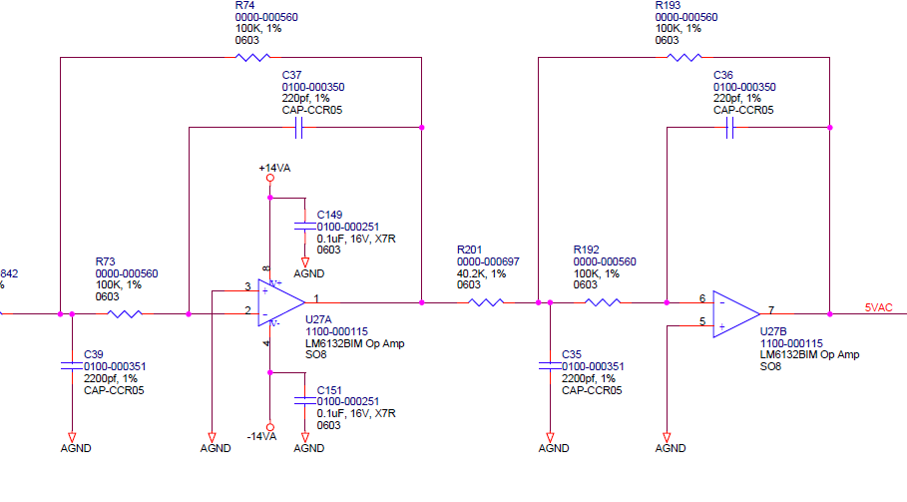
Scope Channel A Connected to R201 to view the output of the 1st Stage – U27 Pin 1.
Scope Channel B connected to R193 to view the output of the 2bd Stage – U27 Pin 7
Scope Channel D connected to the Probe simulator, +input of the Aft Main Probe.

At Ambient the SCU Fuel Qty Outputs were:
Fwd: 200
Main: 404
Aft: 200
Total: 804
Unit Ramped to low temp using the ESS Profile.
10 seconds after power on Fuel Qty Outputs were
Fwd: 216
Main: 440
Aft: 212
Total: 868
Which may not have failed the ESS Test, but are certainly higher than previous readings.
On the next figure, noise on the excitation peak is evident. No noise on the peak of the 1st stage.
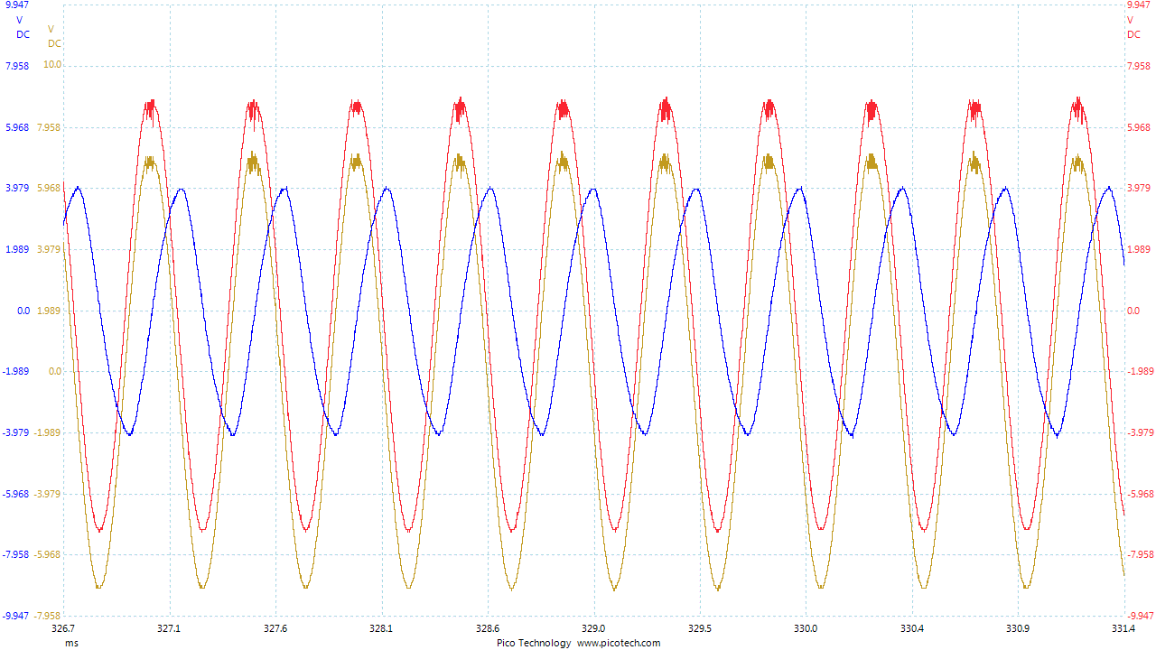

Further Analysis
The 5VAC signal fans out to 5 identical circuits.
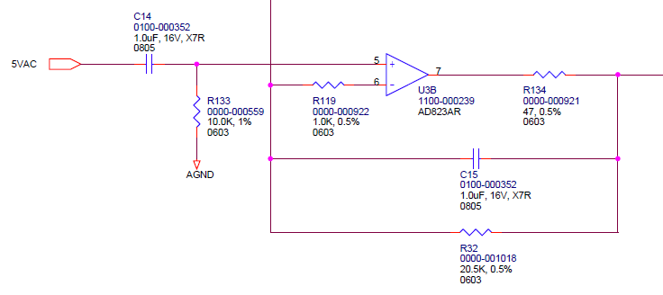

At the peak of the sine wave, the resistor to ground will be sinking 8V/10K = 0.8 mA over 5 circuits is 4 mA.
This figure from the LM6132 data sheet shows that there is a pretty hard current cutoff at low temperatures:
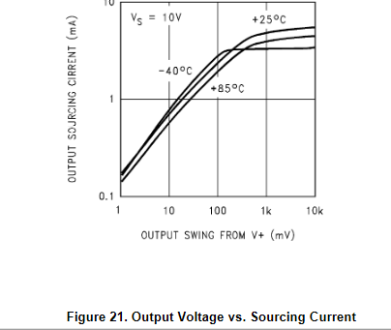
We are not operating near the V+ rail of the op amp, and Vs in our circuit is 28V (+14 to -14). But there is limiting factor that we may be getting into on some op amps.

Future Action:
- Replace U27 with a different op amp in FSC1046 and the other NCMR and see if the problem is fixed.
- Talk with a TI rep about the circuit characteristics of the op amp.
- Perhaps get some Failure Analysis done with these failing chips at TI.
- Think about a change to the circuit that may alleviate the issue in the future.
  - Only implement this if we start getting large fallout during ESS Test.
  - What happens if the 10K resistor is changed to 100K?

