**LoadCell_In- (X01 45 &46) and LoadCell_In+ (X01 47 &48) should measure 75KΩto ground**

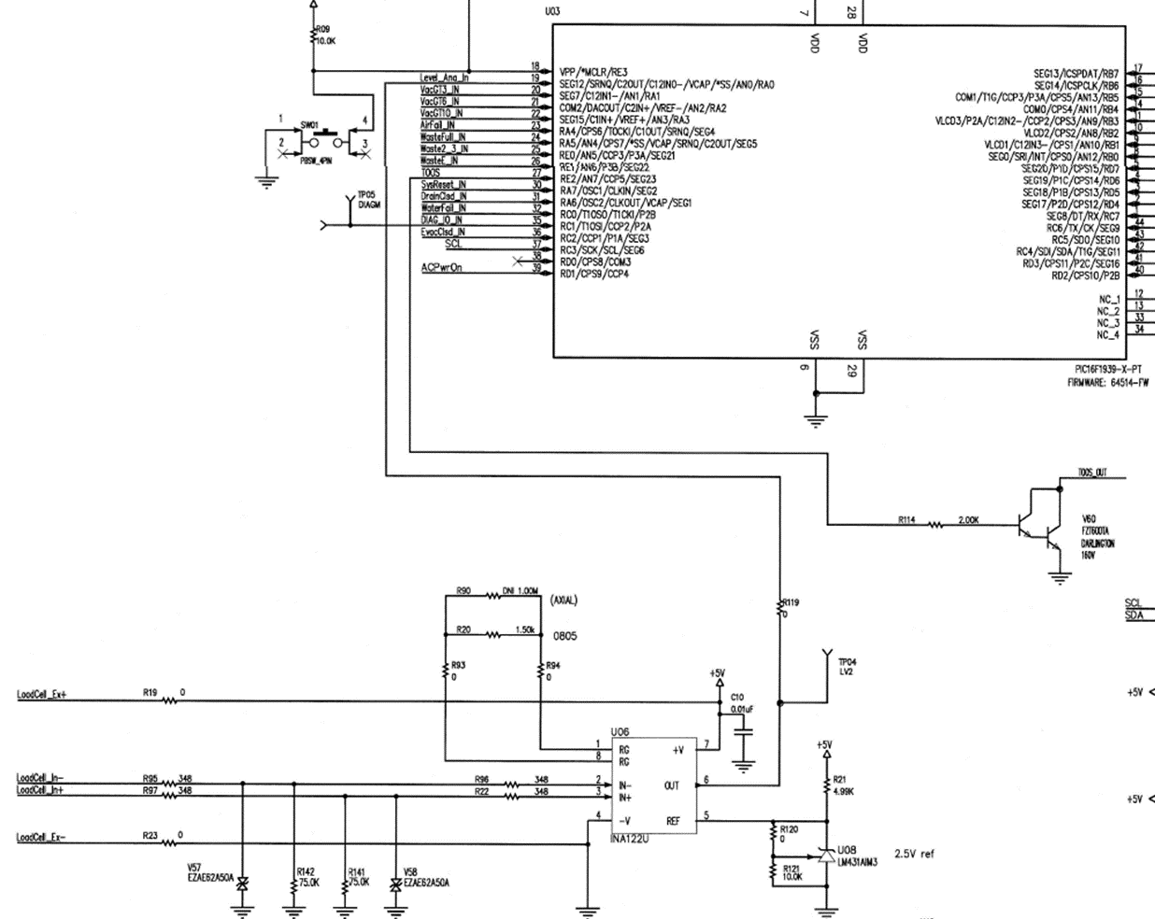

**Test set up. With 0 volts in on pins 45,46,47, & 48; TP04 should measure 0 volts.**

