Noise Calculation for below circuit.
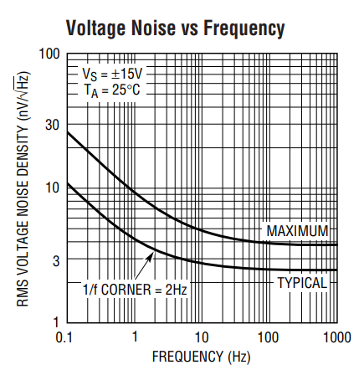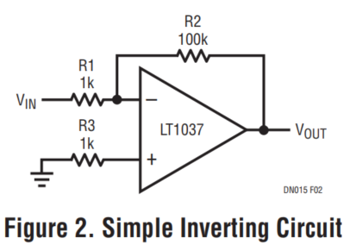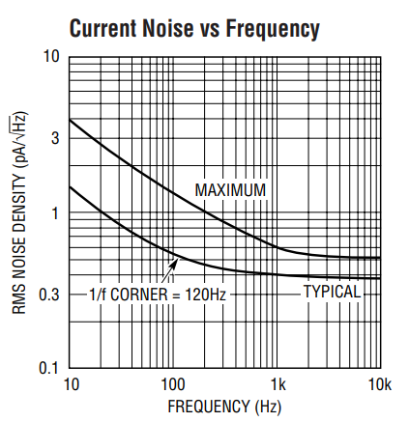
1:
GBW=60MHz, Noise Gain = 101,
so NPB = 1.57 *60/101 = 932.673KHz
2:
en_op: Voltage Noise Density of op amp
env_R1&2: Voltage noise Density of R1 & R2
env_R3: Voltage noise Density of R3
eni_R1&R2: Voltage noise Density developed by current noise in R1 & R2
eni_R3: Voltage noise Density developed by current noise in R3
${en}_{op}=env*\sqrt{1+\frac{F3db}{FH-FL}*\ln\left(\frac{FH}{FL}\right)}$*$\sqrt{NPB}$ (1)
$=\frac{2.5nV}{\sqrt{Hz}}*\sqrt{1+\frac{2Hz}{932.673KHz-0.1Hz}*ln⁡(\frac{932.673KHz}{0.1Hz})}$ *$\sqrt{932.673KHz}$=2414.4nVrms

$env_R1\&2=\sqrt{4*K*T*(R1//R2)} * \sqrt{NPB}$ (2)
$=\sqrt{(1k//100k)} * \sqrt{932.673KHz }$ * 1.28* ${10}^{-10}$ = 3889.7 nVrms

$env_R3=\sqrt{4*K*T*(R3)} * \sqrt{NPB}$ (3)
$=\sqrt{(1k)} * \sqrt{932.673KHz }$ * 1.28* ${10}^{-10}$ = 3909.1 nVrms
$eni_R1\&R2=eni*\sqrt{1+\frac{F3db}{FH-FL}*\ln\left(\frac{FH}{FL}\right)}$*$R1//R2 * \sqrt{NPB}$ (4)
$=\frac{0.4pA}{\sqrt{Hz}}*\sqrt{1+\frac{120Hz}{932.673KHz-0.1Hz}*ln⁡(\frac{932.673KHz}{0.1Hz})}$ 1k//100k *$\sqrt{932.673KHz}$
=382.9nVrms
$eni_R3=eni*\sqrt{1+\frac{F3db}{FH-FL}*\ln\left(\frac{FH}{FL}\right)}$*$R3 * \sqrt{NPB}$ (5)
$=\frac{0.4pA}{\sqrt{Hz}}*\sqrt{1+\frac{120Hz}{932.673KHz-0.1Hz}*ln⁡(\frac{932.673KHz}{0.1Hz})}$ 1k *$\sqrt{932.673KHz}$
=386.7nVrms

Total Noise
$Eno_RTI=\sqrt{({{en}_{op})}^{2}+{(env_R1\&2)}^{2}+{(env_R3)}^{2}+{(eni_R1\&R2)}^{2}+{(eni_R3)}^{2}}$ (6)
= $\sqrt{({2414.4)}^{2}+{(33889.7)}^{2}+{(33909.1)}^{2}+{(382.9)}^{2}+{(386.7)}^{2}}$
=6.044uVrms

