At first, I tried to calculate and simulate the noise of the 3 op amps instrumentation amplifier, but the two results don’t match. So I simulated the noise of OPA2333.

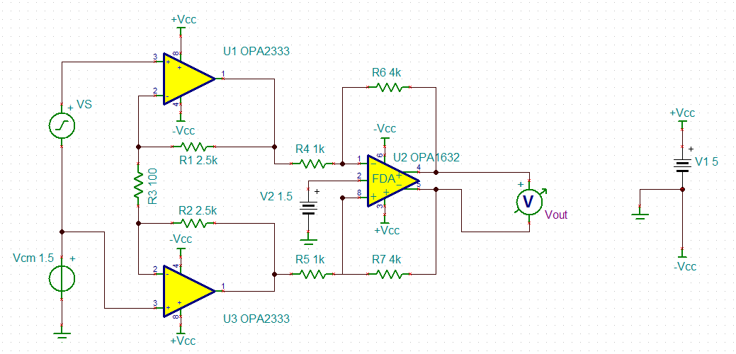

The circuit is as follows:

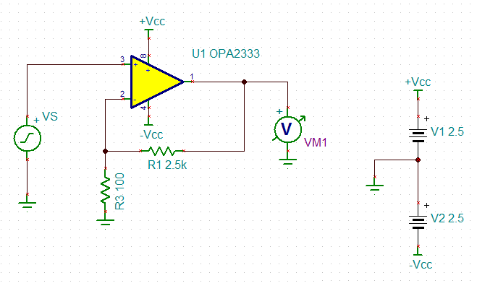

Hand calculation:

The noise properties of OPA2333:

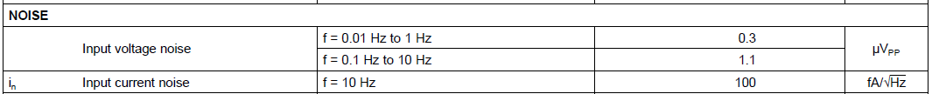

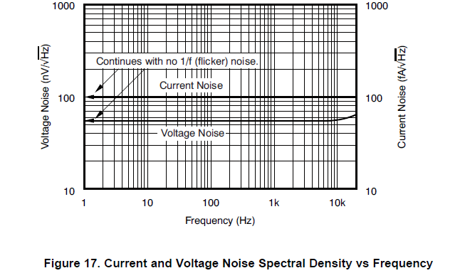

The bandwidth of 2nd order low pass filter is 100Hz and there is no 1/f noise.

Noise bandwidth:

$${BW}_{N}=100×1.57=157Hz$$

Broadband noise:

$$E_{NBB}=\frac{56nV}{\sqrt{Hz}}×\sqrt{157Hz}=701.68nV$$

The resistance noise:

$$R_{N}=R_{1}{//R}_{3}=\frac{2.5×0.1}{2.5+0.1}kΩ=96.15Ω$$

$$E_{NR}=\sqrt{4KTR_{N}{BW}_{N}}=\sqrt{4×1.38×{10}^{-23}×298.15×96.15×157}=15.76nV$$

The current noise:

$$e_{ni}=96.5Ω×\frac{100fA}{\sqrt{HZ}}=9.615×{10}^{-12}V/√HZ$$

$$E_{NI}=e_{ni}\sqrt{{BW}_{N}}=0.12nV$$

Therefore, the total noise is

$$E_{N}=\sqrt{{701.68}^{2}+{15.76}^{2}+{0.12}^{2}}=701.86nV$$

The simulation result is 11.72uV! The results are shown below, and the left one is the output voltage noise spectral density and the right one is total noise.

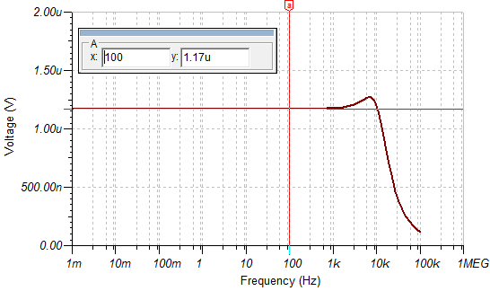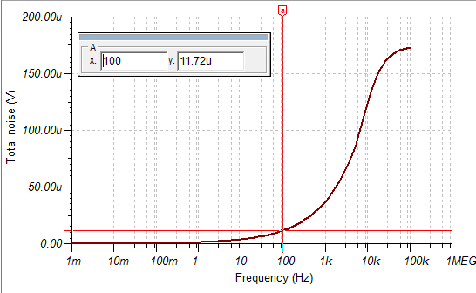

Maybe the noise at low frequency is bigger, shown as the datasheet, so I calculated the noise of 0.1-10Hz and 10Hz-100Hz.

$${BW}_{N}=90×1.57=141.3Hz$$

$$E_{N10-100}=\frac{56nV}{\sqrt{Hz}}×\sqrt{141.3Hz}=665.67nV$$

$${EN}_{0.1-10}=1.1μV_{pp}=\frac{1.1}{6}μV_{RMS}=183nV$$

Therefore, the noise is 849nV.

To analyze the performance of the op amp, the follower circuit is simulated.

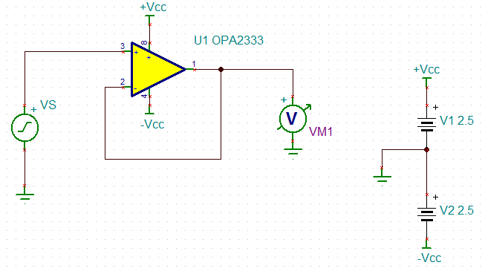

The output noise is 45.03nV/sqrHz, not corresponding to the datasheet (56Nv/sqrHz). Why?

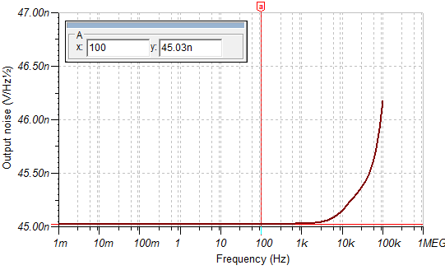

Even if the Ebb is 45.03nV/sqrHz, the noise with resistors is also incorrect, why?