Different 1/f equivalent flatband calculations
Michael Steffes, 3/23/201
There are different forms of this out in the industry,
If we accept the underlying spot noise equation to be given by this equation, a simple result can be derived. And the point here is to integrate the power over some frequency span and develop a single flat spot noise number that will integrate to that same power. This is from an old noise app note I did for BurrBrown, which basically repeated an earlier noise app note I did for Comlinear on this fundamental topic. https://www.ti.com/lit/an/sboa066a/sboa066a.pdf

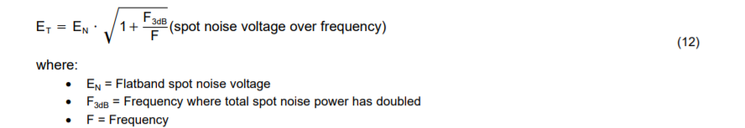
I had simply run the integration many years ago to yield a simple and accurate result. Not sure where the other forms came from (and not interested enough to work on that), and they might be equivalent – lets test those in a TINA sim example using a macro developed by Bill Sands and used by the TI folks. Here is a starting point example of just a spot noise simulation. Then, this shape should integrate to a simulate RMS noise that can then be converted back to a single flatband number – and compared to the calculated values for the different equation forms.
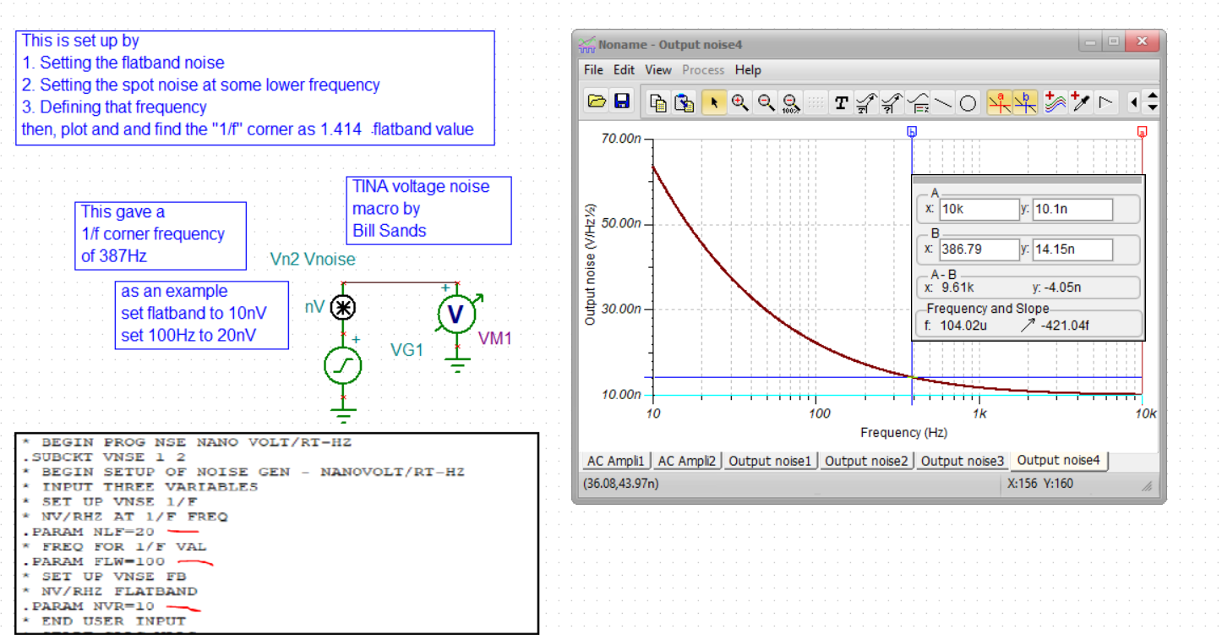
Now let’s get the integrated noise over a span that includes this 1/f region, do 10Hz to 1kHz, set up like this where the total noise option in TINA is doing the noise integration to get an RMS noise
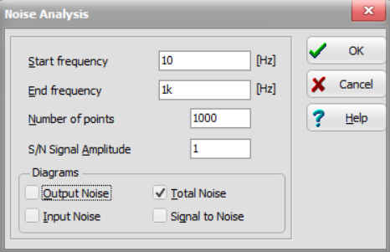
This integration continues up of course, but we are only interested in the final 1kHz value – 528nVrms here
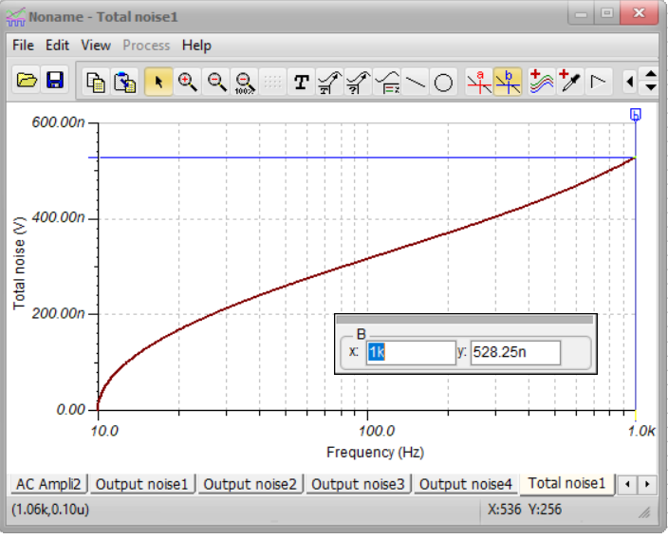
Now the equivalent flat spot noise that should integrate to this same number, from my 1996 BurrBrown app note it given by this equation
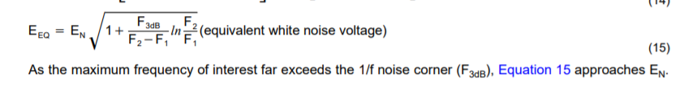
Putting in numbers,
En = 10nV
F3dB = 387Hz
F2=1kHz
F1= 10Hz
Eeq = 10nV*sqrt(2.8) =16.73nV/rootHz
Then, we should be able to take this times the sqrt(1kHz-10Hz) and get the TINA result above,
Erms = 16.73nV*sqrt(990) = 527nVrms exactly matching the TINA sim integration. So I would say this form works pretty well (and many years of testing has led me to believe that).
Let’s try those other equations out there.
What shows up in the TI precision material (and this is actually a long legacy from the BurrBrown precision team).
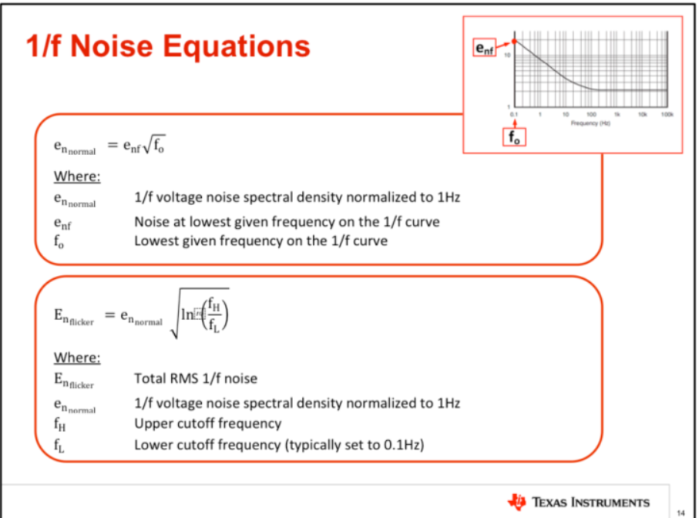

So I think what they are saying it that the equivalent spot noise to integrate is that top equation in the lower block, putting in the example numbers here
Enflicker = 10nV*root(ln(1khz/10Hz)) = 21.46nV
Then, using this for the total rms noise 10Hz to 1kHz would predict, 21.46nV*root(990Hz) = 675nVrms. Not very close to sim, but conservative – I never thought that equation was very accurate, apparently not.
Then the ADI equation,
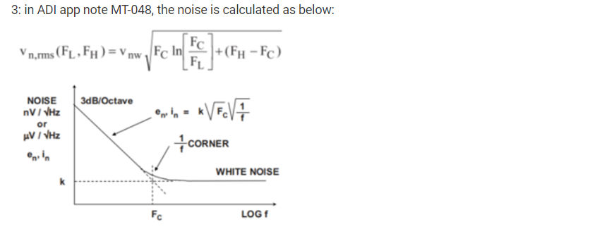
So this equation is trying to go straight to an RMS number. Fc is the 1/f corner frequency. And I think Vnw is the flatband number? (yes, nw means noise white, the flatband number).
https://www.analog.com/media/en/training-seminars/tutorials/MT-048.pdf

Putting in numbers here,
Fc = 348Hz
Vnw = 10nV
FL = 10Hz
FH = 1kHz
This evaluates to 472nVrms – little lower than the actual TINA number of 528nVrms. Not sure what they were doing here, almost like they were trying to get an equivalent frequency of integration, but its not working as well as the exact equation in my old noise app note.
So I don’t have the interest to step through the alternate derivations to identify the misteps, but they do not appear as accurate the simple result from SBOA066a.
Incidentally, if I multiply my equivalent spot noise equation by the root(Fh-Fl) to get the RMS noise over that frequency span (what ADI is trying to deliver), the equation becomes,
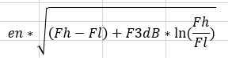
Fh = high frequency end of integration
Fl = low frequency end of integration
F3dB = 1/f noise corner frequency
en = white noise value or flatband value.
So it looks like maybe the ADI equation needed to have Fl in the (Fh-Fc) term instead of Fc?

