OPA2810 data sheet comments,
Michael Steffes, Dec. 3, 2020
Kind of reviewing this as part of an e2e question on BW vs Slew Rate vs FPBW.
1st checking the true GBP small signal, sim model gives 63MHz – also, the plot to the right here is in an odd spot, and does not mention amplitude?? Missing that it seems,
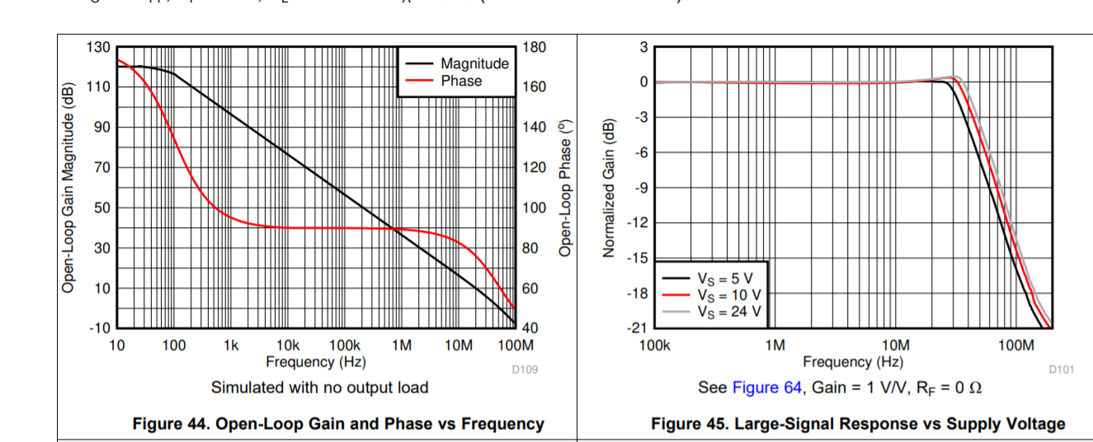

And then, the pertinent spec block on 10V supply, Lots of different ways this gets done, oddly, here they have used a 20% to 80% for slew rate, possibly the least accurate (the best is the dV/dT on a slew limited edge to see where it goes flat).
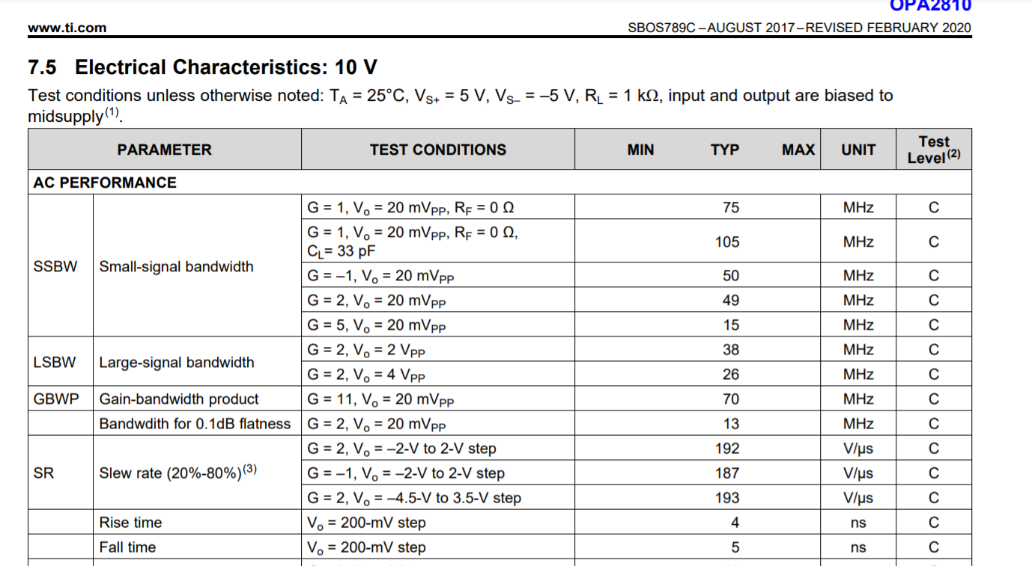
Here is the Aol plot, 40dB Aol projects to 63Mhz GBP, the Aol = 0dB xover at 51Mhz – that 57deg phase margin should be giving a very slight model peaking in closed loop gain of 1 with about 1dB peaking and a 1.6X F-3dB extension from xover to about 82Mhz F-3dB small signal – that is in Planet Analog the Signal sped up insight #5, https://www.planetanalog.com/stability-issues-for-high-speed-amplifiers-introductory-background-and-improved-analysis-insight-5/

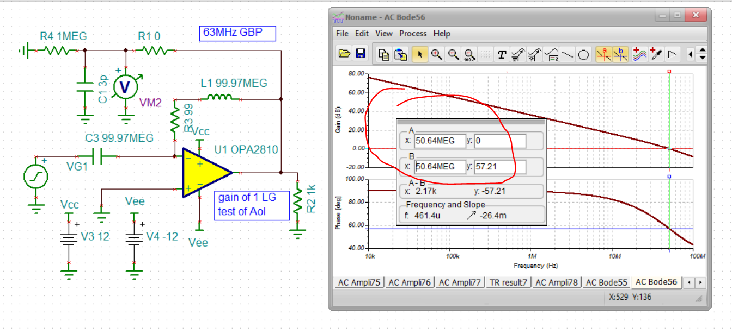
And indeed running a closed loop gain of 1 (the supplies look odd, but right here) matches theory very well, 0.8dB peaking and 79MHz F-3dB,
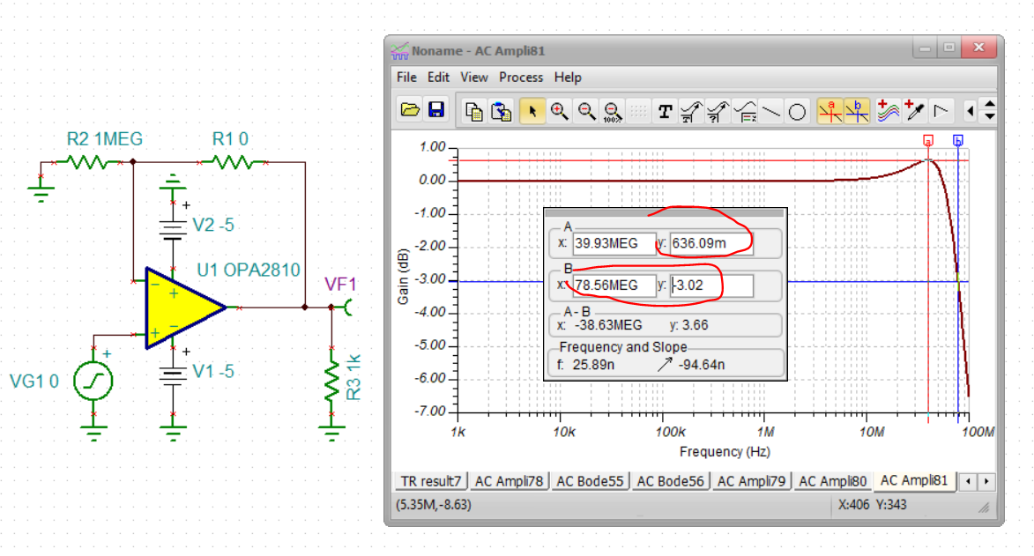
And then this also matches the spec line gain of 1 measured(?) of 75Mhz. So that is all holding together pretty well actually. Now, slew rate to FPBW? That 20 to 80% on the gain of 2 plot here is +6 to -6V range where the falling edge seems slower – that is always a pain when that happens in trying to map to FPBW – also, these time plots are nearly impossible to read for dV/dT. I am going to guess about 40nsec for the 12V negative transition, or about 300V/usec – really hard to tell but the spec line kind of clusters around 200V/usec.
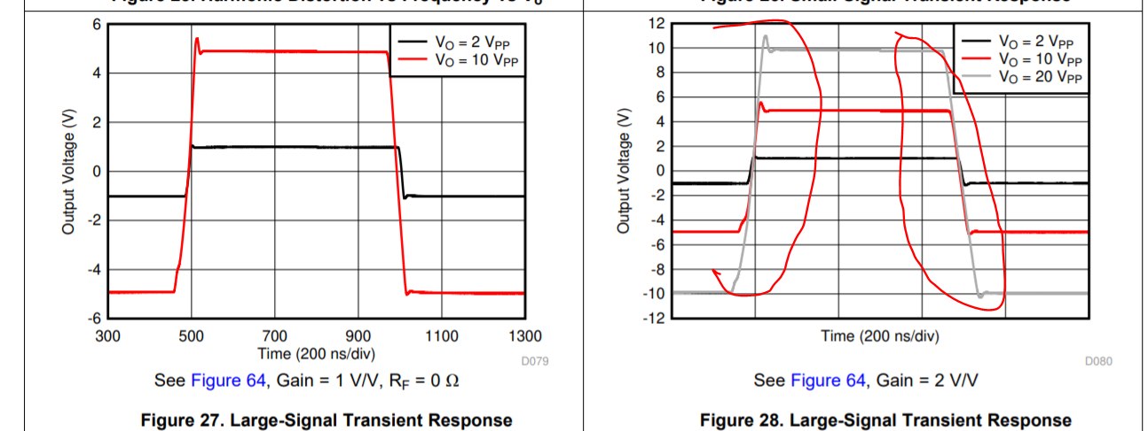
What is really strange about the LSBW spec line above is doubling the output swing does not ½ the FPBW – that seems to be that transition region between small signal effects and large signal effects.
In any case, assume that LSBW spec line is measured gain of 2 (using gain of 2 instead of 1 to avoid input CM slewing limits). Now, the big miss in the legacy mapping is if you are actually looking at the -3dB point, the fundamental of your highly distorted output spectrum is -3dB down from low frequencies – the amplitude you need to use is 0.707*Vp at lower frequencies.
Solving for SR from the 2Vpp 38Mhz number is then 0.707*2pi*38MHz = 170V/usec (not a bad match actually). But I think this this result has been reduced a bit by the raw closed loop BW (gain of 2 SSBW is 48Mhz, not much more than measured LSBW). I tried to work through that issue in the 2nd half of this article, this one also shows the much better way to extract slew limiting on an edge using a simple point slope approach,
https://www.edn.com/what-is-op-amp-slew-rate-in-a-slew-enhanced-world-part-2/
Now check the 4Vpp 26Mhz – here the slewing effects are dominant and solve to 0.707*2*2pi*26MHz = 230V/usec – which is closer to the large signal step number.
So its not easy to make this mapping – but the dV/dT approach is definitive.

