The circuits and corresponding waveforms on the following two pages show the zero bias and 0.2V bias conditions. Operating at zero bias would be easier, but introduces that spike when operating in integrating sphere . . .
Not sure I know exactly why, but adding the bias circuit with a simple forward biased Schottky fixed the problem. It might be that the filtering at the non-inv input prevents the autozero from triggering at transition from dark current segments of the waveform? If I use a 100k resistor to isolate as in Figure 4 of datasheet, I get continuous autozero spikes, but reducing that to 100 ohms gives a clear waveform about 0.2V above ground as shown on pg 2. Note that VBAT in this system is a single Li-ion cell about 3.7 - 4V. I will replace the Schottky with a stable reference in final circuit - just prototyping at this point.
It seems that the autozero circuit operation is proprietary according to the datasheet – Is it, in fact, running all the time, or only under certain conditions at the input? Are there any app notes that give a little more info on how the autozero works?
I will next try reducing or removing the 0.1uF cap to see if I can get back some frequency response. Ultimately, I’d like to run down to the limit in the AFE4490 which is a 50usec pulse width. Right now I am using the default 500usec pulse width.
I did not attempt filtering output as I want to keep BW as high as possible for the 50usec case.
Note that the end application is a test fixture for our SPO2 sensors on an assembly line, but this testing will influence our next generation SPO2 circuit design. Right now, I am driving the differential input of an NI USB 6343 DAQ – the final test fixture will likely use that, or faster version, the NI USB 6351 DAQ. Both have a small signal bandwidth of ~1.2MHz and input bias currents of ~100pA. Inputs are listed as 10Gohm in parallel with 100pF. Connection from Photodiode to TIA is 2ft of RG316. Connection from TIA to DAQ is 2ft of RG58. Photodiode spec, below:
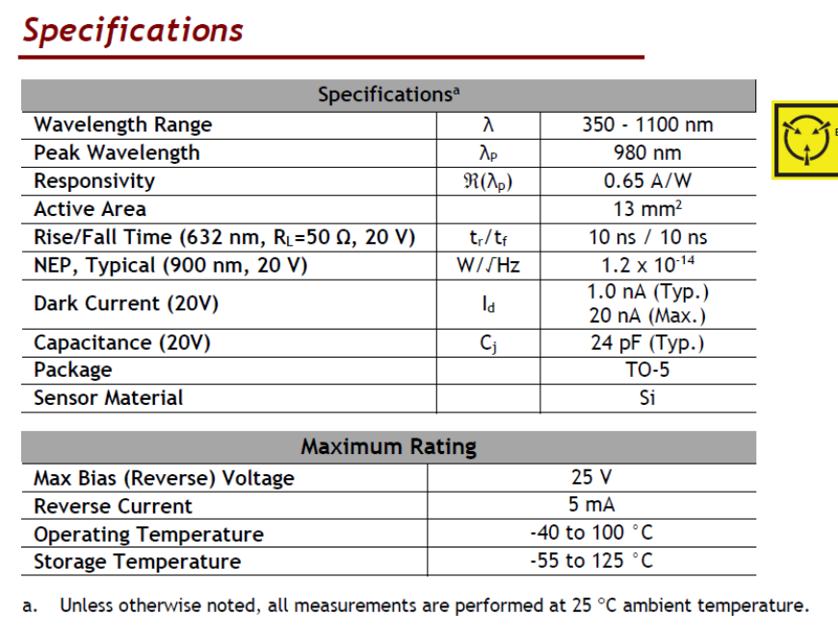

Vbias = 0V

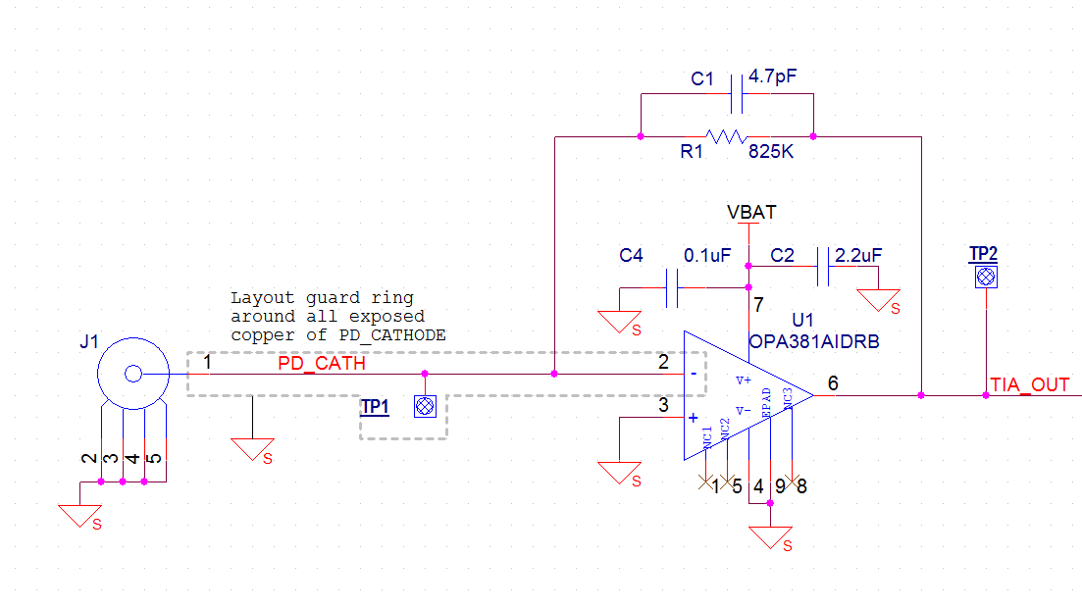

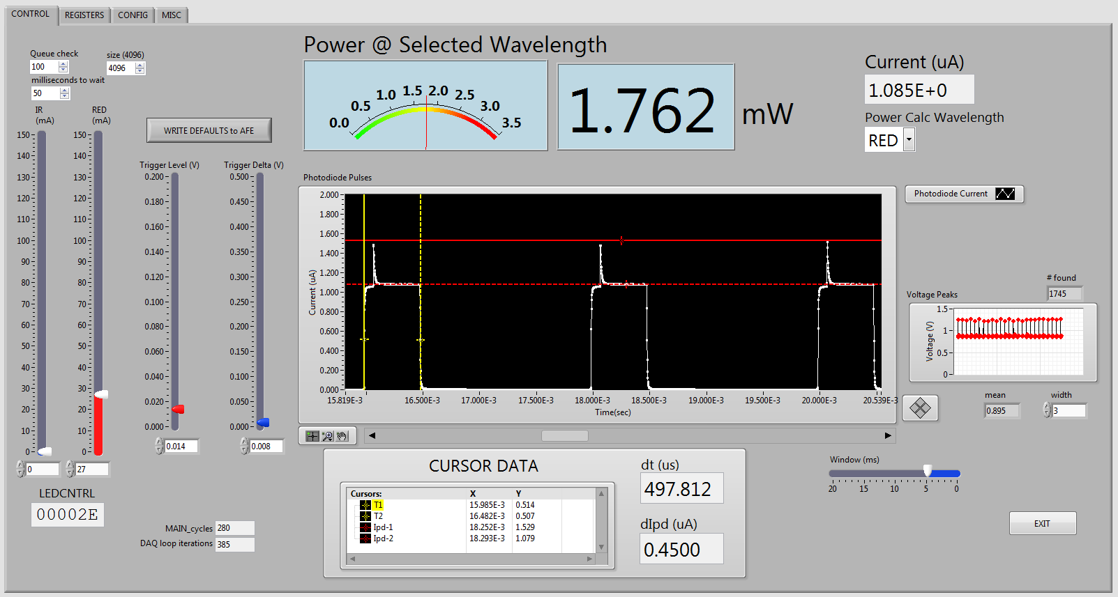

Vbias ~0.2V

