OPA388IDBVT Test Report

The circuit diagram as the following picture shown,

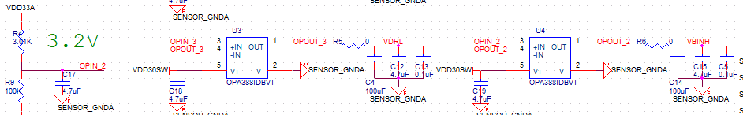
Input:OPIN2
- In the red box below is the location of OPA388IDBVT.
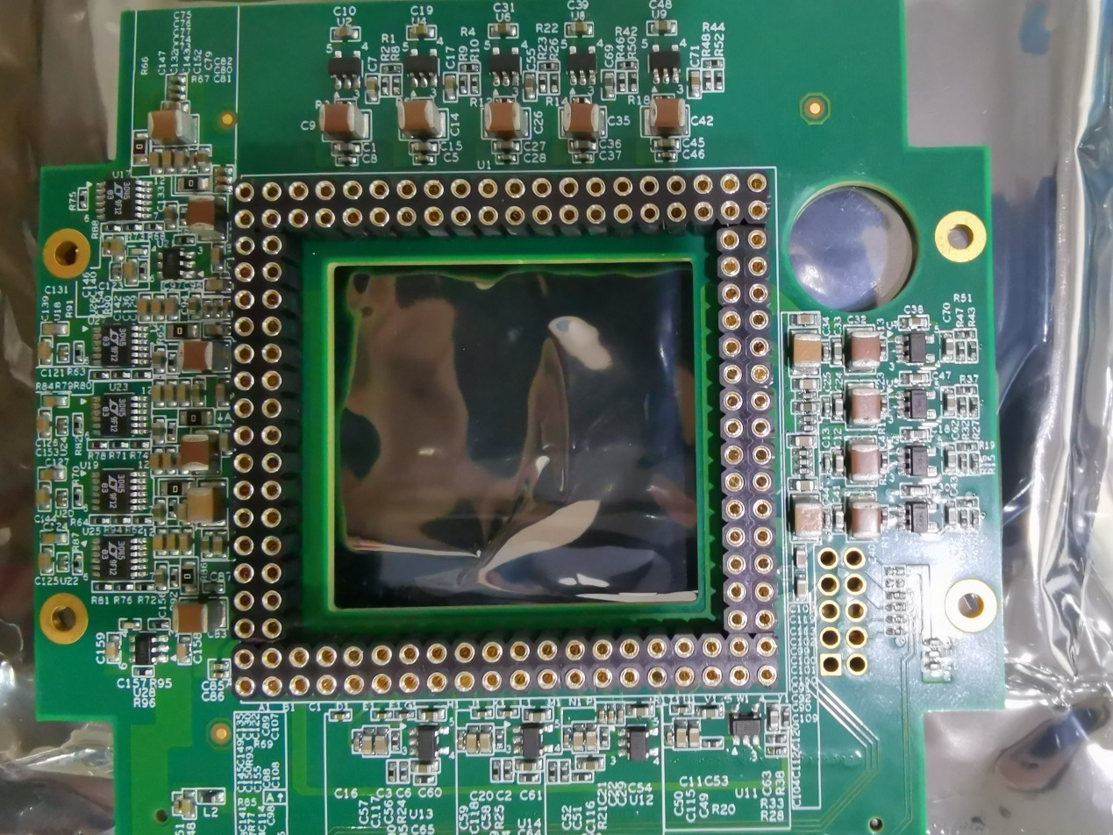
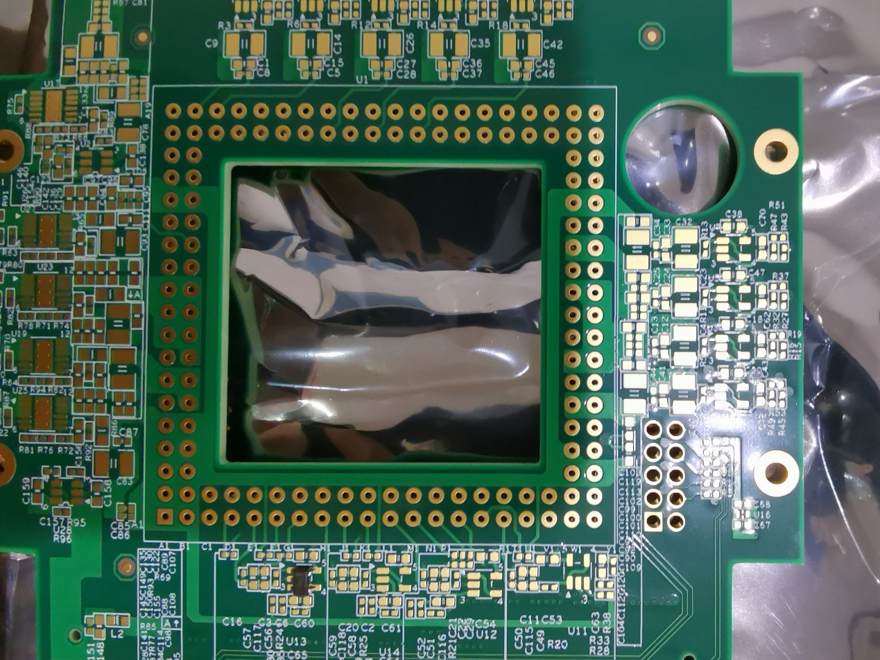

- Good parts tested.
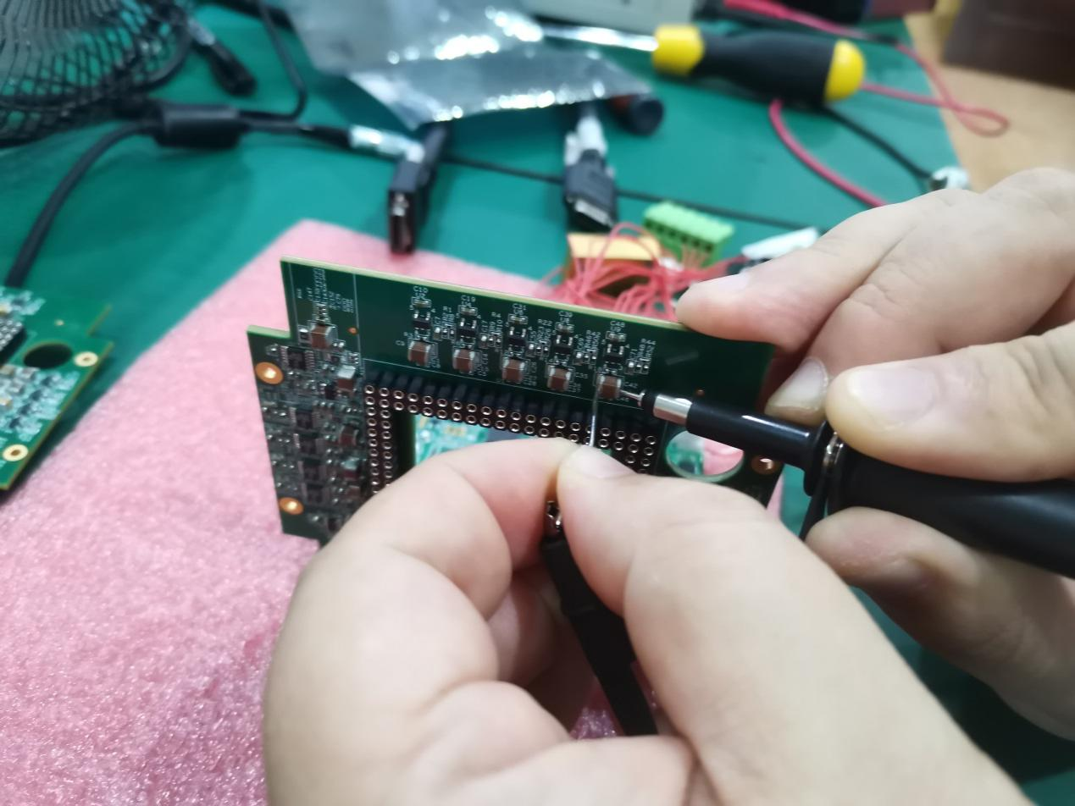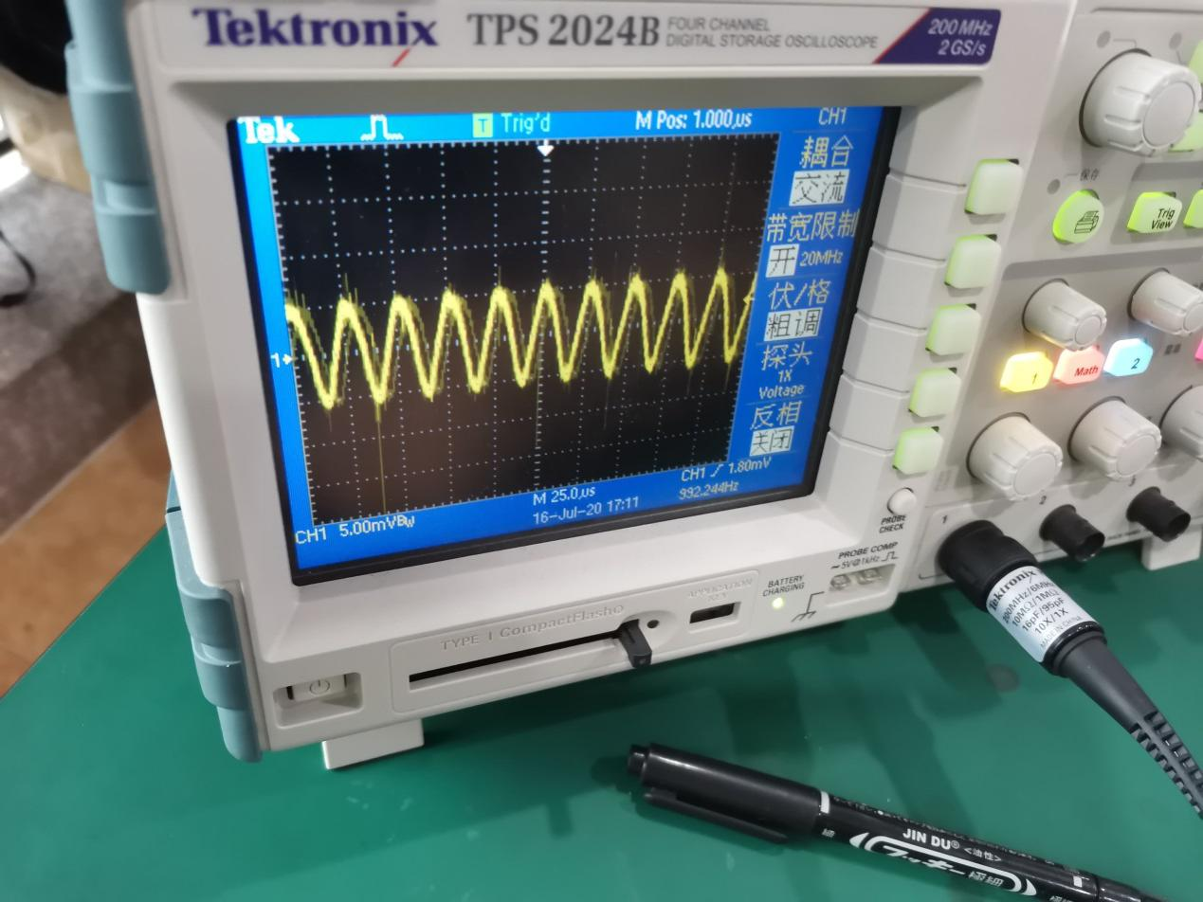
- Mouser parts tested：
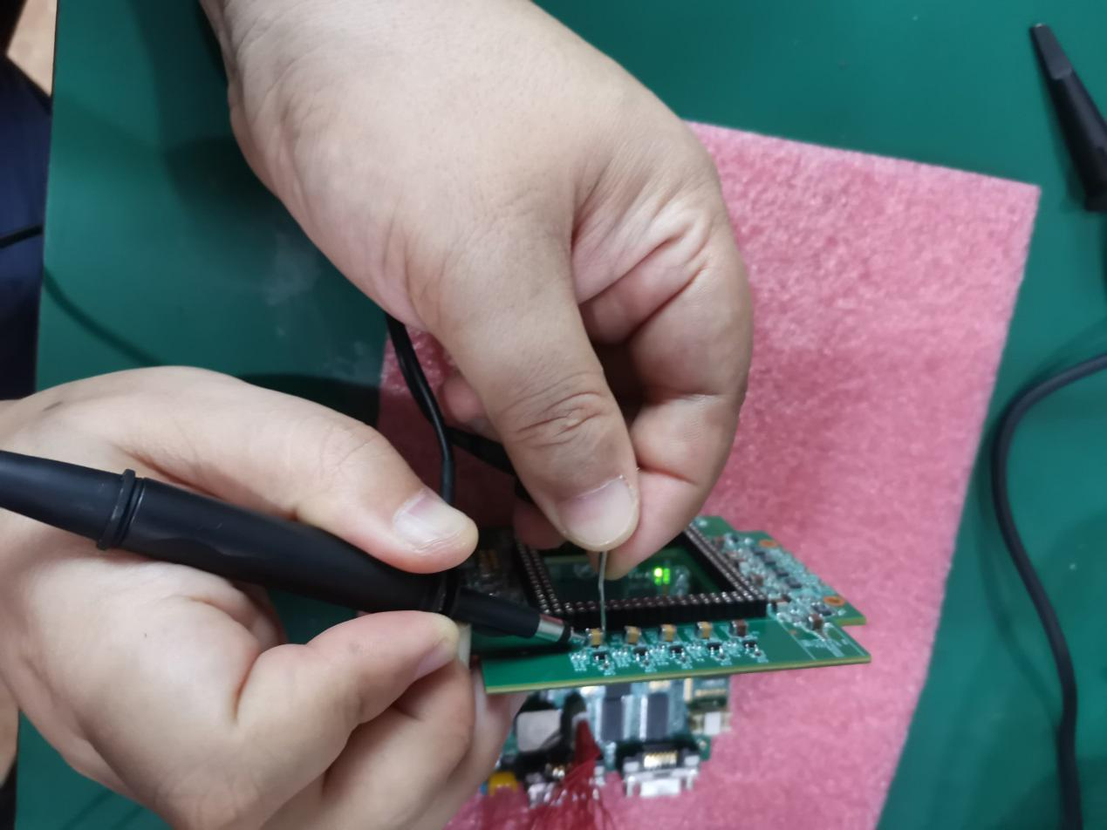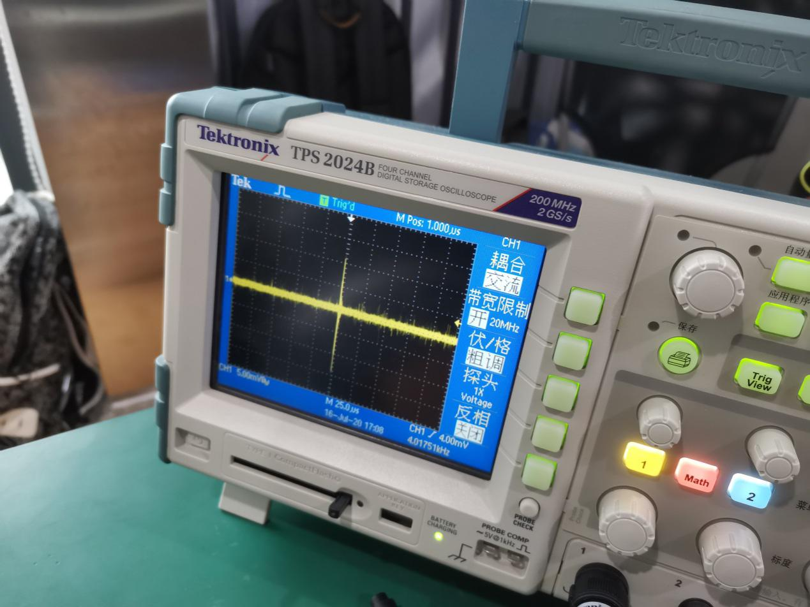

4.Result:Our good parts can output complete sine wave normally, but the parts can not output sine wave.We tested 39pcs parts,all parts can’t output sine wave.

