OPA541AP question
Problem Description:

Using OPA541AP to build a circuit which can output large current, the circuit mode is simple and forward input, the ratio is 1 to 4. power supply ± 15V, the load is 2 ohm resistor (located between the op amp output and the ground), the signal input is AC signal, the frequency is 1kHz, and the amplitude is 100mV. After the circuit is built and powered on, the power and current are normal, and there is distortion at the bottom of the output waveform (at the load resistance), as shown in the figure below:
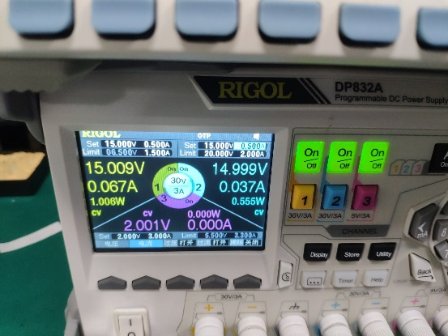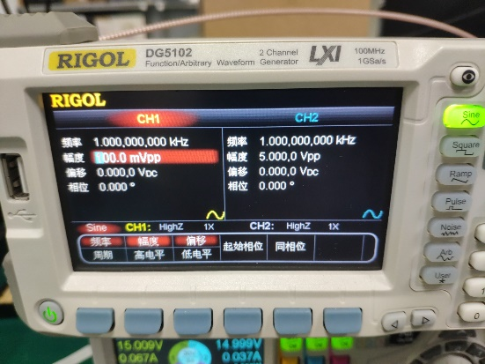
power supply Signal generator input signal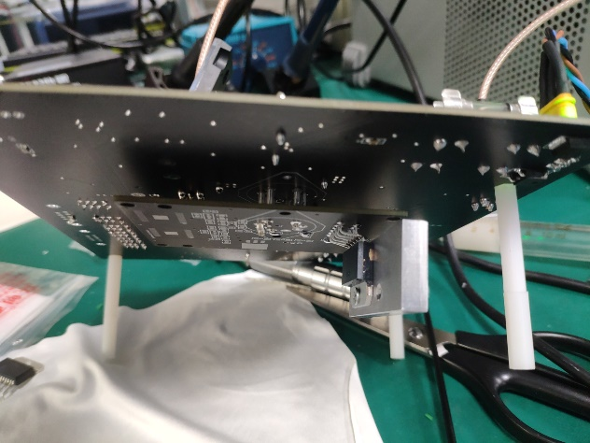
OPA541AP
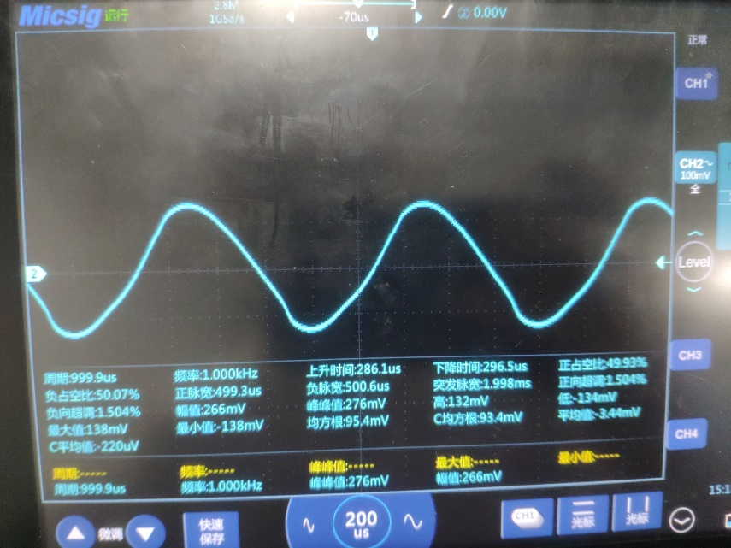
When the gain is 2.7
When the op amp gain is adjusted from g = 2 to g = 5, the distortion of output waveform does not disappear.

Question: what causes the distortion?

