- Complex load on OPA544 Howland Current Pump output

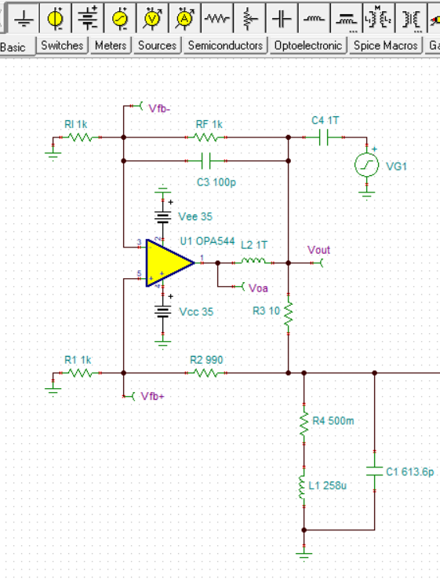
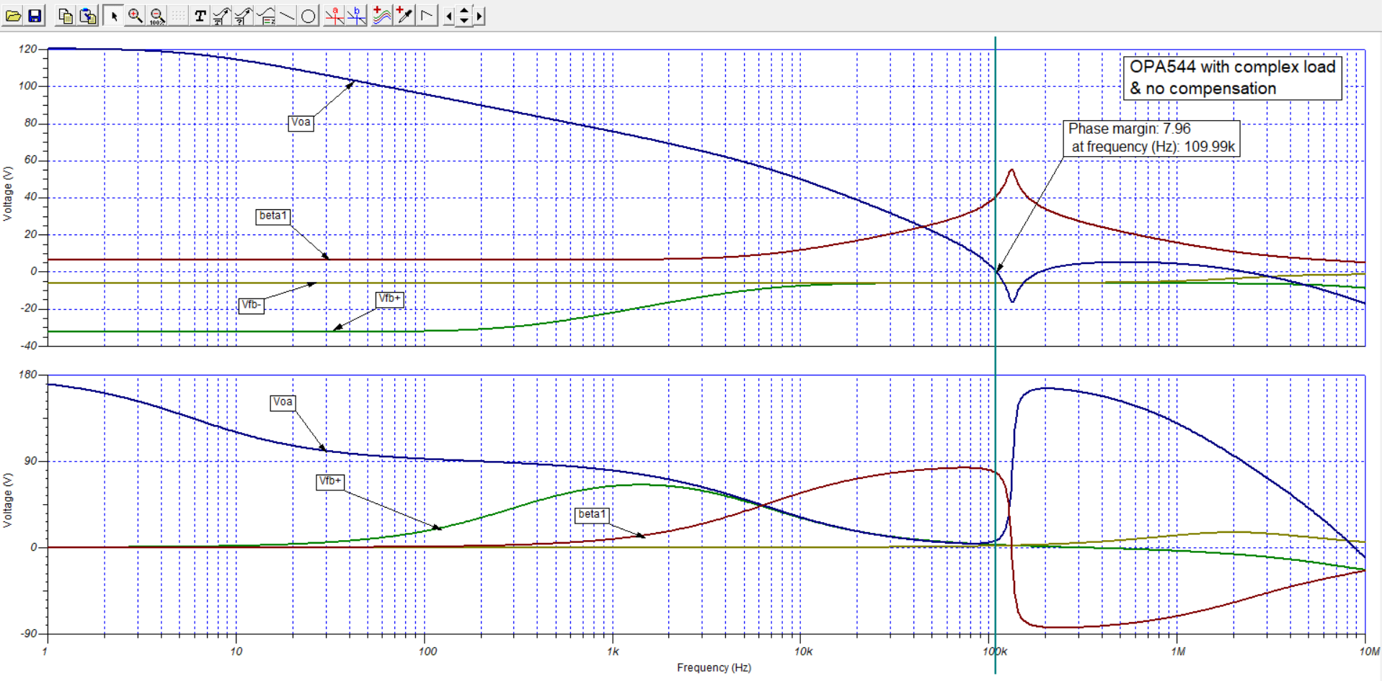
Phase margin appears to be only about 8 degrees result in severe gain peaking.

- Complex Load plus RC snubber (Zobel network) across load
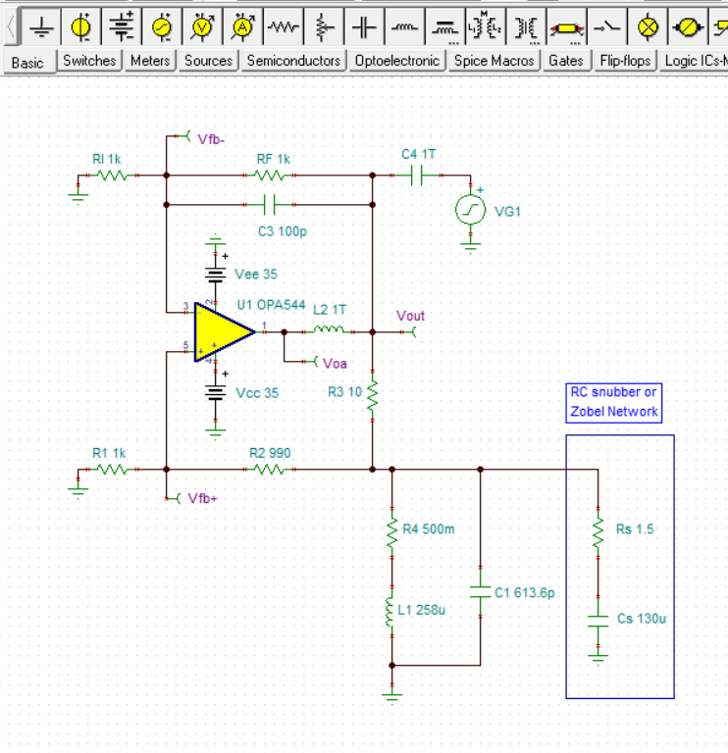
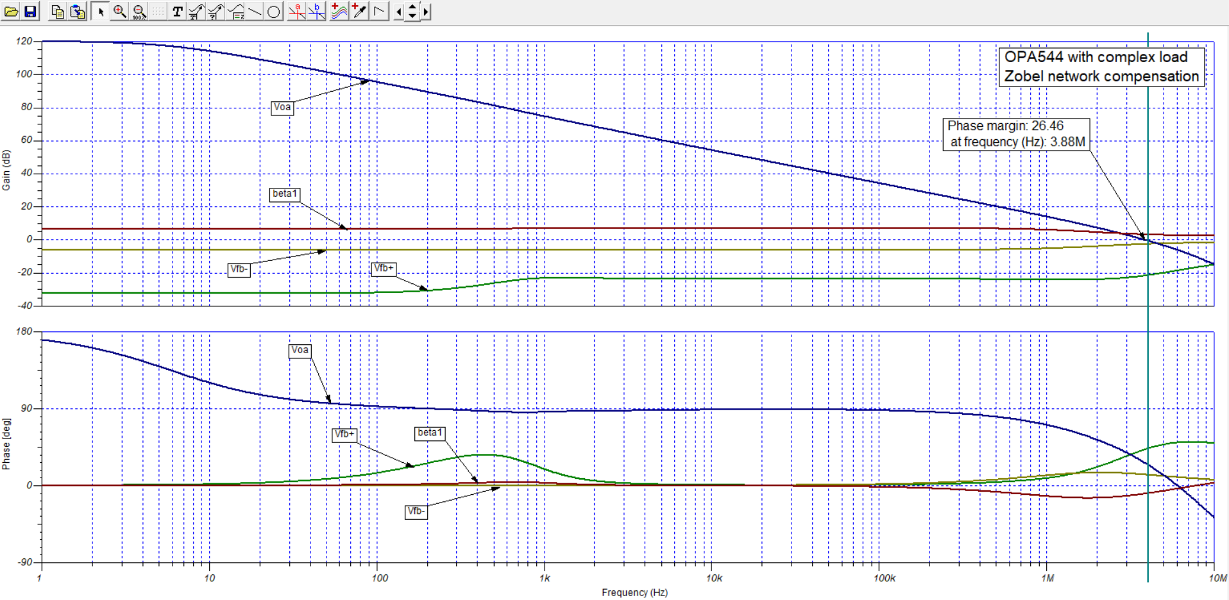
Adding the RC network increases the phase margin to about 26.5 degrees which should enhance stability and reduce gain peaking.
- Adding a 2.7 Ohm output isolation resistor in conjunction with the RC snubber
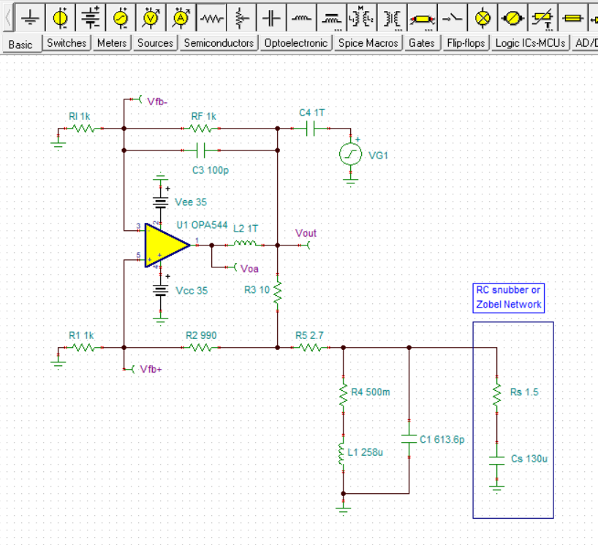
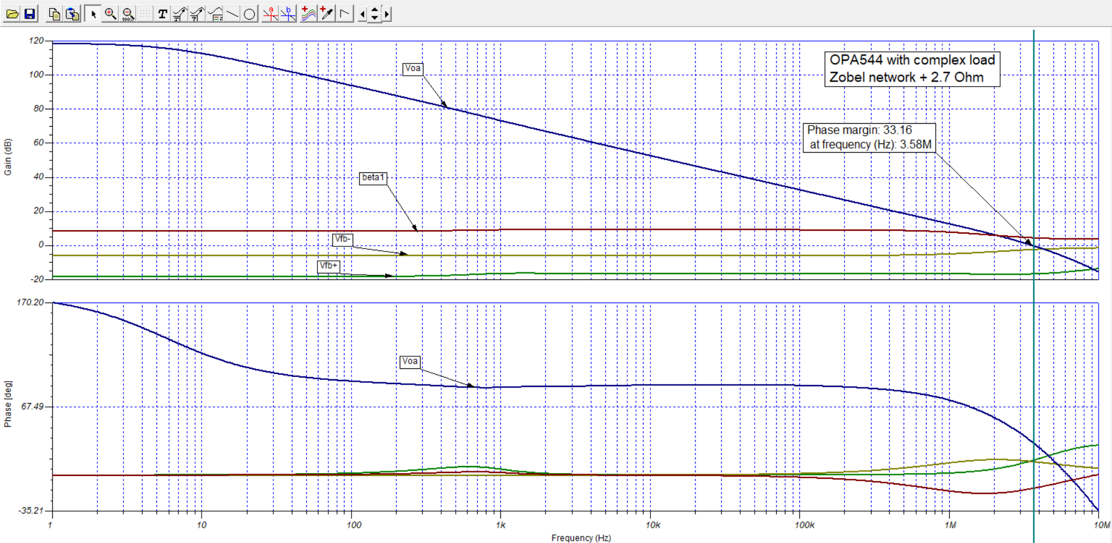
The phase margin increases to about 33 degrees which should better stabilize the circuit and further help reduce gain peaking. Adding the isolation resistor does reduce the output voltage compliance range a little so that would have to be considered.

