1. Based on the verification of dismantling C33 and C36, the OPA551 noise problem still exists when a sine wave signal is applied to the input. The noise level is related to the frequency of the signal source and the driving current of OPA551. The attached diagram shows the relationship between the input waveform of U3 and the output waveform of OPA551 load 100R.

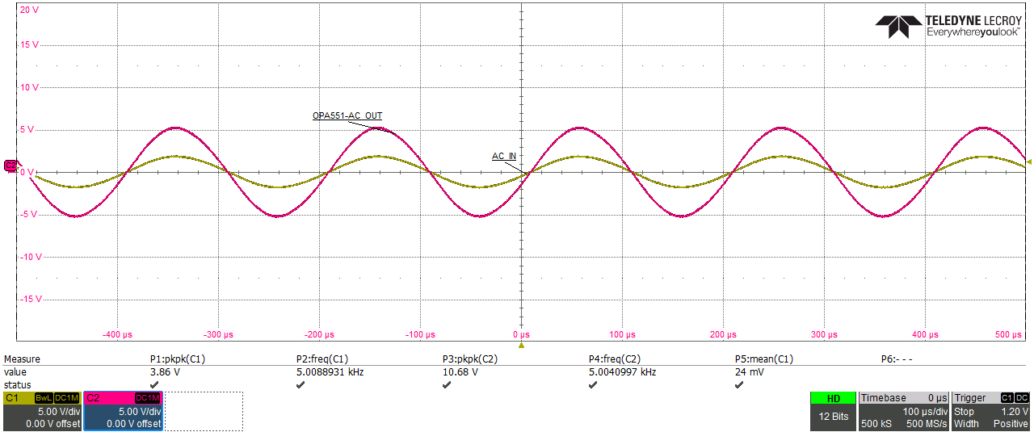

2. Directly apply a 5KHz sine wave AC signal source to U4 PIN_ 3 (OPA551), DNI R36 R43, RL=100R RC ≈ 0, output sound present.
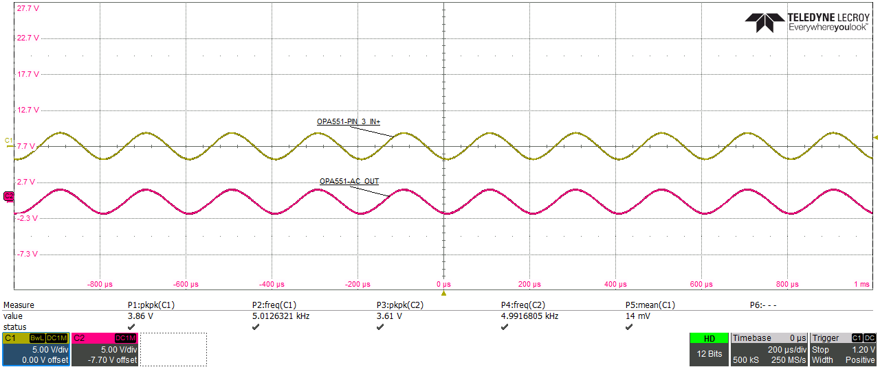

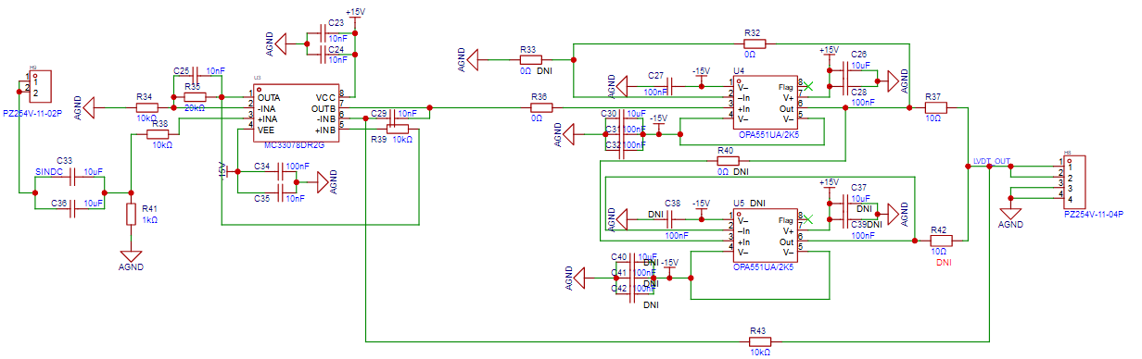

3. Directly apply a 5KHz sine wave AC signal source to ALM2403-Q1 PIN_ 2 PIN_ At 4 (R92 R97), RL=100R, RC ≈ 0. Appears to emit sound similar to OPA551.
