OPA552 stability
Here is the original ckt, shows about 48deg which is not bad, It is very possible that the 8pF total input C I am using is lower than physical device. Also, what is the load – really – The easy think to try is to drop Rf and R2 down by a factor of 10X
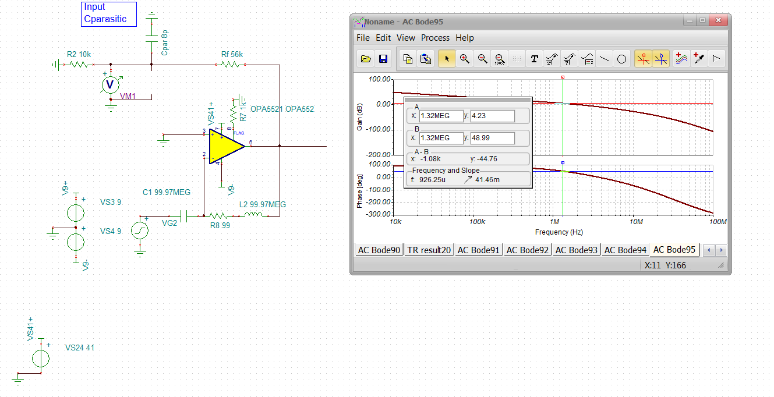

This approach is described in these articles,
https://www.planetanalog.com/author.asp?section_id=3404&doc_id=565056&
https://www.planetanalog.com/author.asp?section_id=3404&doc_id=565077&

If I add a 50pF load, the phase margin drops down to 33deg, more like the overshoot you are seeing,

