Inverting OpAmp configuration.

Gain = -0.1

Vin = -4V

Vout = 0.4V

RL = 0.4 Ohm

I_Limit = 0.4mA

I_Load = 0.4V/0.4Ω = 1A 🡪 enter current limit

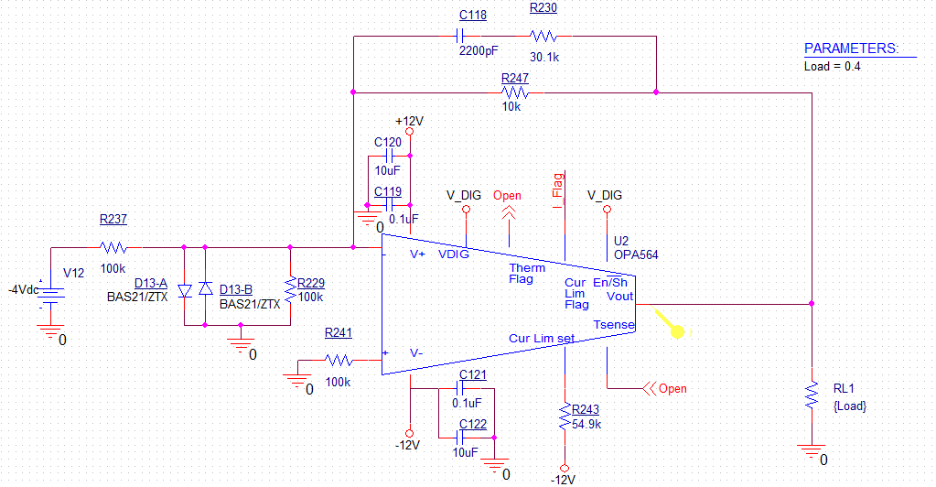

Output current simulation:

It can be seen that the output current is limited to the 0.4mA setting and the output voltage is shutdown since the short circuit is not removed after ~30ms, then the chip turns on again for ~10ms and turn-off again, the output behaves like hiccupping.

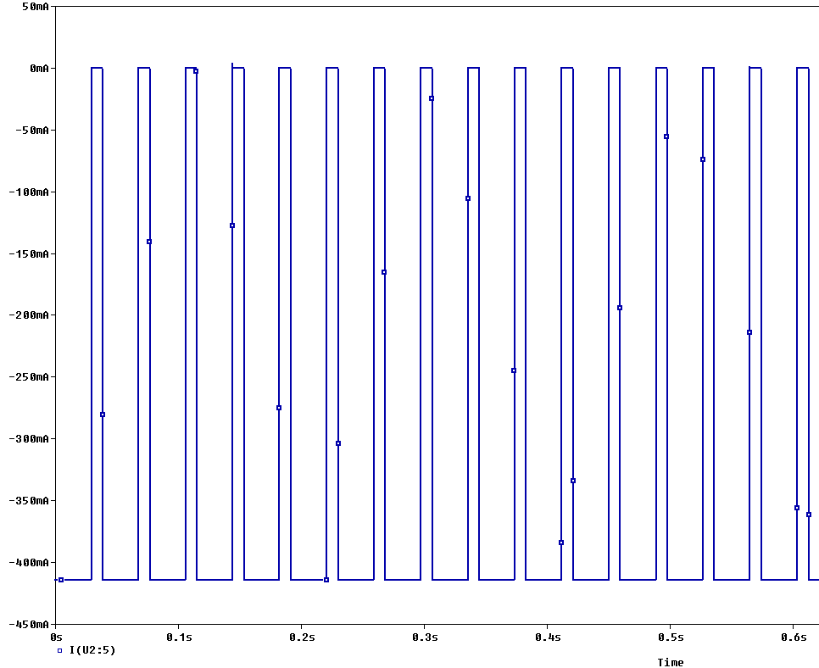

On the other hand, if I add a small load the closed loop of the opamp (highlighted in yellow), the output current doesn’t hiccup anymore and the ocuput current is continiously ~400mA:

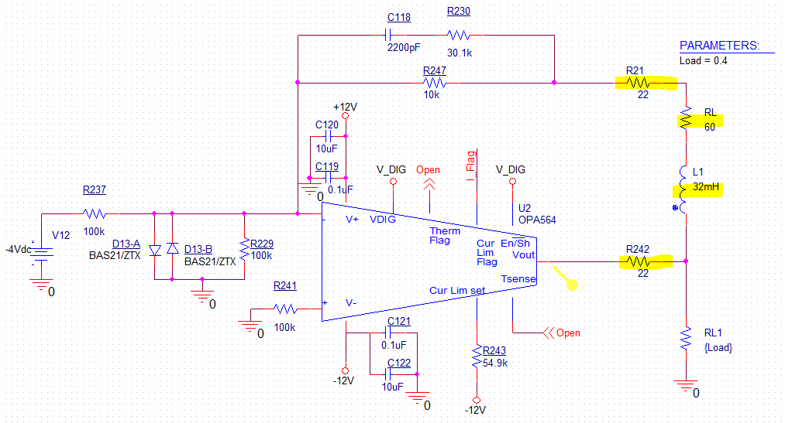

Output current: Constant 400mA output, without hiccups.

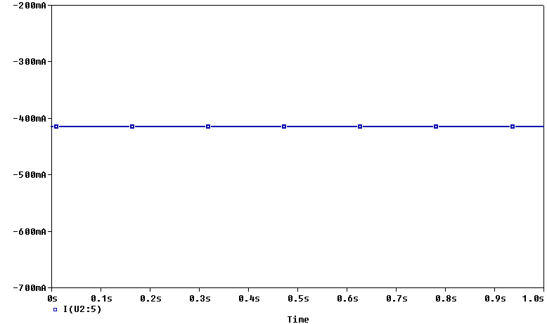

**So my question is, which output behavior should I expect from the OPA564? Will it be continuous or will it hiccup?**