Hi Manuel,
OK, I will recopy what I have posted (and more so because I had no scope shots!). No one has attempted to answer it; mind you I cannot find what happened to it! I actually do think it is a limitation in the opamp design itself and as indicated, there is nothing on the net about this! I have attached the circuit in question. Please ignore my amp and voltmeters everywhere!
Firstly consider the results below. VG1 is set to 350mV 0-Pk @ 50MHz; Opamp IP – VinOP is virtually the same except for minor effects from the limiters presence. The OPA818’s output – Vop is 3.5V 0-Pk, there is no clipping but only slew and BW limitations. The current flowing into +Vin input < 800uA 0-Pk. All is well.
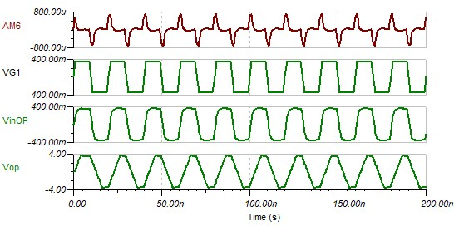
Ok now let’s drive VG1 = 5V 0-Pk.
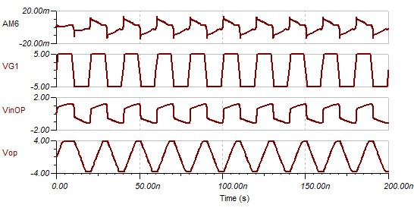
We can see that the limiters are kicking in to keep VinOP below +/-5V Pk-Pk. Look at VinOP input current (AM6), it is almost +/- 10mA Pk-Pk!!
Now let’s make VG1 = 35V 0-Pk. The opamp input - VinOP is still way below +/-5V Pk-Pk, as specified by data sheet but with not much change in output. AM6 is now well above +/-10mA Pk-Pk and hence we have device destruction!!
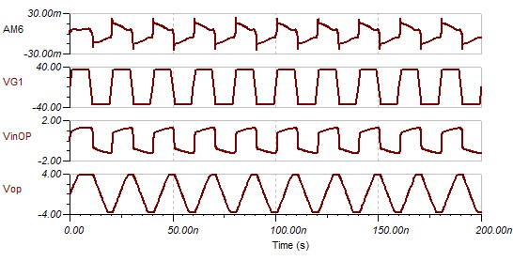
Now let’s drive the OPA818 at 1MHz = 1/50 the frequency. So VG1 = 0.35V 0-Pk.
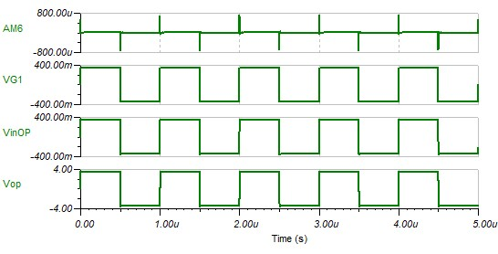
The Pk-Pk output of everything is about the same. Now let’s set VG1 = 5V 0-Pk.
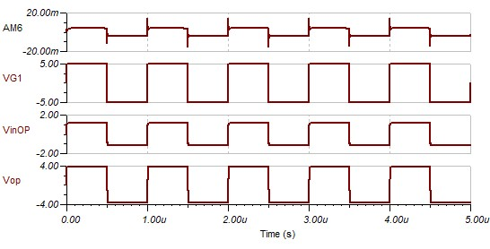
Notice that at this much lower frequency of 1MHz the bulk of the input current: AM6 is below +/-10mA but there a high frequency component there is well above +/-10mA!
Now to finally check at VG1 = 35V 0-PK.
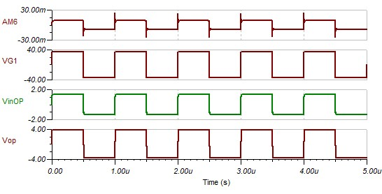
Again the bulk of the input current: AM6 is still below +/-10mA but there a high frequency component there is well above +/-10mA!
Next I have disconnected the limiters and set VG1 to 0.35V 0-Pk sinewave. Input current is limited by R3 + R11 = 200Ω.
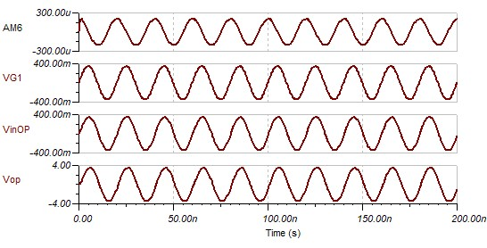
Vop is not clipping and AM6 0-Pk is well below 300uA, let alone 800uA.
Now let’s set VG1 = 5V 0-Pk sinewave.
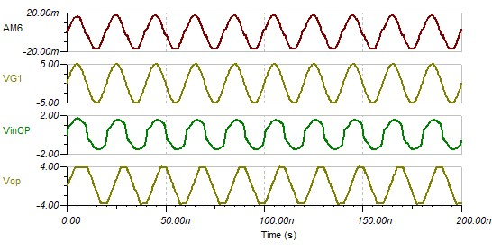
Notice that VinOP is distorted when output Vop is clipping and AM6 is well above +/- 10mA Pk-Pk!
OK, now the last sim! Let’s try the same conditions above except with VG1 set 1MHz frequency.
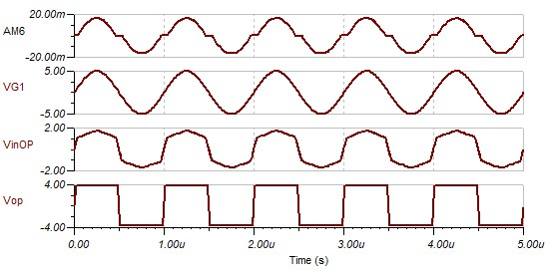
This last set of curves is very revealing! The opamp input current AM6 is virtually zero when the input voltage is < or = +/- 1V and this nearly matches when the output is in the linear region and not clipping. Below is a close-up around the period when AM6 ~ zero.
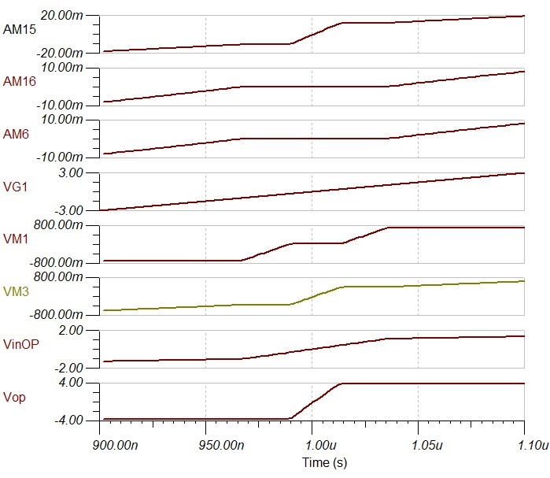
The output is well and truly clipping before the input current rises substantially! Close observation of VinOP indicates that some sort of clipping function occurs around +/-1V Pk-Pk. I have also included traces for the inverting input (VM3) and the differential input (VM1). Also included the inverting input current (AM16) and the current flowing into R2 (AM15). Current – AM15 follows VM3 which is to be expected. Currents flowing in and out of OPAMP (AM6 & AM16) are identical.
Notice that the differential voltage (VM1) is virtually zero whilst the output is in the linear region – this is due to normal OPAMP action because it will ideally force VM1 to zero due to feedback. Once the output goes into clipping it is impossible for the OPAMP to keep VM1 at zero potential difference with increasing VG1 signal level. For a short period of time notice that as VM1 rises OPAMP input currents are still zero and VM3 & AM15 remain unchanged because they are following the output which is steady via feedback resistor R1. VinOP is following the input VG1 as it should with no input current.
BUT as VG1 continues to rise at a certain point AM6, AM16, VM3 & AM15 all begin to increase! However VinOP now does NOT follow the input VG1 indicating the differential impedance is now dramatically decreasing. The only reason for the current through R2 (AM15) to increase at this point is from that which comes from the source VG1 via the impedance across the OPAMP inputs! The output at this point cannot contribute anymore current because it is clipped!
Notice at the same point discussed above VM1 voltages are clipped!
It appears that the differential input is internally limited to +/-0.7V – this looks like protection diodes! BUT the data sheet states the max differential input voltage is +/-5V Pk-Pk with +/-5V rails!!! Below is a copy directly from the datasheet:-
7.3.1 Input and ESD Protection
The OPA818 is built using a very high speed complementary bipolar process. The internal junction breakdown voltages are relatively low for these very small geometry devices. These breakdowns are reflected in the Absolute Maximum Ratings table. All device pins are protected with internal ESD protection diodes to the power supplies as shown in Figure 8.
These diodes provide moderate protection to input overdrive voltages beyond the supplies as well. The protection diodes can typically support 10-mA continuous current. Where higher currents are possible (for example, in systems with ±12-V supply parts driving into the OPA818), current limiting series resistors should be added in series with the two inputs to limit the current. Keep these resistor values as low as possible because high values degrade both noise performance and frequency response. There are no back-to-back ESD diodes between VIN+ and VIN–. As a result, the differential input voltage between VIN+ and VIN– is entirely absorbed by the VGS of the input JFET differential pair and must not exceed the voltage ratings shown in Absolute Maximum Ratings table.

Below is a copy of the relevant details in the Absolute Maximum Ratings Table:
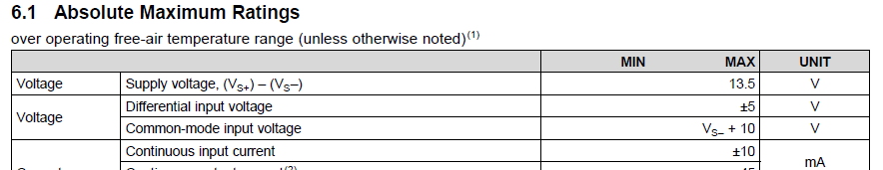

Below is the circuit of the ESD input protection:

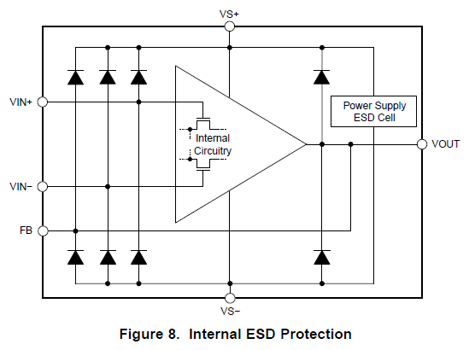

HAVE I MISSED SOMETHING HERE???

Your help would be much appreciated. It looks like differential protection diodes have been inserted in the models which DO NOT reflect reality!! Unless there are limitations with the input FETs? The data sheet indicates that apart from the protection diodes connected to the rails, the ONLY thing connected between VIN+ & VIN- are the gates of the FETS!!

Which is right - the datasheet or the model?

Thanks for your help.

Best regards,

Peter

