OPA828 model tests and Zt testing from SBOA354 document

New model Aol test, yes right at the 45MHz quoted in datasheet,

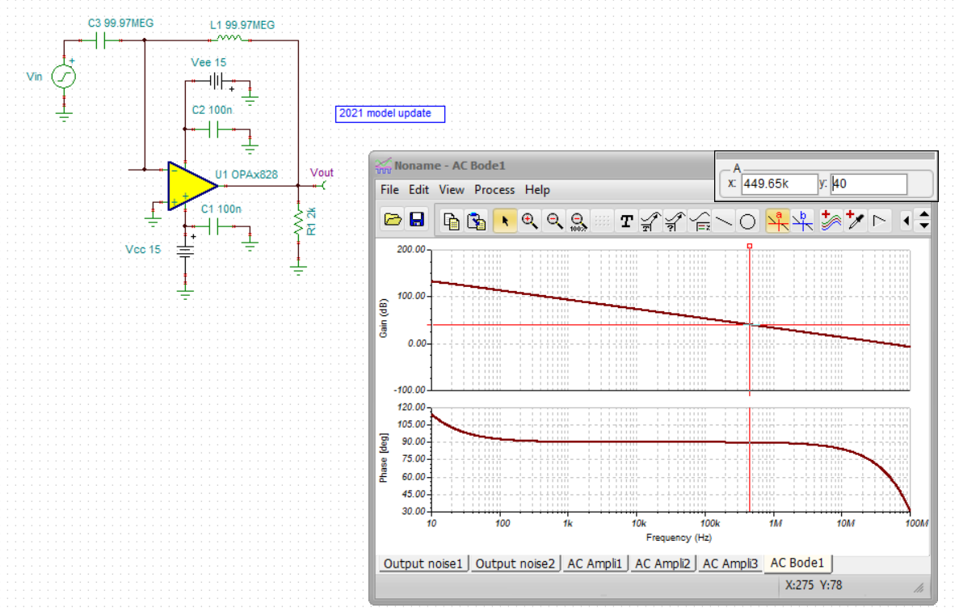

100pF source C from SBOA354

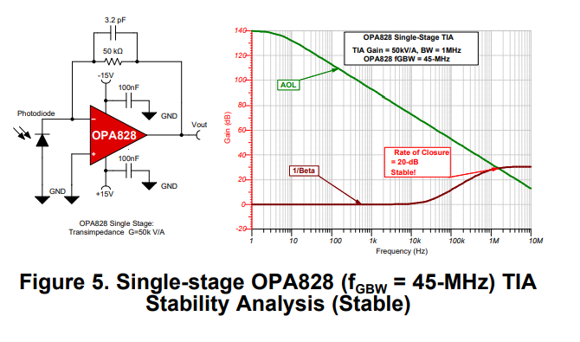

This design is for a 100pF Cd and the datasheet shows 15pF total for Cdiff and Ccm

So Fo = sqrt(27.7kHz\*45MHz) = 1.1Mhz.

Feedback pole is at, 1MHz, so the approximate Q = 0.9

Approximate phase margin is then, 56deg

Putting this into a closed loop Zt sim, about 1.32Mhz closed loop BW.

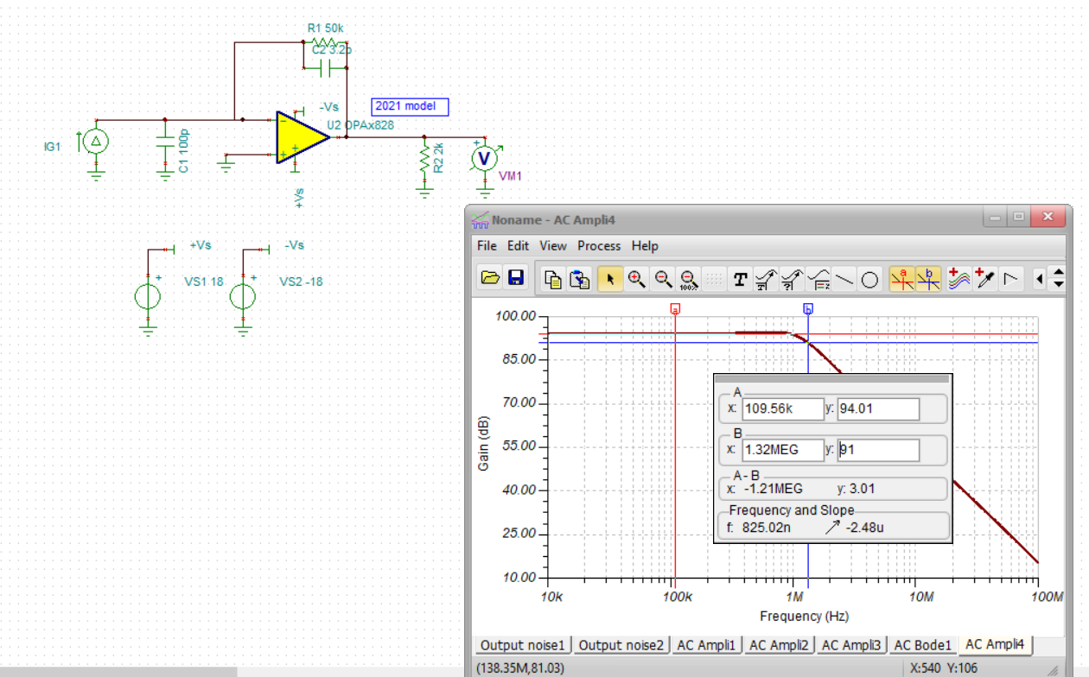

I would have set the feedback pole at .707 of 1.1MHz to get 1.1Mhz closed loop, that is a C of 4.1pF

And yes, there that is, nearly exact at 1.1MHz.

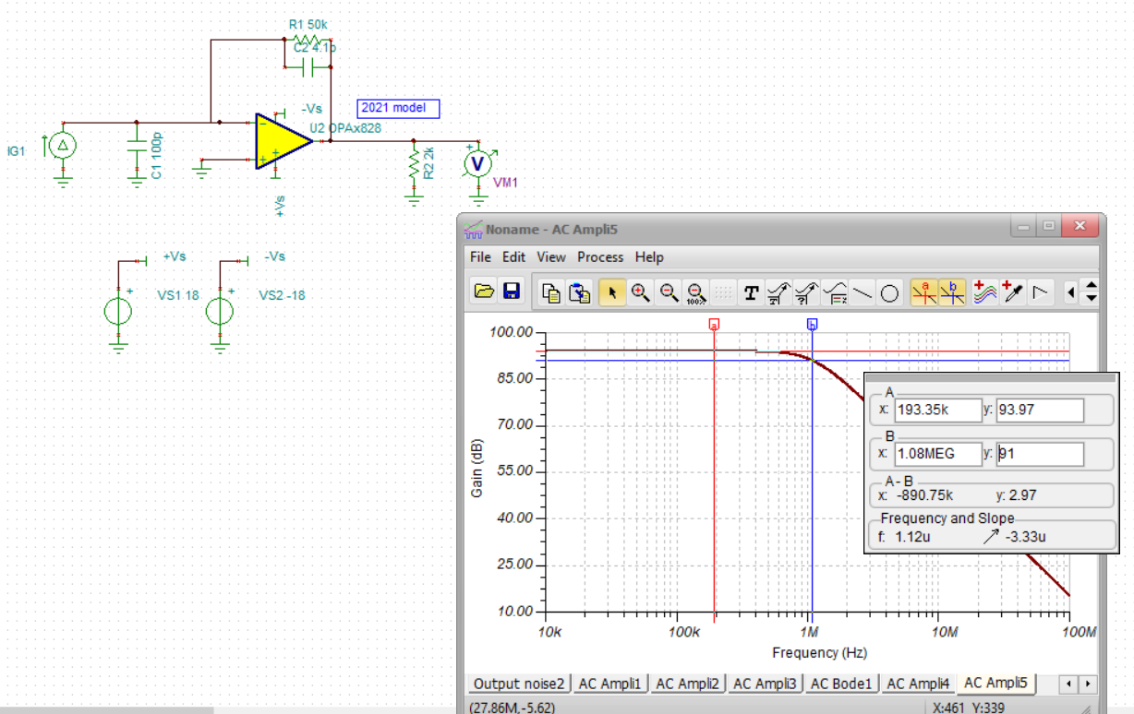

If I put this into the Ztcalculator from TI (Hasan) I get very similar results.

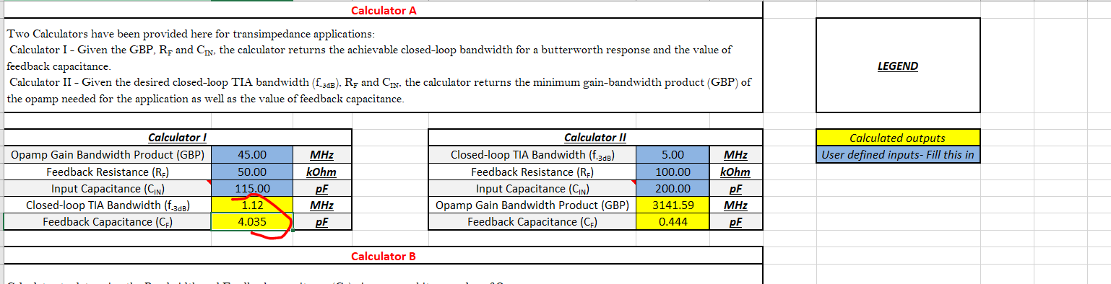

And now pull out the Cf equation from the Maxim app note, TUT5129

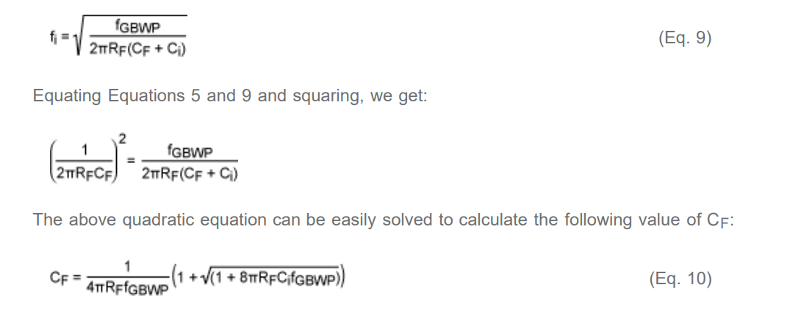

Evaluating this for this design gives a Cf = 2.88pF. Reading the text, this is again targeting the feedback pole at Fo so yes, this 2.88pF matches that approach, just a little more accurate including Cf in the Z1 equation. Putting that back into the TINA sim (instead of the 3.2pF in the TI app note gives more like the expected Q=1 result, about 1.1dB peaking,

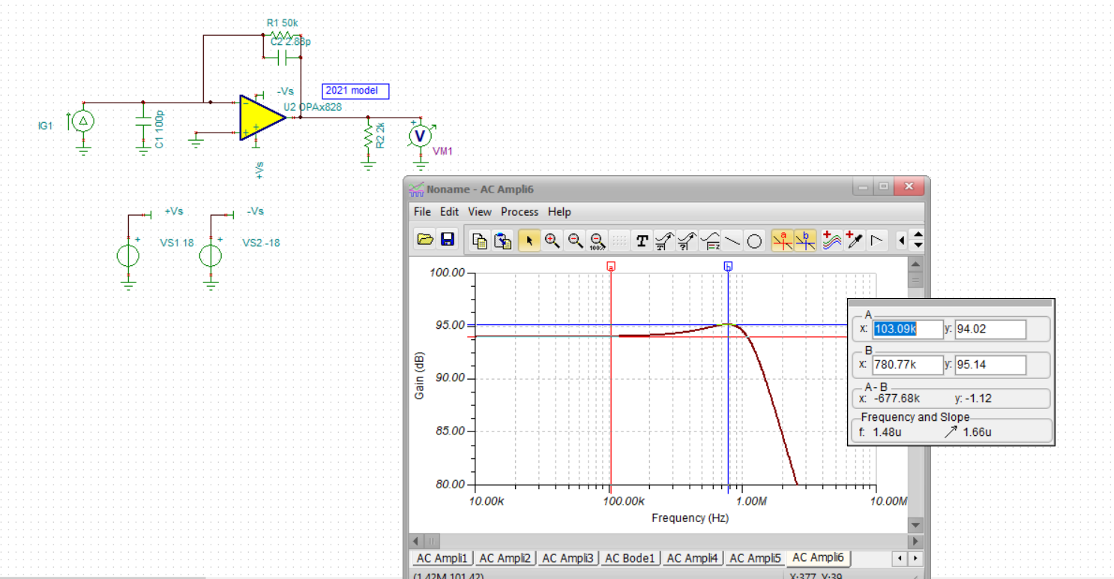

If I now go to my full Zt calculator and target this design, it predicts we should see this,

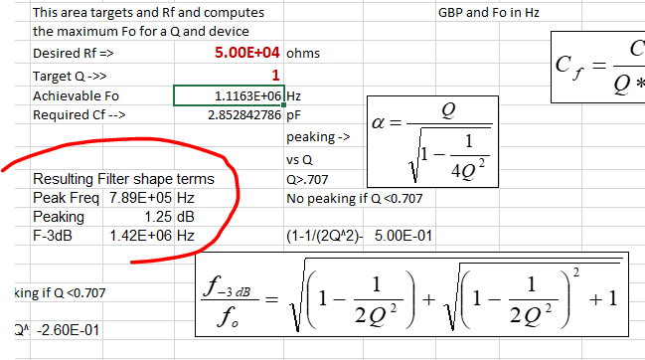

Looking for the F-3dB in Tina,

Everything is matching up well, So the theory is apparently very good and the app note is just mistaking the feedback pole frequency as the closed loop pole.

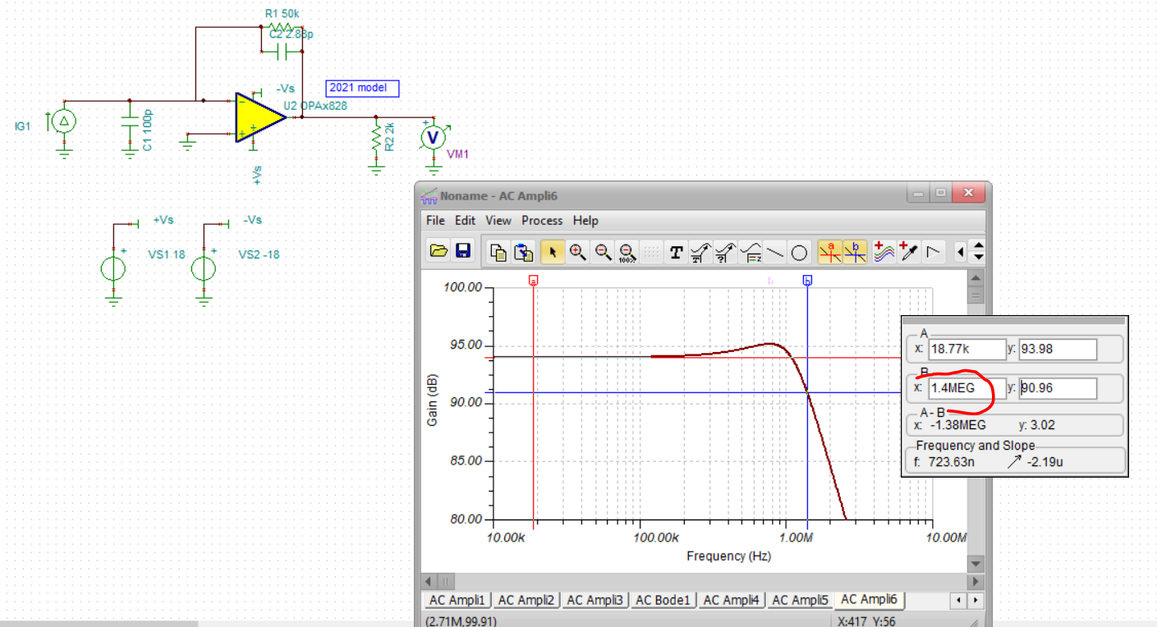

And then if I go to Gerry Graeme book (Photodiode Amplifiers op amp solutions) on page 58, he gives a very involved solution for Cf with zeta as the variable – doing that equation with zeta = 0.707 and the targets here gave 4.03pF which matches what the high speed tool gives from Hasan – I bet he used that equation. And not much different than what I am calculating in the simplified solutions in the slide deck.

