OPA928 Bias current Test summary -20230526
Test purpose: To evaluate the bias current of the OPA928.
Test situation: The evaluation board OPA928 EVM board was used to test the TIA part of the circuit as shown in the figure below.
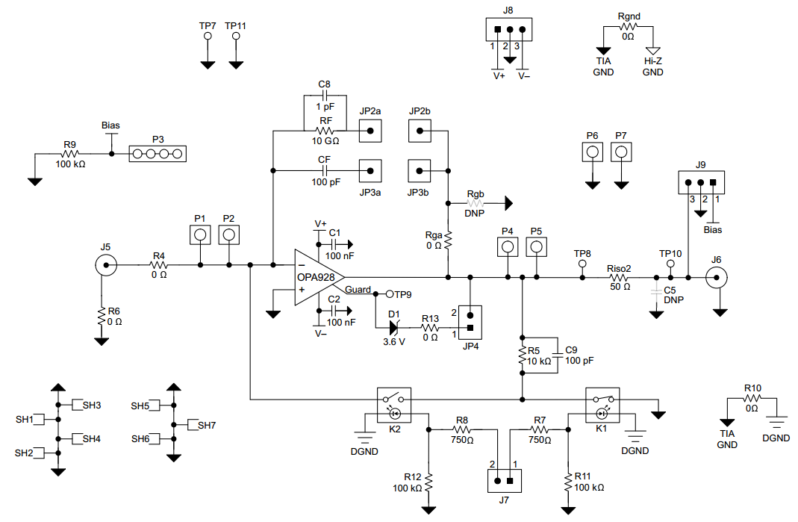
The configuration is as follows:
1. The input J5 is suspended;
2. JP2 disconnect;
3.JP3 short connect with short circuit cap;
4. Disconnect JP4;
5. JP7 suspended;
Output with coaxial cable connected to the sodium volt meter measurement.
This circuit is configured as an integrator working mode, using U_{out}= $\int_{0}^{t}{I(t)dt}$/C=I*T/C, that is, I=U*C/T, according to the recorded output voltage and the corresponding time point and capacitance can be algorithmic offset current value.

After recording three sets of data, we get three sets of test results as shown in the table below:
Serial number | T(s) | U(V) | Δ U / Δ T | I(pA)
1 | 36 | 0.34056
 | 55 | 0.32034 | 0.001064 | 0.1064
 | 69 | 0.30469 | 0.001119 | 0.1119
 | 82 | 0.29128 | 0.001031 | 0.1031
2 | 26 | 0.61812
 | 87 | 0.55197 | 0.001084 | 0.1084
 | 178 | 0.44944 | 0.001127 | 0.1127
 | 224 | 0.39422 | 0.0012 | 0.1200
 | 255 | 0.35715 | 0.001196 | 0.1196
3 | 40 | 0.64339
 | 195 | 0.40478 | 0.001539 | 0.1539
 | 288 | 0.26688 | 0.001483 | 0.1483
 | 420 | 0.085 | 0.001378 | 0.1378
 | 583 | 0.11883 | 0.00125 | 0.1250
 | 717 | 0.26866 | 0.001118 | 0.1118
 | 901 | 0.44567 | 0.000962 | 0.0962
 | 1090 | 0.60339 | 0.000834 | 0.0834
 | 1269 | 0.73008 | 0.000708 | 0.0708
 | 1445 | 0.83598 | 0.000602 | 0.0602
 | 1519 | 0.87551 | 0.000534 | 0.0534

It can be seen from the test results of group 1 and 2 that the bias current is on the order of 100 fA. The test results of Group 3 show that the bias current changes from 150 fA to 50 fA with the extension of the test time. All the three groups of tests are very different from the nominal bias current value of 1 fA of the OPA928.
At first, it was suspected that the capacitance value of integrating capacitor was wrong, so we replaced the patch capacitor CF on the EVM board with a 33pF ceramic chip. The result showed that the current value tested after replacement reached the order of 10pA, and the same result was obtained when the previous patch capacitor was replaced, so no data was recorded.
In this regard, I would like to ask you to help analyze the following questions.
1. Is there any problem with the bias current test itself?
2. Whether the evaluation board itself supports the measurement of 1 fA magnitude of current, whether the circuit board needs special treatment when the current of such magnitude is tested, if so, what should be noted if the performance indicators of this chip are used in the process of use?
3. When a chip with a bias current of 1 fA magnitude is used, whether ordinary welding (such as dirty pad) will bring about a bias current of two orders of magnitude or even greater change.

