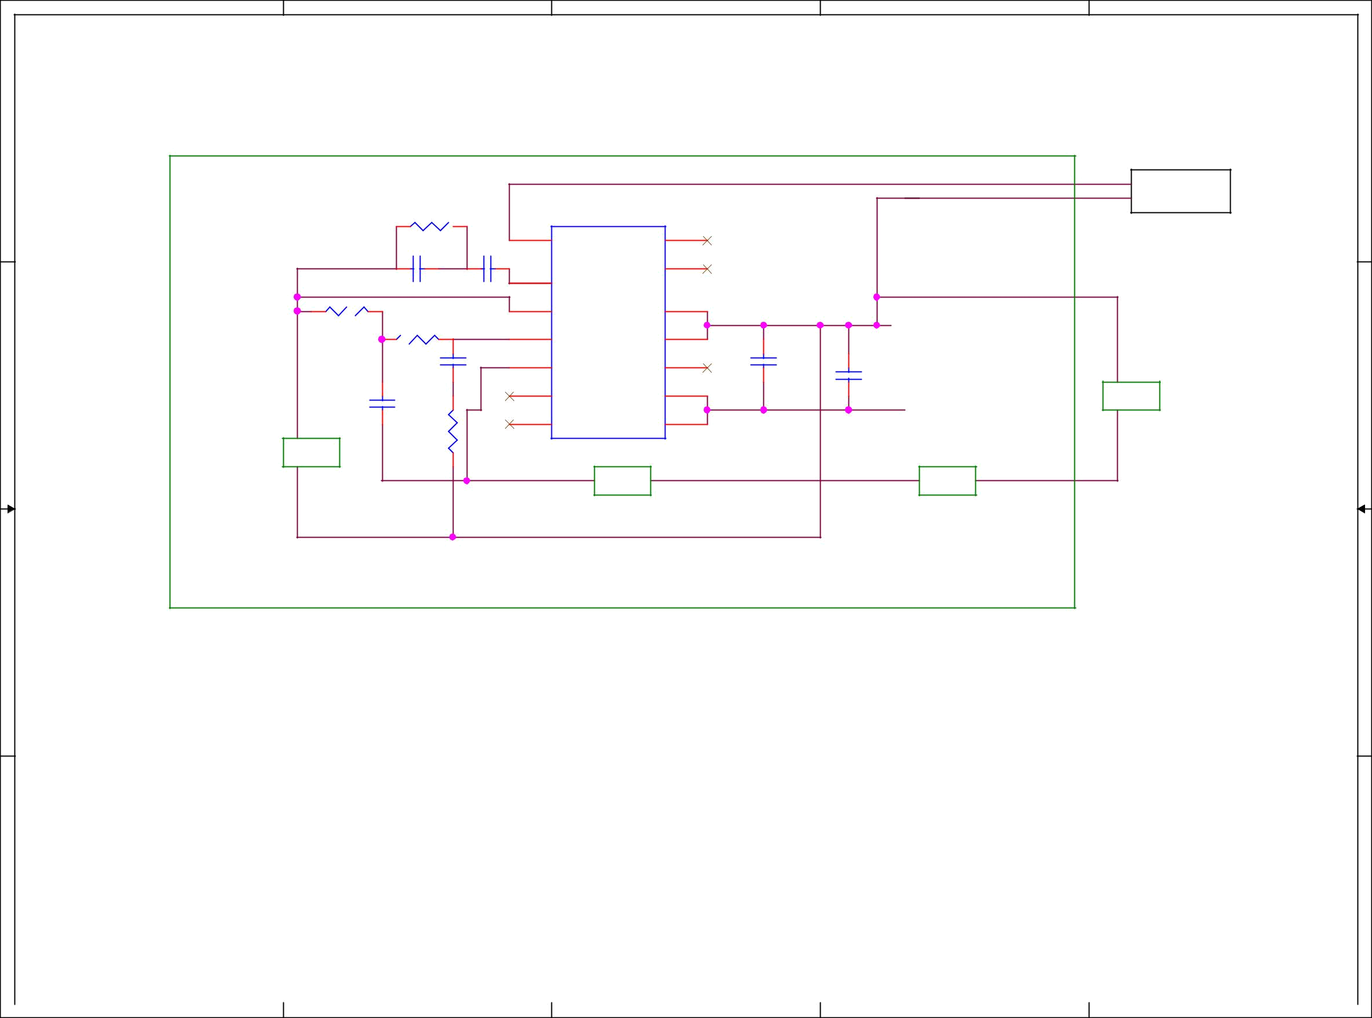  5 | 4 | 3 | 2 | 1

D | LM2907 |  |  |  |  |  |  |  |  |  |  | D
 |  |  |  |  |  |  |  |  |  | HALL FREQUENCY INPUT
 |  |  |  | R3 |  |  |  |  |  | HALL REFERENCE
 |  |  |  | 28K |  | U1
 |  |  | C3 | C1 | 1 |  |  | 14 |  |  | MOTOR | HALL FREQUENCY/
 |  |  | C3 | C1 | 1 | TACH(+) | NC | 14 |  |  | TACHO | FREQUENCY
 |  |  |  | CAP NP
 |  |  | 200NF |  | 2 |  | NC | 13
 |  |  |  |  | 2 | CP1
 | R2 | 10K | 100K |  | 3 | CP2 | GND | 12
 |  |  |  |  | 4 | IN+ | TACH- | 11 |  | GNDC
 |  |  | R1
 |  |  |  | C2 | 5 | EMIT | IN - | 10 | C5 | _{C6} GNDC
 |  |  | 2NF |  | 6 |  |  | 9 | 100NF | _{C6} GNDC
C |  |  | C4 |  | 6 | NC | V+ | 9 |  | 1.3UF |  | C
 |  |  | 2NF | R4 | 7 |  |  | 8 |  | VIN POWER | MULTIMETER
 |  |  | 2NF | R4 | 7 | NC | COL | 8
 |  |  | 10K |  |  | LM2907
 | TP4
 |  |  |  |  |  | TP2
 |  |  |  |  |  |  |  |  |  | VOUT

B | B

A |  |  |  |  |  |  |  |  | A
 |  | Title
 |  |  | <Title>
 |  | Size | Document Number |  |  |  |  | Rev
 |  | A | <Doc> |  |  |  |  | <RevCo
 |  | Date: | Saturday, July 14, 2018 | Sheet | 1 | of | 1

5 4 3 2 1

