Popcorn noise pictures from e2e
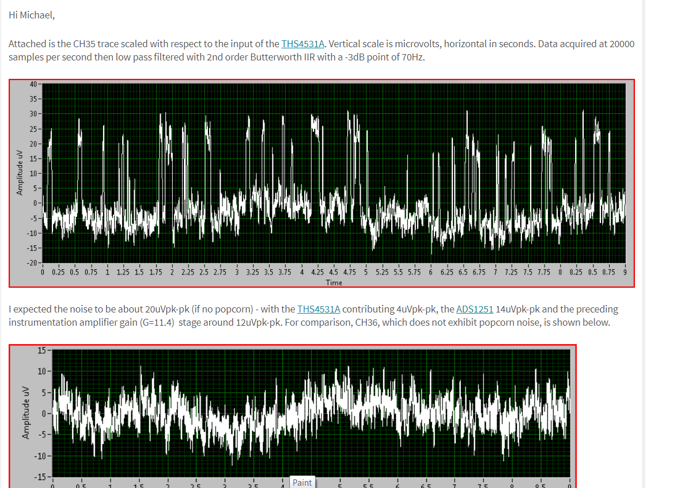

https://e2e.ti.com/support/audio/f/6/t/725471?tisearch=e2e-sitesearch&keymatch=popcorn%2520noise

And then another one,
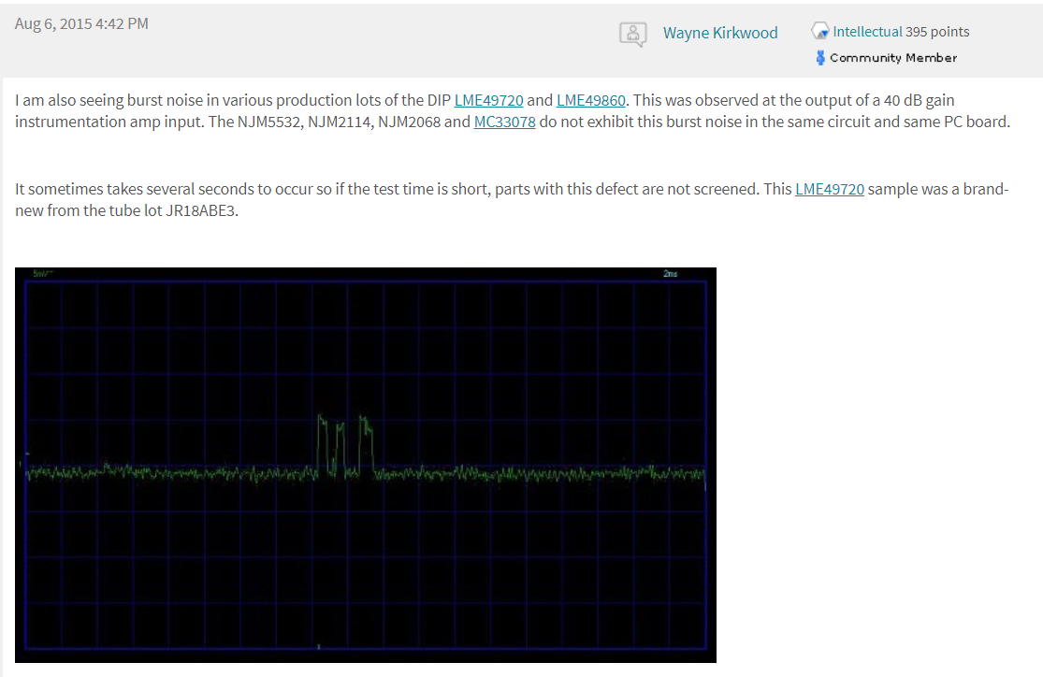
This was another audio app,
https://e2e.ti.com/support/audio/f/6/t/415907?LM4562-LME49720-low-frequency-noise

