Protecting THS4522 or THS4552 from overdrives
Here is an initial circuit – I am using the upgraded THS4551 (or dual THS4552) as it is much improved on noise and DC precision over the older THS4522, These look good, about 1Mhz to the cap load.
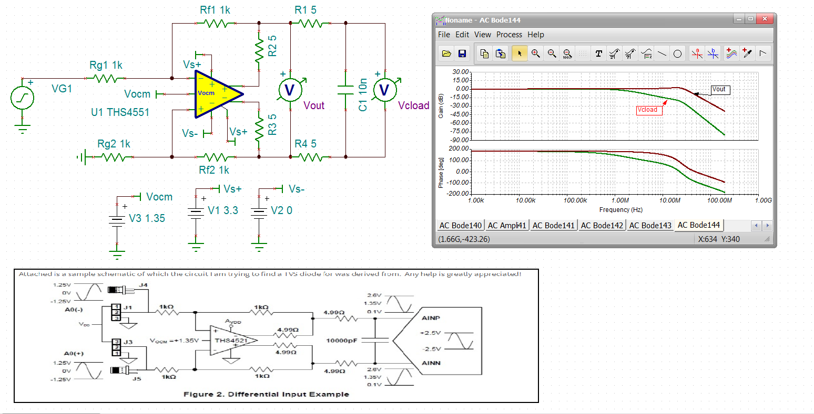

Normally, you can check stability really quickly by looking at spot noise at output pins for peaking – looks ok,
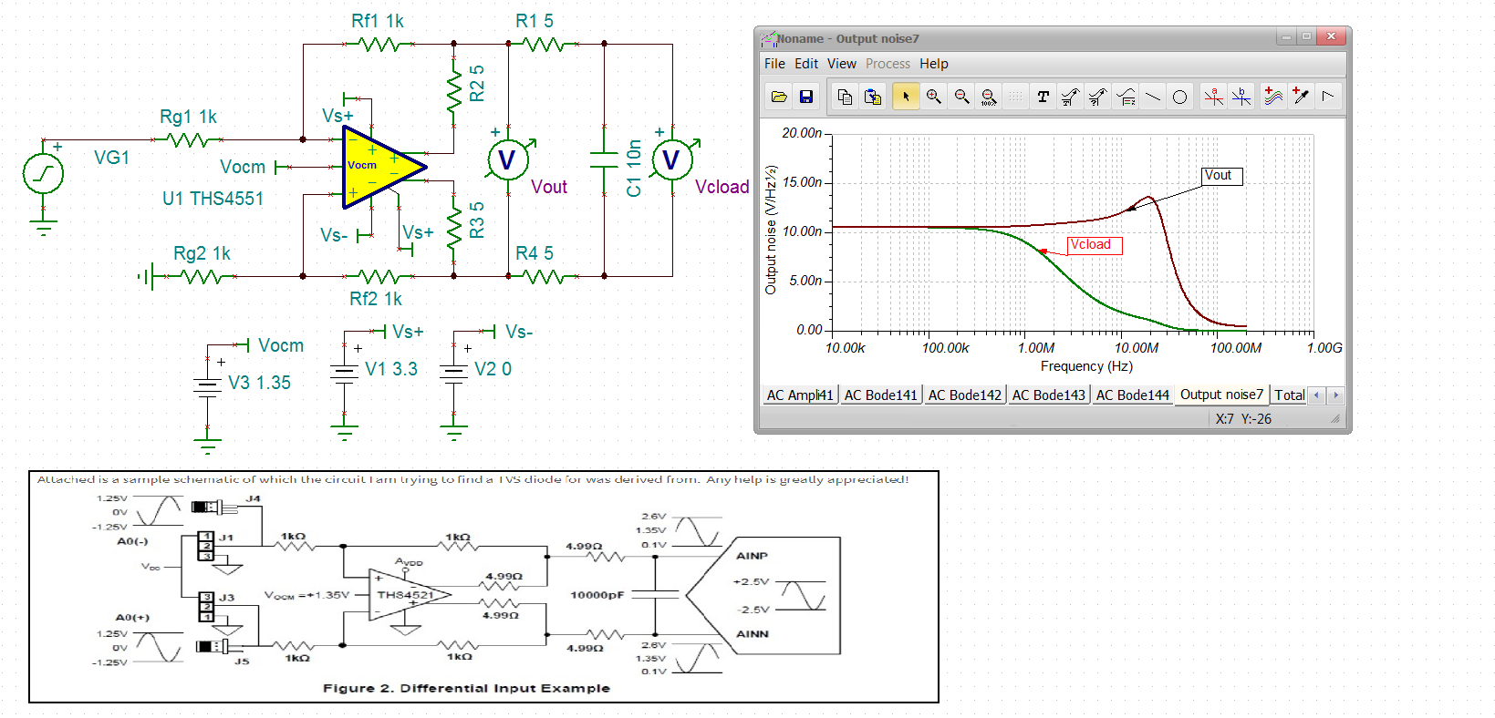
Now, if you have very high inputs possible, you need to use those input resistors to control currents to clamp diodes. Say an input was going to go over the supply rails – well if we add BAV99 (or something like that) inside those Rg resistors split into two pieces – the current into the input will be the difference in the external diode on voltage and the internal ESD steering diodes to the supplies. Normally want to limit that to <10mA where no more than 50ohm limiting split is needed. For differential protection need diodes across those same points where again those diodes will take all the current and as long as they don’t build more than the stated +/-1V max Vin diff, no current will go into the pins. Lets split the input resistor into 900ohm to that protect point then a 100ohm into the summing junctions – the BAV99 are very low capacitance and there was a TINA model in the library for the V11 I have.
Adding those into the input lines, gives this – a little more peaky at the output pins but very similar to the cap load.
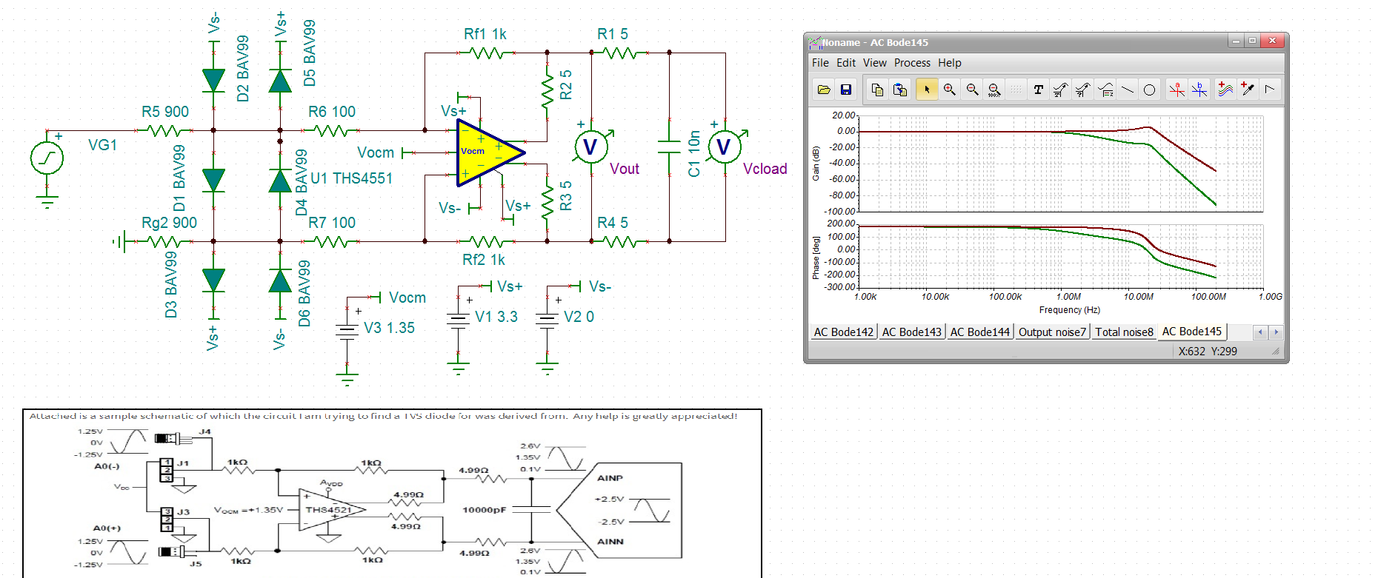

Check the noise. Yea, little more peaking at the output but at the Cload is ok – looks stable,
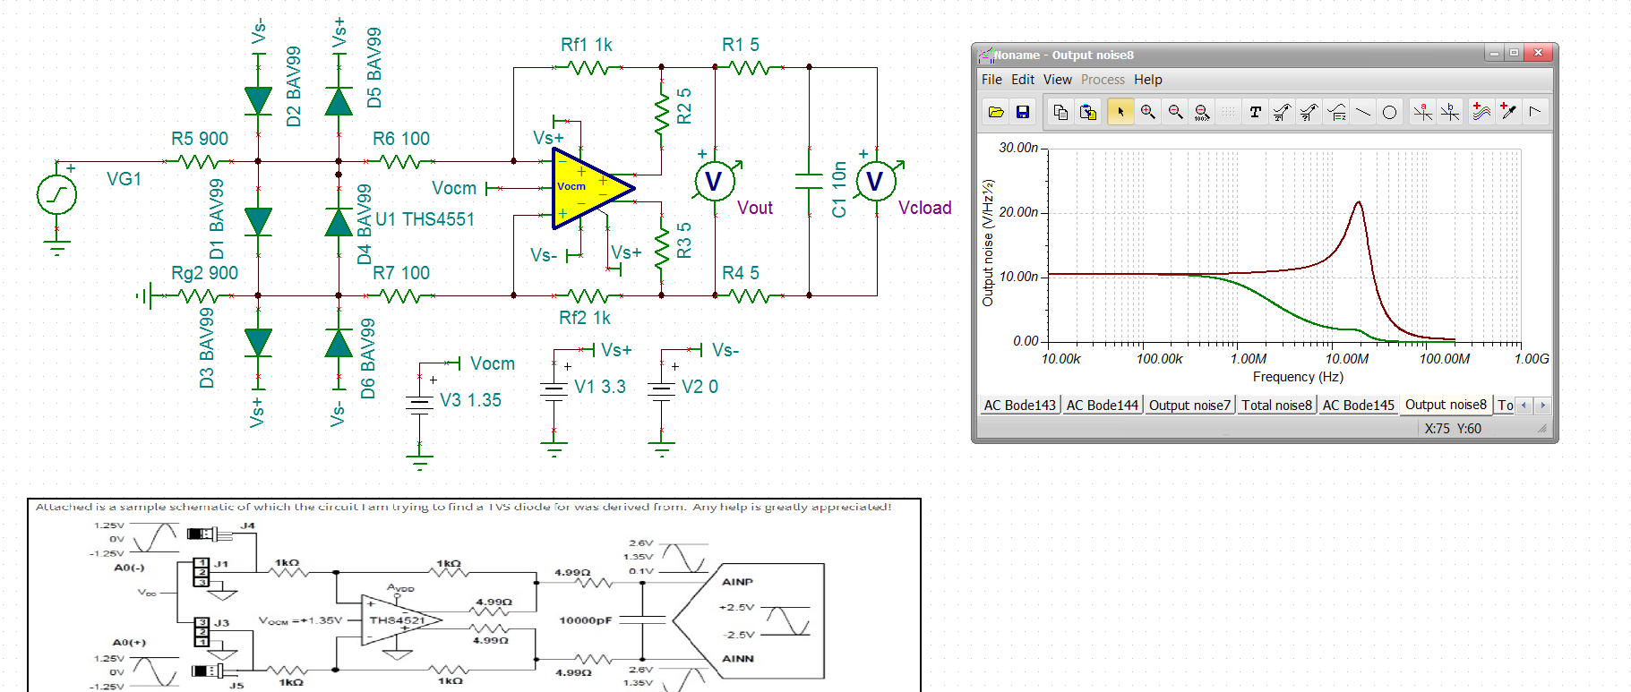

Now for overdriven inputs, I could not get the transient to converge – also, running a DC sweep with really big inputs failed but here is probing that protection voltage node on a -2 to +2V DC sweep. Want to make sure the voltage there does not go more than a diode below ground or a diode above the supply.
Used 3.3V supply here to help protect the ADC on overdrive.
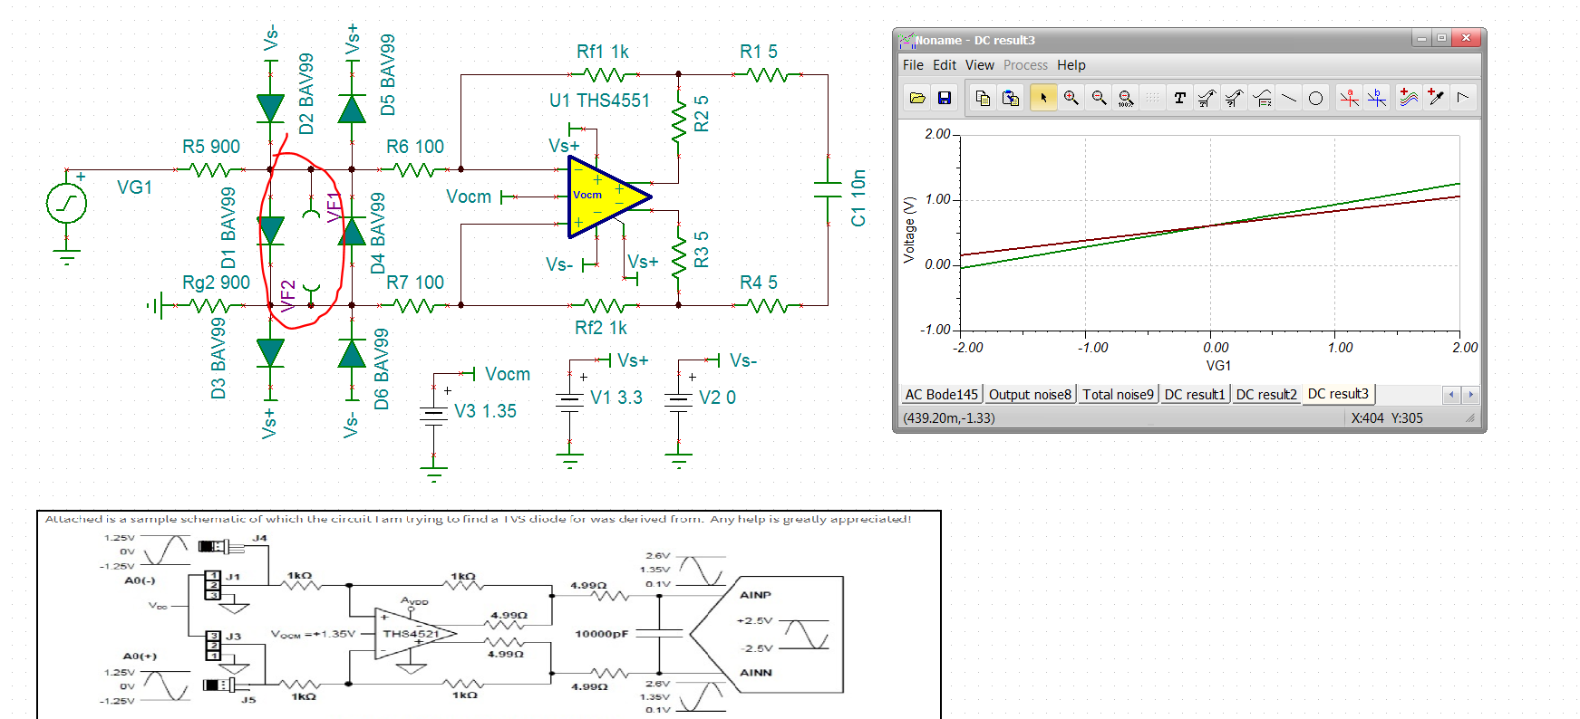

TINA is having a lot of trouble running the sims that go into limiting or diode turn on. Hopefully you get the idea.

So I tried dropping in the 2016 update to the THS4522 model, probably different – it seems to finish the sims. Here is an input current measurement for the Vg1 going -5V to 5V and you can see where currents start to flow, but low.
