We are developing an AC/DC power supply based on three AC input line voltages without neutral.
- INPUT Nominal power voltage: 200VAC L-L
- INPUT Power voltage range 158.5-232VAC
- INPUT Power supply frequency 360-800Hz
The core of the design are three PFC controllers (UCC2817D). Below, the PFC that serves one of the three INPUT lines.

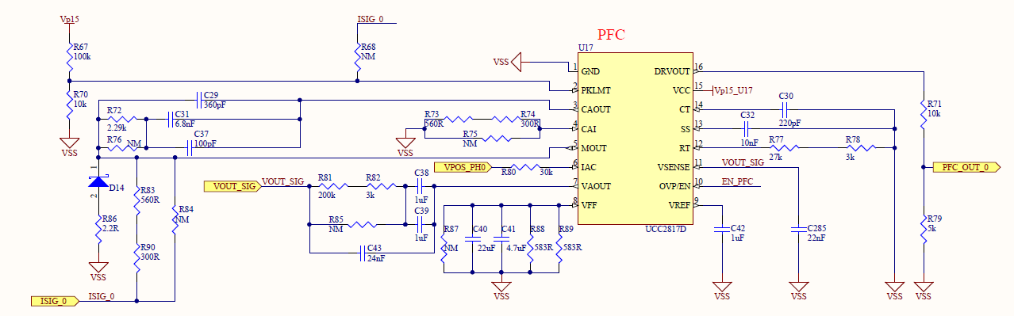
The question is about how to implement proper current feedback(s) to UCC2817D.
Our current understanding is that we have to provide a full bandwidth current feedback signal to PKLMT, so that UCC2817D component can limit the current peaks, and a pass-bass current feedback signal to MOUT, so that PFC can align current with voltage.
This means that we need to collect a current feedback that contains information at relatively low frequencies (360-800Hz) and relatively high frequencies (100KHz, switching frequency of PCF).
This is not so easy to do because TA that supports high frequency lose low frequencies, while Effect Hall sensors usually lose high frequencies.
For this reason we are thinking to use another TI component, the AMC1301.
Basically the idea is to collected current information via a shunt resistor and to use this information as input to VINP of AMC1301.
Below the schematic for the proposed circuit.
Note that VDD1-GND1 is about 5V.
What do you think? Can it work? Any suggestion from your side?

