Review of Zt design flow for OPA858 (Sonja)

Michael Steffes, 5/18/2020

Early schematic tells me several things

Detector diode C = 3pF

Relatively low gain = 2.8kohm

This is a MOS input device, normally more applicable for Rf >50kohm, might want to look at the OPA855 a bipolar input with lower input noise (.98nV vs the 2.5nV OPA858)

AC coupled output into 50ohm here, likely into a terminated 50ohm load

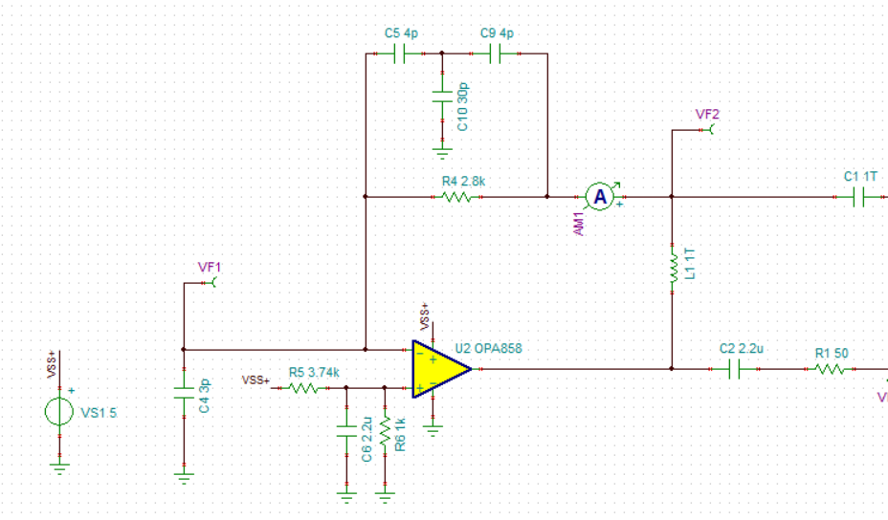

Ok, first off we normally consider only the Ccm +Cdiff as adding to Cdiode, but that is assuming a grounded V+ input – if the impedance is not zero then the V+ Ccm can get into the analysis. Continuing with this ckt and the OPA858, change the V+ bias network to this

1. Added 100pF hold short at higher F as the 2.2uV goes self resonant
2. Sometimes, the input Q (particularly bipolar, if you go to the OPA855) does not like the resonance of the source C – adding a series input R fixes that, here 10ohm
3. I needed to add that 100M at the T to get simulation to work – floating node otherwise,

So this looks pretty good, this is developing a 4pF/(1+30pF/4pF) = 0.47pF feedback C. About 202Mhz F-3dB

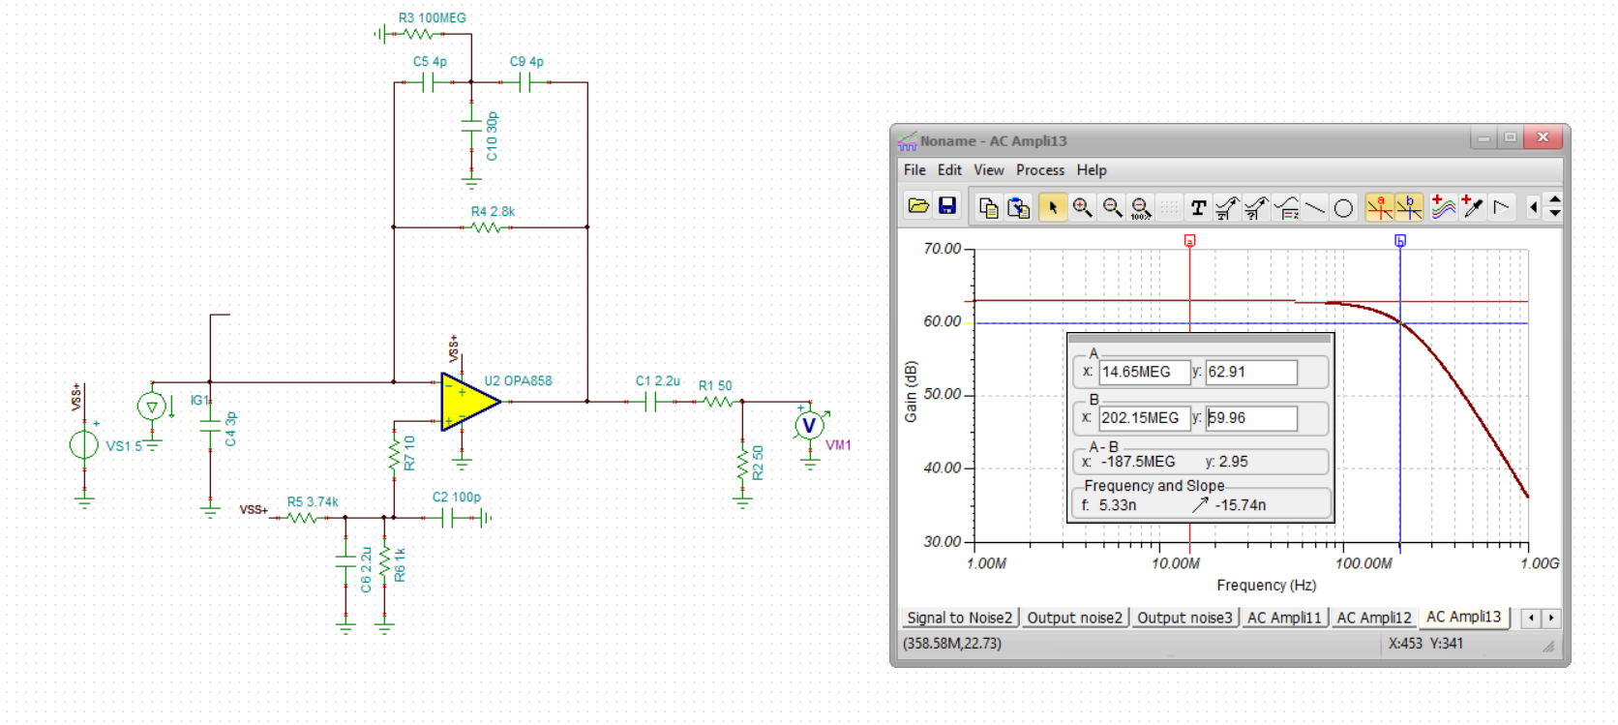

Now lets go back to some earlier analysis flows to design max BW Butterworth from the start,

1. Total input C is 3pF + 0.82(Ccm+Cdiff) = 3.82pF
2. TINA model shows 5.4GHz GBP
3. If Cf set to get Butterworth, closed loop F-3dB expected at about 283MHz, I am getting that from this equation, I will attach this design flow presentation as well – the Z1 below is the zero in the NG (=1/2piRfCs)

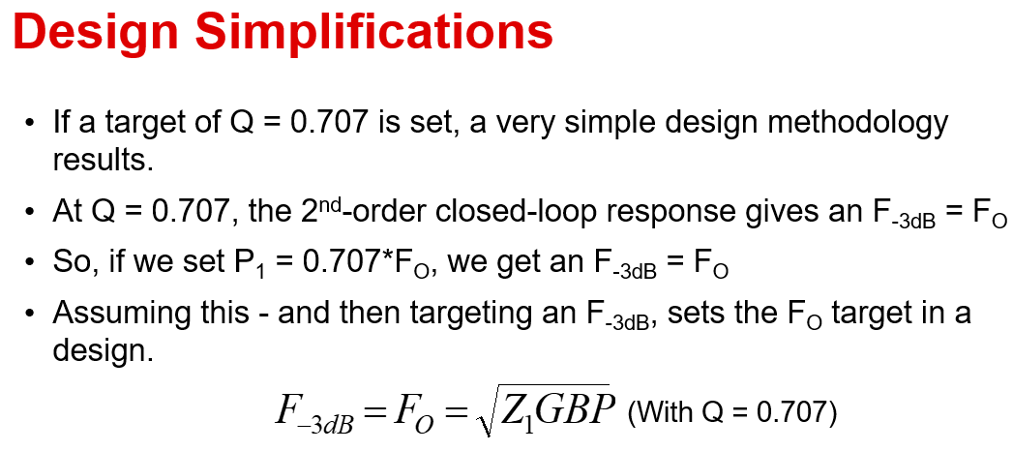

So anyway, the starting design is a bit overcompensated and should be able to get more – the butterworth feedback pole location is at 0.707 of this above 283Mhz, or at 200Mhz – with 2.8kohm gain that is .28pF feedback C.

Now, standard SMD R’s are about 0.18pF parasitic, so I need an added .18pF in the T network – here is that adjustment to the original circuit using 1pF in the T,

Looks to be just a bit higher Q than 0.707, can tune this in to Butterworth by decreasing the T Cap to ground slightly. But there it is closer to the ideal BW at 310Mhz.

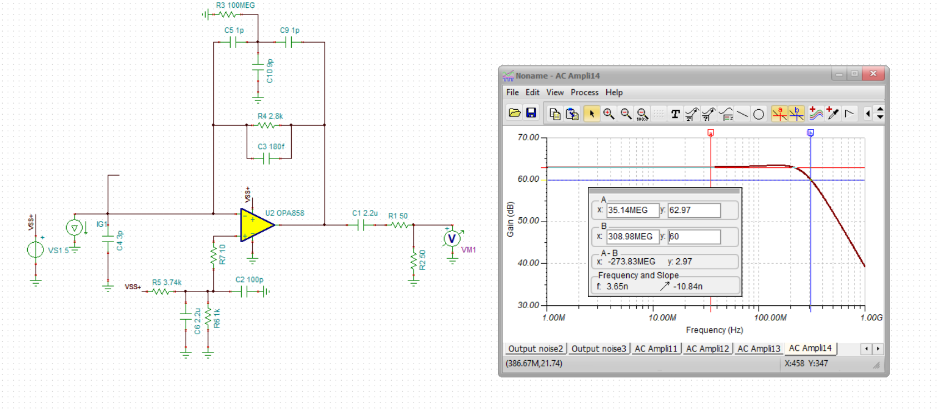

Anyway,

1. Should maybe consider the lower noise OPA855 for this relatively low Zt gain – will give a lot better noise.
2. Make sure you include feedback R parasitic C – that 0.18pF came from a lot of bench measurements – there are lower C special Rs’ but you are ok here so far with standard SMD
3. The design flow in the ppt I will include has proven pretty accurate and useful.