Review of the THS4503 EVM schematic,

Michael Steffes, 1/7/2021

This older FDA emerged from Dallas in the 2002/2003 timeframe. This was very early in the FDA days where the active input impedance aspect of a single to differential stage was not well understood. Hence, the default circuit is slightly off on its R values. Essentially, I am using tools I developed many years after this EVM was done to help me do FDA characterizations.

It is apparently intended to

1. 50ohm input match from a 50ohm signal generator
2. Single ended to differential gain of 1
3. A relatively light load with an attenuating interface through a ADT4-1WT (the schematic shows an invalid ADTP4-1WT part number, but the BOM shows a standard mini-ckts balun – used here as a 2:1 step down. This maps 4\*50ohm = 200ohm across its input nodes to appear in parallel with the 280ohm differential R, This gives a differential load of 797ohm, close to the 800ohms discussed in the text, also a big attenuation in the output signal to the measurement equip. The output interface looks correct in its R values.

Here is the schematic,

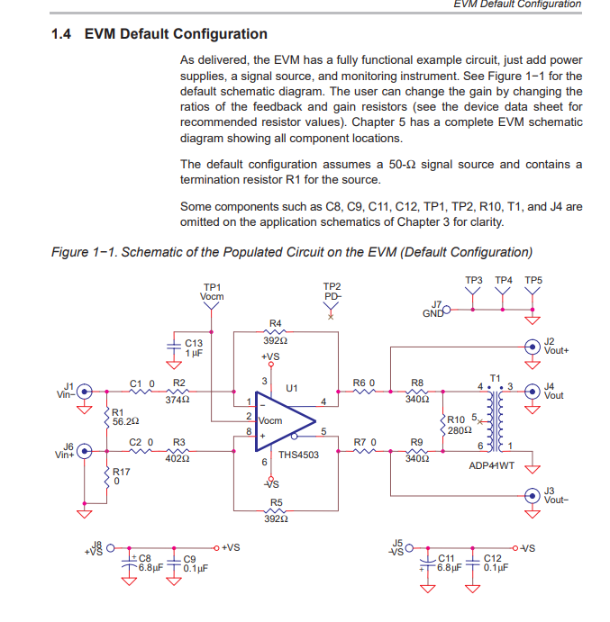

This is a pretty old part, where this shows up on the front page, not sure why anyone would use this anymore with so much better parts out there, but in any case,

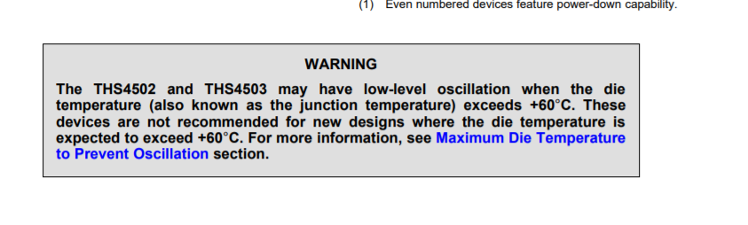

Anyway, staying with the 392ohm feedback R, the exact and closest E96 R’s are here,

Termination to ground on input, Rt, exact 55.33, use 54.9

Input resistor on signal side Rg1, exact 386, use 383ohm

Resistor to ground on non-signal side, Rg2, exact 411, use 412ohm.

So going over to TINA and using some balun models I have, the original EVM schematic looks like this, without output network first,

0.27dB gain, slightly high as the input R values are off a bit, 254Mhz is low vs datasheet, maybe the 800ohm load will help,

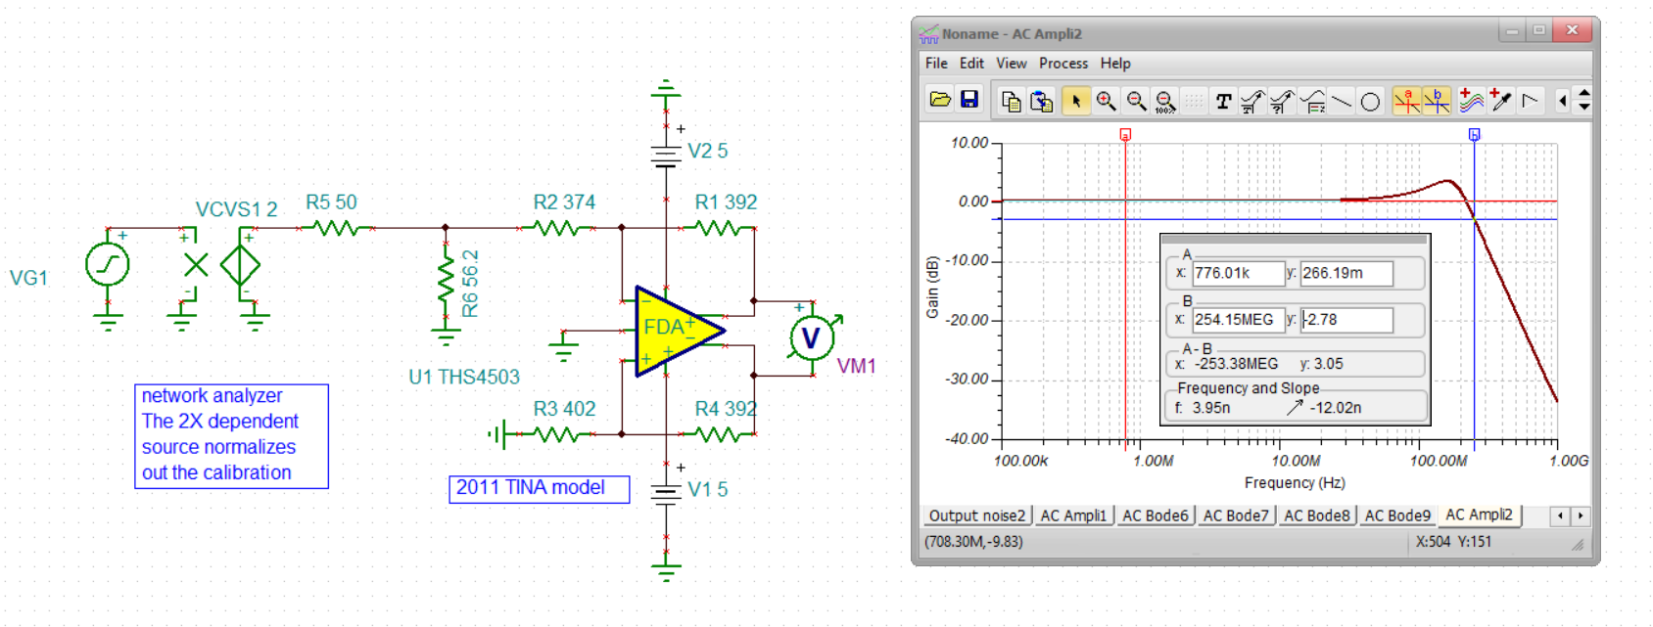

So add in the output network, and here is the balun info,



There is the sim with the balun, note the high pass but it shows about 245Mhz high end cutoff – not much lower than the no load FDA output.

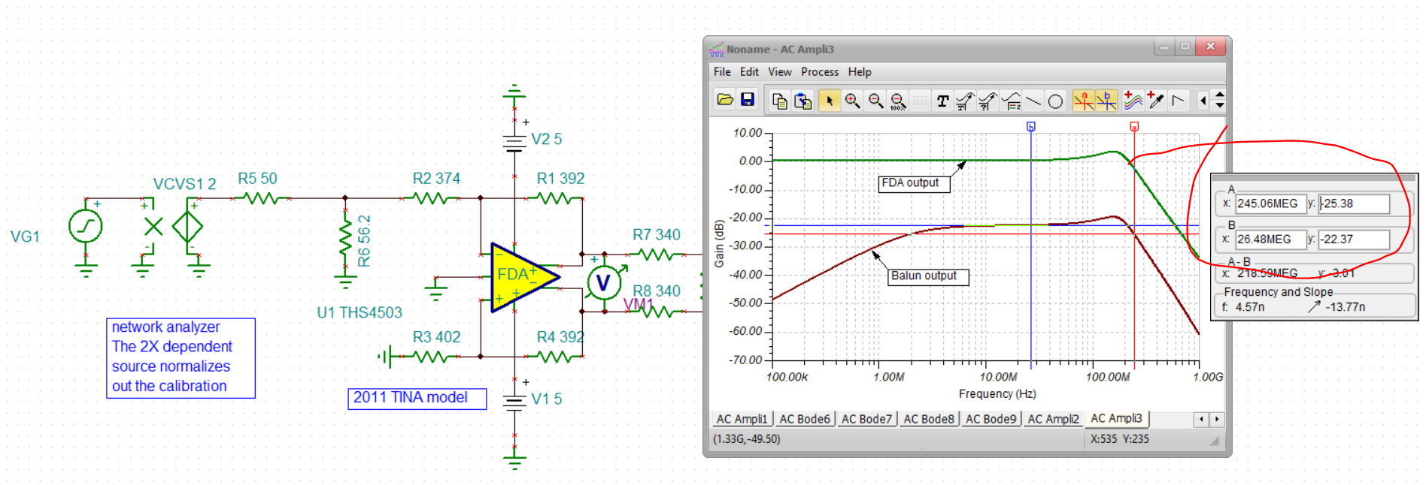

So now lets adjust this to the corrected input side R values, yes this is a lot closer to the expected 0dB gain to the differential output pins. That -0.02384dB is a gain of 0.9973

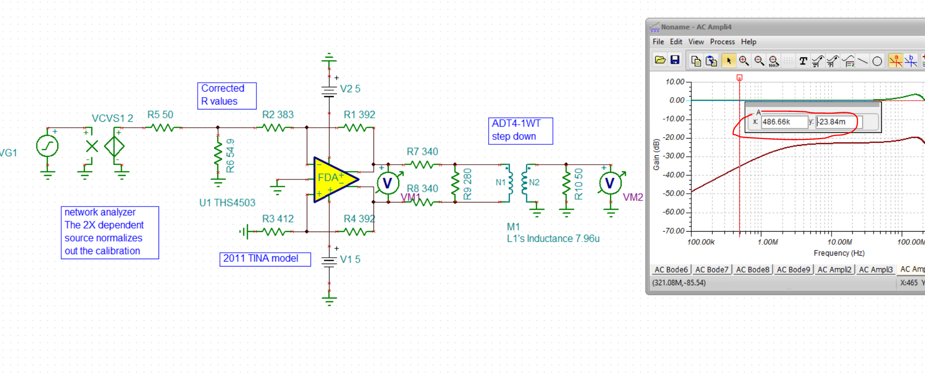

Much later, I went to a different output transformer approach shown in the THS4541 datasheet to get a broader flatband.

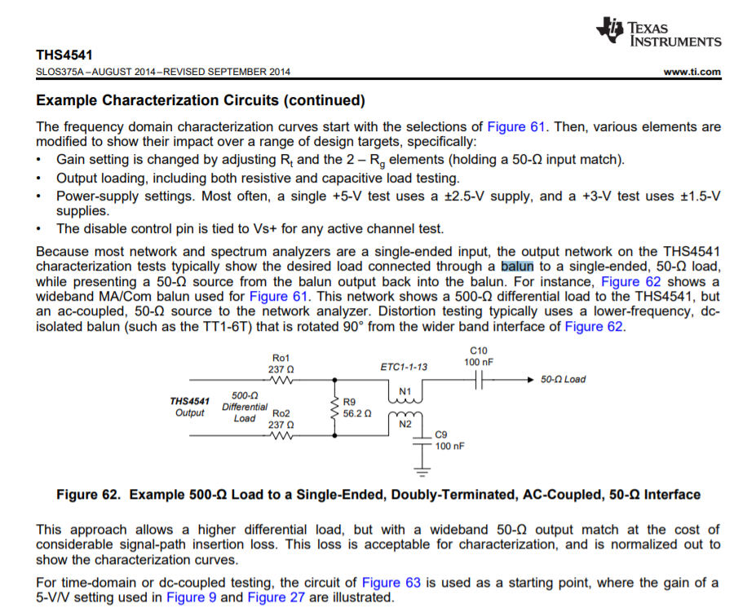

Using that one with still an 800ohm diff load to 50ohm measurement equipment gives this output interface using the lower band ADTL-4-75 balun model, gives better flatness going down in F and a bit better high end rolloff – a lot more insertion loss of course. These rotated baluns are much broader passband but have to have blocking caps.

