SAR driver ckt with MFB tuning with THS4551
This comes from a TINA file Louis provided to a customer. Just looking at the MFB filter.
Initially, the ckt would not run giving irregular ckt errors inside the THS4551 model – I dropped in my earlier 2016 model from the datasheet circuits and it ran fine. It sims stable, here is an SNR sim out to 200kHz using 4.5Vpp max (1.575Vrms).
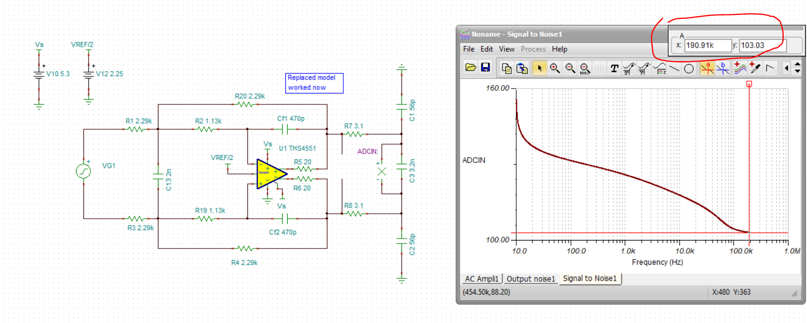
The RC values are of course giving a little higher noise than necessary – both higher R values and more peaked noise gain.
1st, what is the nominal filter – extracting from the RC above,
The Fo and Q are what we need, the THS4551 is quite fast for this requirement (filter wise) but part of the need is for a low broadband output impedance to recover from sampling event quickly. Not actually a butterworth according to this, and the post RC is at 11MHz, so not sure what was going on.
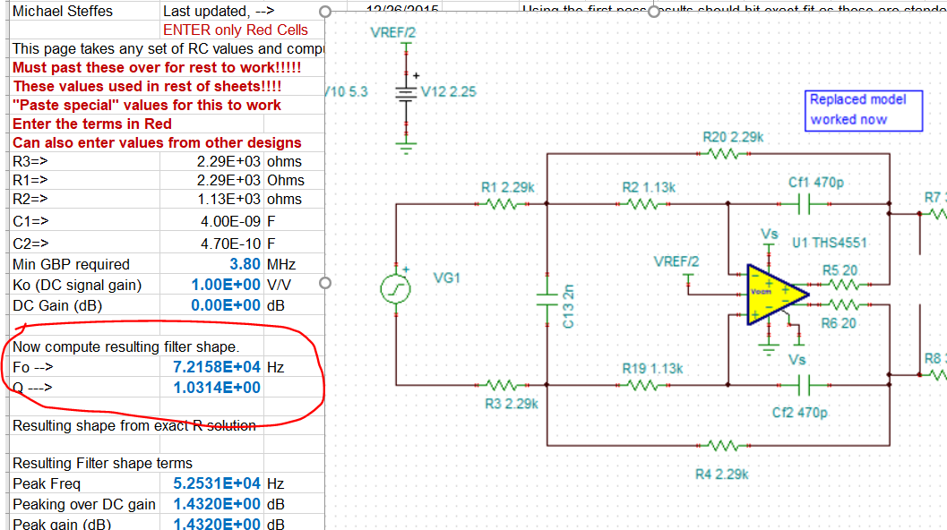
And running a SSBW to the output pins, yes it is peaking like a Q=1 filter would,
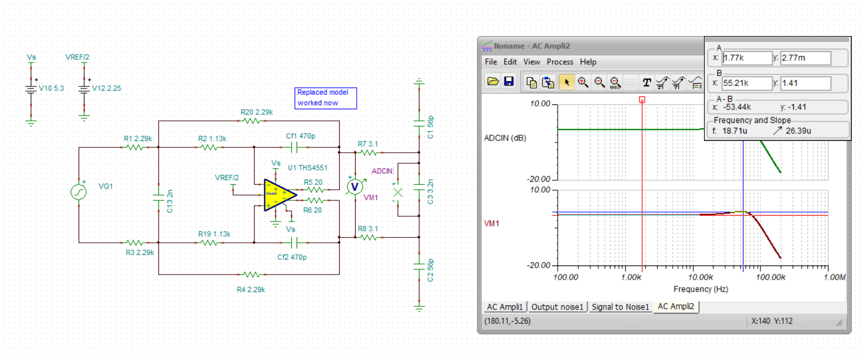
Anyway, going on and targeting more like a 750ohm input R on each side (double that for the source load in band), Here is a best fit RC solution reducing noise gain peaking, had a lot of trouble with the 2016 model not running, dropped in the 2019 update, ran fine again – anyway this is much better SNR with the new RC values – mainly just the lower R values, but the lower NG peaking helps some also.
Here, the best filter fit RC values stepped off one E96 value from perfect gain of 1 to improve filter fit. I left the output RC the same,
