Some composite power amplifier circuits.

This non-inverting composite seems to have a pretty nice frequency response. (I was getting kind of odd LG results, had to sort of ignore those as the closed loop looks fine) I removed the overall feedback cap as that was giving a 6dB to 0dB gain transition, giving kind of an odd step response,

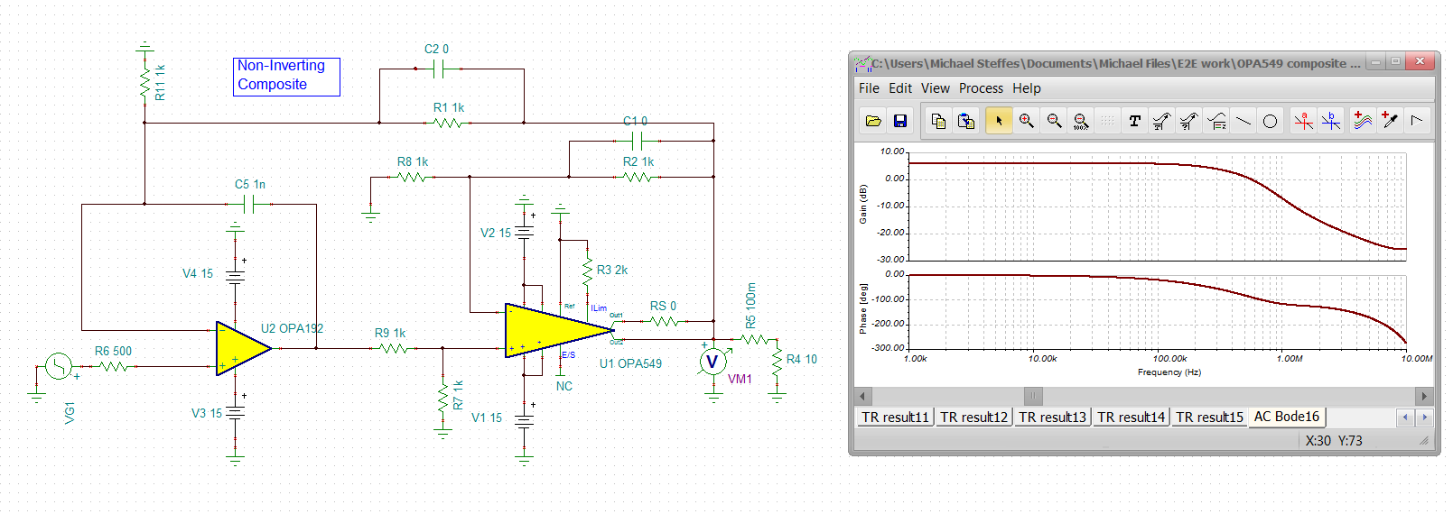

Now the step response with a faster input edge shows a couple of issues. This is 20kHz input.

1. It is going slew limited, but recovering ok – you can tell that by the single overshoot and recovery to final value
2. Definitely seeing a crossover delay going negative – this is probably in the output stage of the OPA549.Kind of impressive that shows up, must be a transistor level model (yes it is).

Here is too fast an input edge rate in this gain of 2 ckt. (seems to be slewing at about 5.4V/usec, seems low)

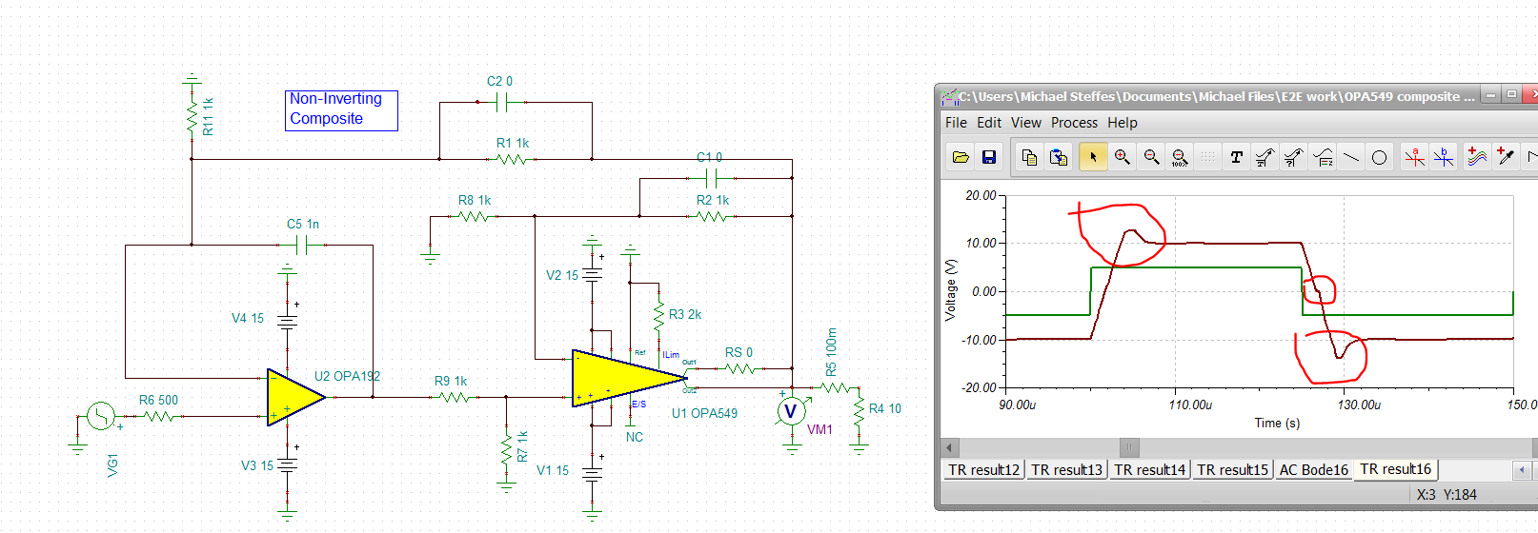

Slowing the input edge down to 2usec for a 10V input (5V/usec input slew rate) step looks much better – still have that crossover issued,

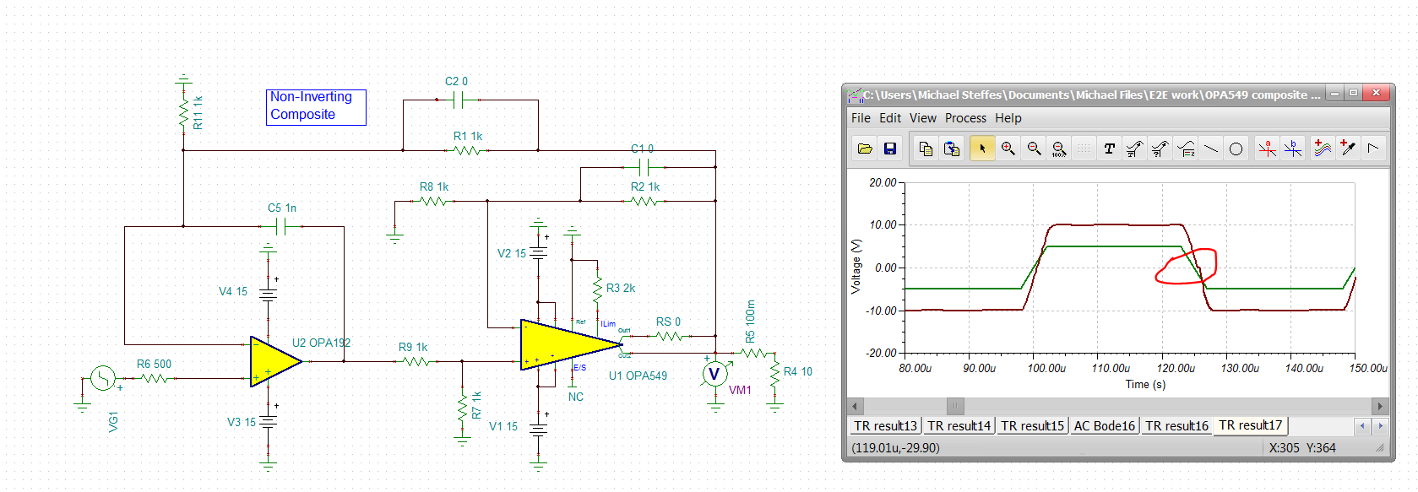

Zooming in on the top flat region, there is really no bouncing around, and almost no overshoot,

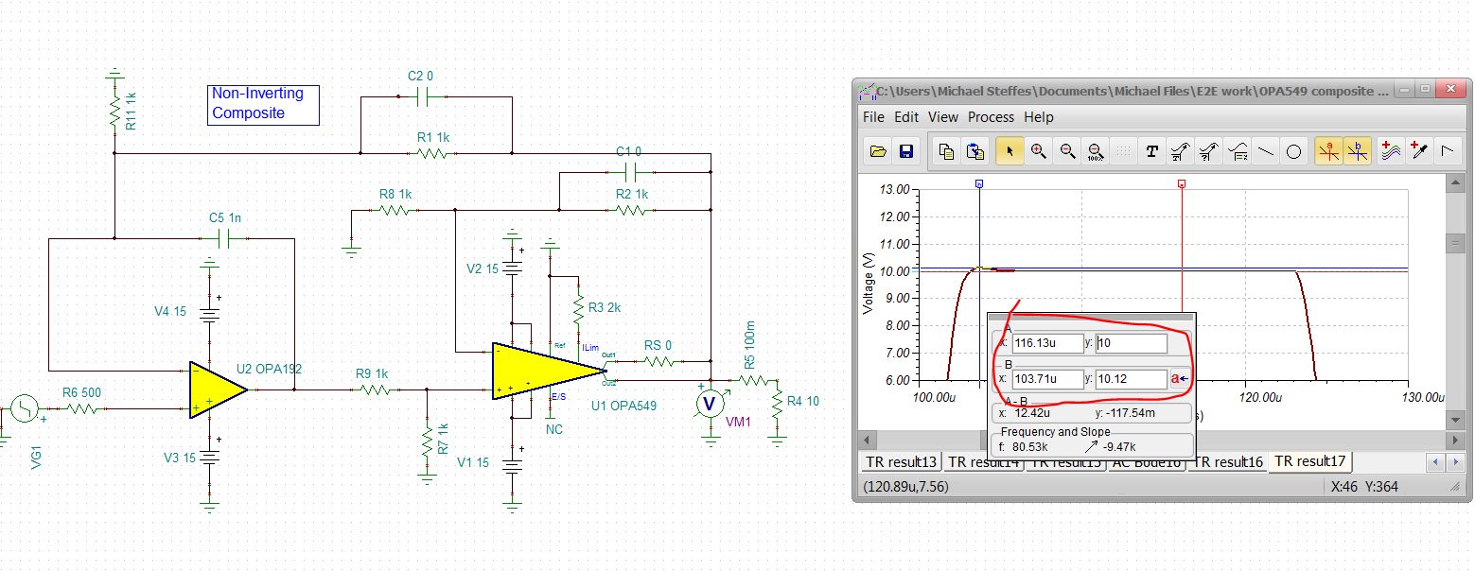

Zooming in on that negative going crossover, looks to be a 270nsec dead zone – wonder if that is really in the part?

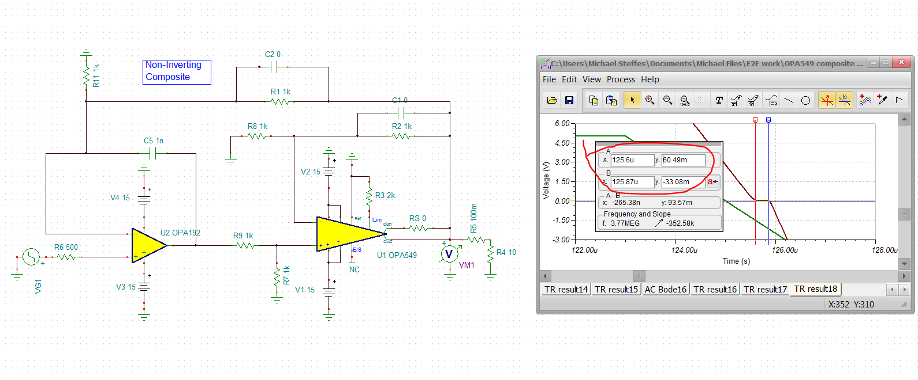

Anyway, so this looks pretty promising, but you do need to keep the step edges slowed to stay out of slew limiting – and might need to check if that crossover deadzone is a OPA549 issue – don’t think it is a loop issue.

Now, I can control the closed loop response much better in an inverting design. Here let’s go gain of -1V/V. Still needed that integrator in the input stage, This is shaping the loop noise gain up with those two capacitors to a lower xover with better phase margin.

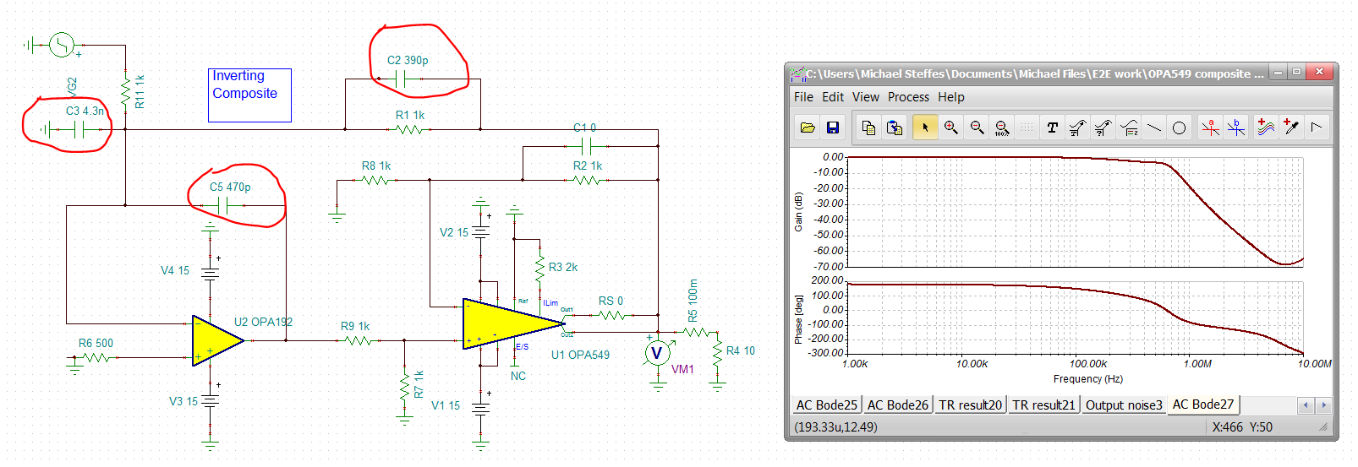

So once again, coming in with too fast an input edge gave very poor step response, this is a +/-10V input with 500nsec edge,

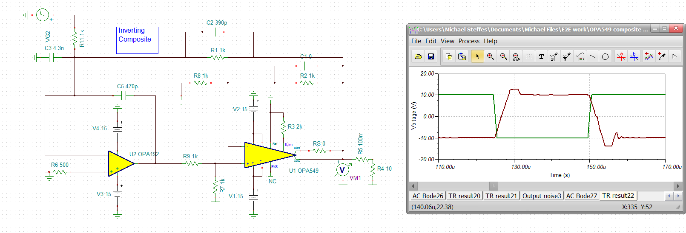

Slowing that down to 2usec, gives a very nice pulse response, but this also still has the negative going dead zone at xover.

