Some review on a THS4551 based audio MFB filter
Michael Steffes, Aug. 2, 2019
Here are the initial RC values and what they produce in an ideal sense, Note the physical C across the diff inputs is doubled for standard single ended op amp equations. So this is a 53kHz F0 with a low 0.64 Q giving an F-3dB of 47.7kHz.
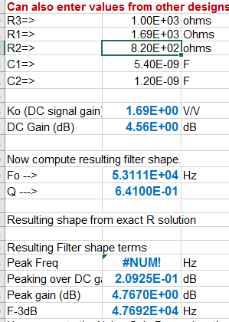
This is using this RC numbering from an earlier app note.,
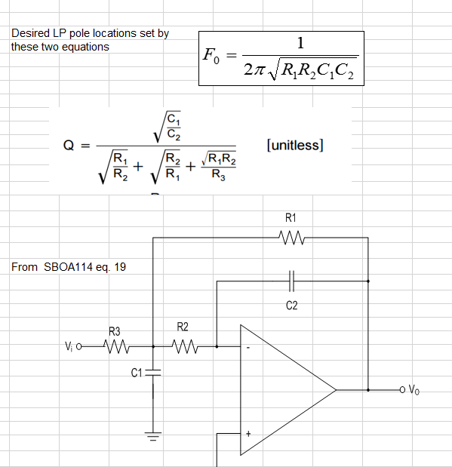
Running a TINA sim on the original ckt, shows quite a lot of attenuation at 5MHz, but evidence of low phase margin out above 100MHz,
So lets check the LG=0dB phase margin, Yea, LG=0dB around 100MHz with only 18deg phase margin – that is probably the open loop Zout interacting with the feedback cap.
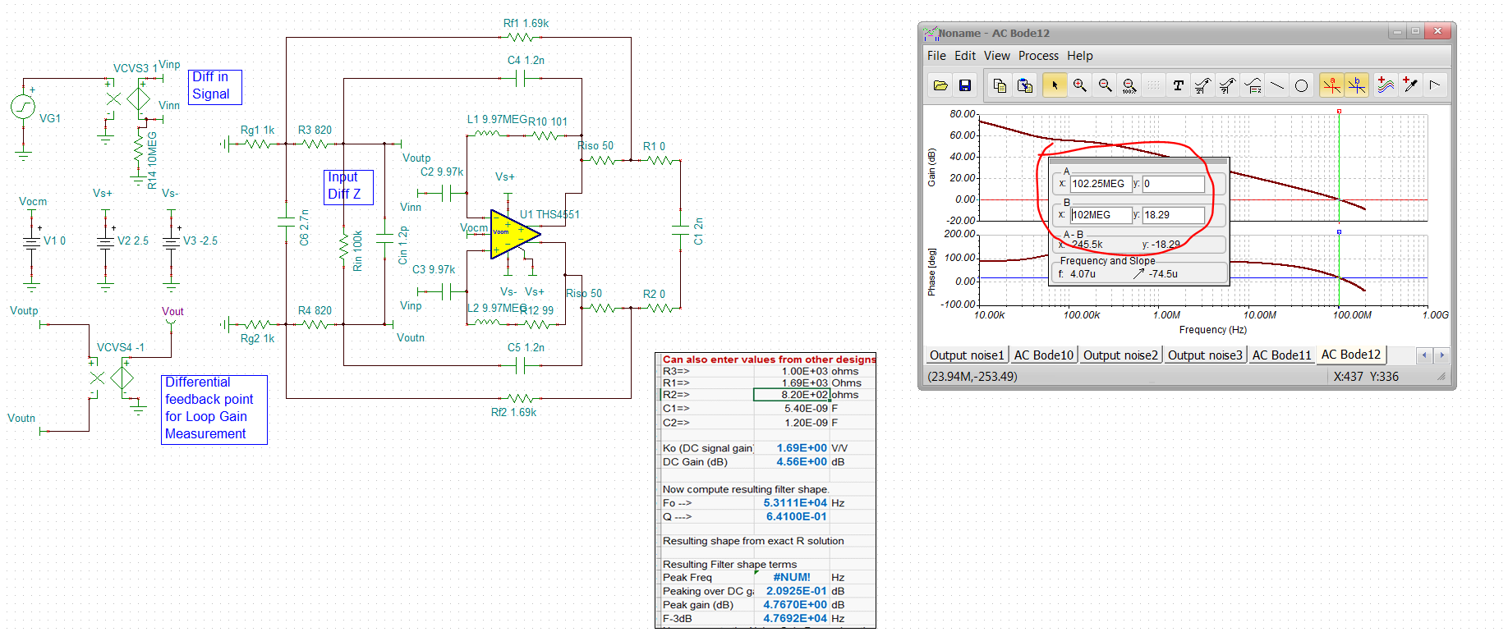
Before we work on that check on slight RC changes to the filter design,
Here is the original LG plot using the THS4551 – which is way fast for this, but that is to get really good HD. Min LG about 58dB – really good for low HD.
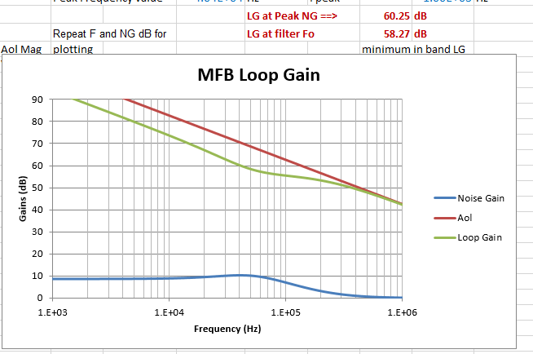
This filter is pretty well designed, only slight improvement possible with lower NG peaking,
Here are new values, This is on the best E96 fit page,
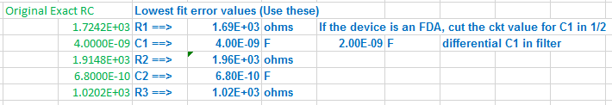
And here is the new LG plot using these values, incremental increas in min LG. This is just from increasing the lower NG zero frequency with a better RC solution flow, so a “free” 2dB increase in LG essentially reducing the distortion slightly.
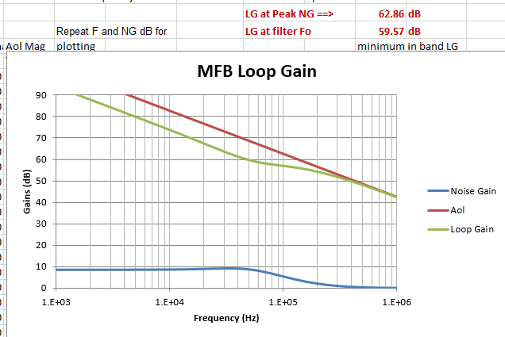

So now, lets’ start using these slightly adjust values in the closed loop and LG sims. But first try to compare SNR. For some reason, I cannot get the file with the original RC to give good results, but the updated RC values look ok,
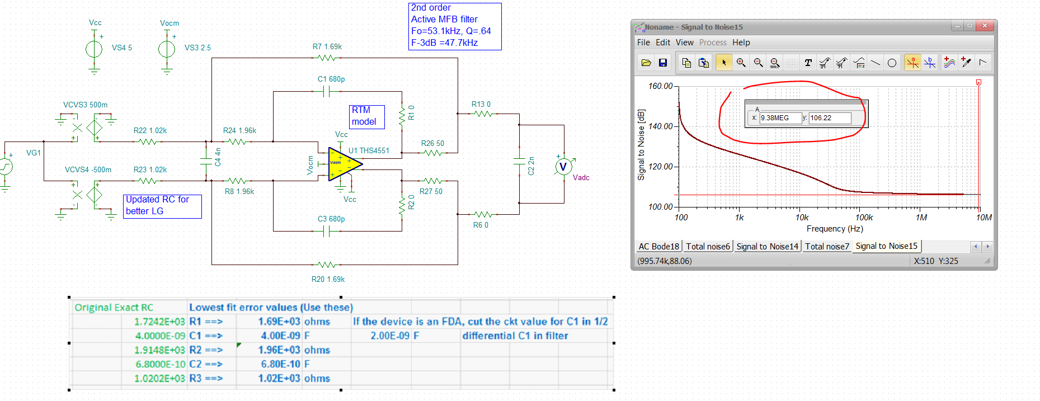

So these updated values hit the desired shape but definitely oscillate, this is the reactive open loop Zol interacting with the feedback and load C. Couple of small changes fix that, and now I have 45deg phase margin,
Reduce the 50ohm inside the loop to 20ohm and connect the filter C outside those – add 10ohm series outside the loop to the 2nF cap.
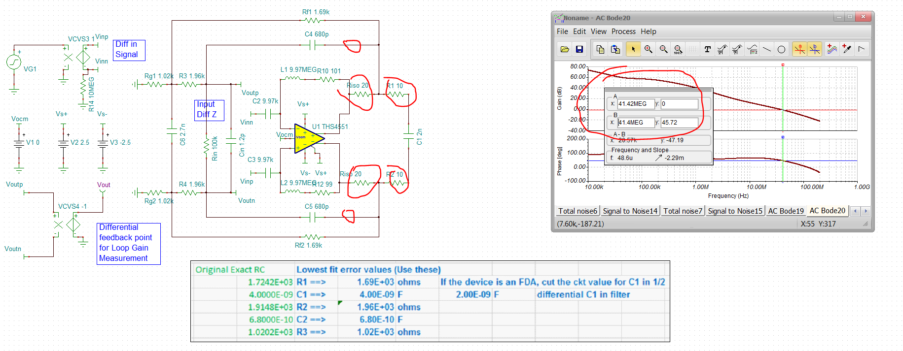
Repeat the SNR with these changes, little worse,
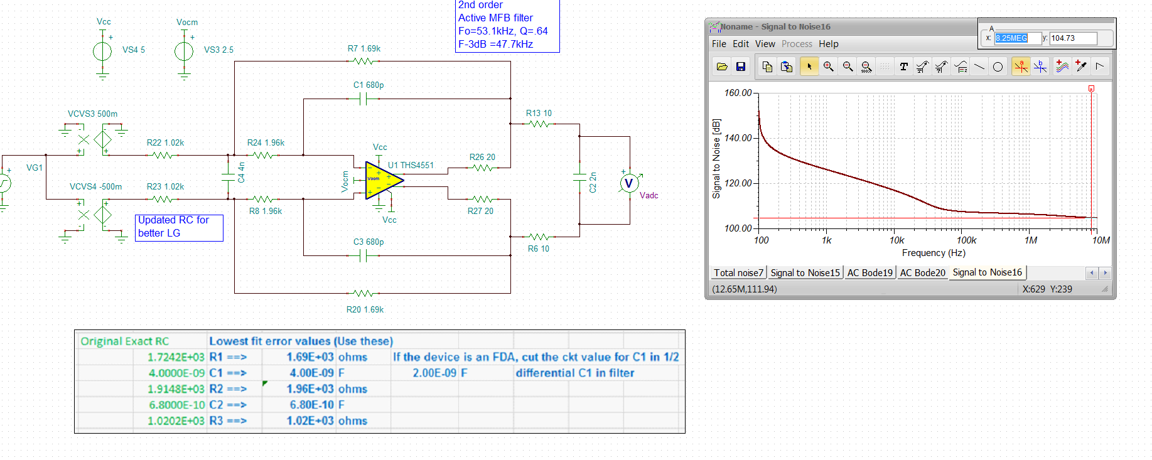
And then the close loop response, don’t see that little bump at 100MHz indicating low phase margin any more,
