THS3001 issues,
Large signal high slew rates get into a secondary non-linearity beyond slew limiting. This is a swept F test, but a super fast large edge is probably going into another mode and then slowly coming out – we used to call this sgueging in CLC.
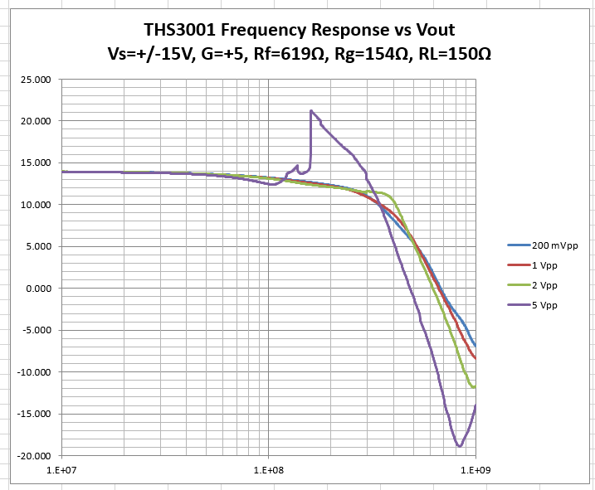
And then here is some more data laying the THS3491 measured data on top of this,
