THS3491 Disable operation discussion
Updated Dec6, 2016 from Nov30 version
Michael Steffes
Both packages provide a REF pin and PD pin. In general, it is intended that the REF pin be driven (normally to ground) while the PD pin will be a logic control switching the device into and out of its powered on state. Some of this discussion is related to dropping into a THS3091IDDA pinout where the REF pin on pin 1 and the PD pin on pin 8 are shown as NC pins. Here is the older device pinouts the THS3491IDDA are intended to upgrade.
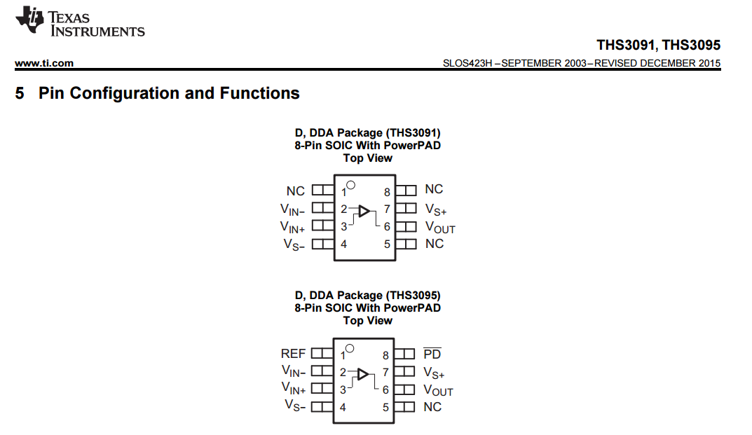

The NC pins (1, 5, 8) on the THS3091 are in fact no connects – there is no bond wire behind those pins. This also means that different combinations of actual connections are possible on existing THS3091 boards (ground and open being the most common)
Turning to the new THS3491, its available packages and pinouts are here.
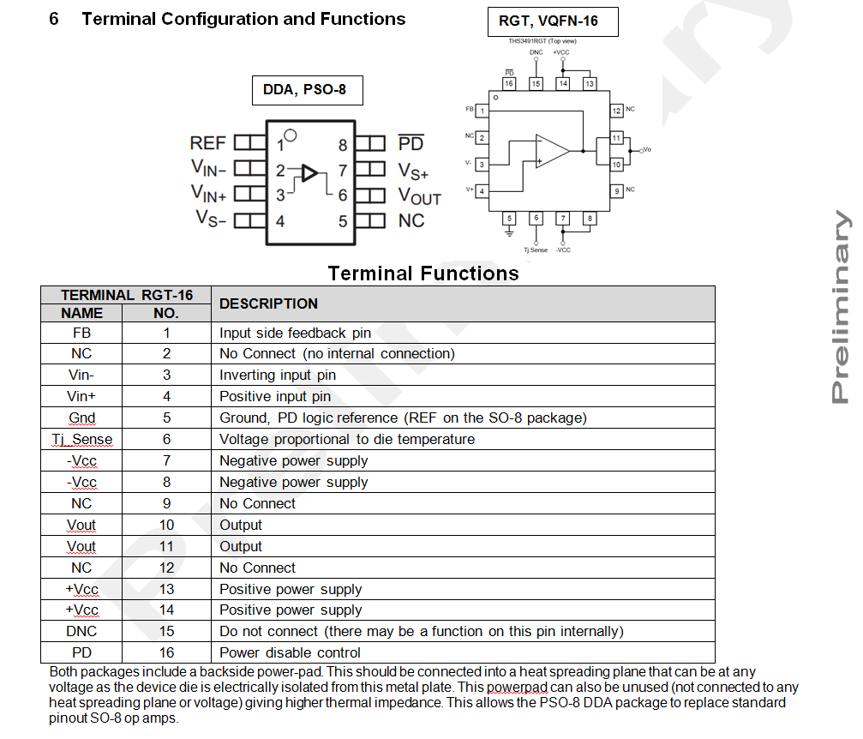

The DDA package was intended to operate correctly if placed into a THS3095 design. The details are different internally.
In general, the simplest case is with both pins driven as intended for the THS3095. Its thresholds are here
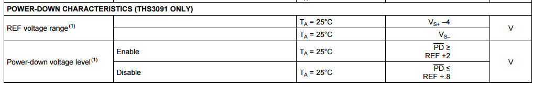
THS3095 only
The THS3491 thresholds are here.
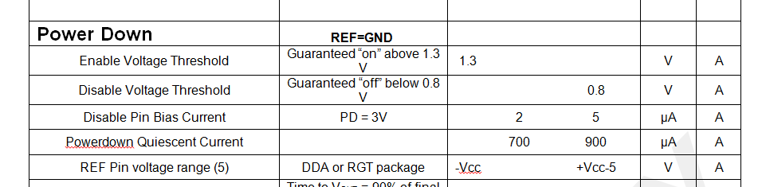
Where footnote (5) says this
(5) The REF pin may be used to control the PD function over a wide or single supply range. 30V single supply would set REF to ground, the negative supply, and operate with ground referenced PD control voltages. The REF pin on the RGT package also has the Tj Sense resistance connected to it.

So, the turn-on point is 1.3V above the REF voltage, turn off point is below 0.8V above the REF voltage.
So if a THS3095 was designed to use the disable feature, that same control will work with the THS3491.
Now some details on the THS3491.
Like the THS3095, the REF pin can be set anywhere between the –Vcc and +Vcc-5V (the THS3095 was +Vcc-4V on the high side). The PD pin can be driven to a voltage anywhere inside the supply range and operate with the thresholds described.
The REF feature was intended to allow a GND input to be applied to REF over a wide range of possible supply voltage combinations. So a single supply 30V application (where the negative supply is at ground), could still put ground on the REF pin and operate the PD disable with a 0V to >1.3V logic swing.
When disabled, only the supply current decreases – no isolation is intended. In fact, in disable mode, anything that might produce > +/-1V differential voltage across the input pins will turn the THS3491 back on. This includes input voltages and/or a voltage swing applied to the output pin that divides back to the V- input through the Rf & Rg divider. This is also noted in the THS3095 discussion where +/-0.7V differential across the inputs is enough to turn on the THS3095.
Now consider some combination of REF and PD that might appear dropping into a THS3091IDDA design (or other devices that show different things on pins 1 and 8)
- First, floating both the REF and PD pins will turn the THS3491IDDA on. However, the voltages you would measure at each pin will seem odd. The REF pin will be about 1V below the +Vcc while PD will be about 2V below +Vcc. The internal disable circuitry is actually off, but in a mode that turns the amplifier on. This would allow the THS3491IDDA to drop into the THS3091IDDA pinout and operate if pins 1 and 8 were floated.
- Second, if both pins1 and 8 are at ground (say in a THS3091 layout), the THS3491IDDA will turn off.
- 3rd, if the REF pin is at ground, and the PD pin is floated, the THS3491IDDA will turn on. So starting from a THS3091 layout that grounds pins 1 & 8, pin 8 will need to opened to float high.

THS3491IRGT considerations. This device has the same internal structures on the die as for the THS3491IDDA, but since these will be new designs, it was decided to just call for the REF pin to be a ground pin. An added feature on the die was to add a temperature sense output on pin 6. This is simply a temperature dependent current source from the positive supply into a resistor where the other side of that resistor is connected to pin 5, what is also the REF pin on the die and pinned out as such on the THS3491IDDA package. For simplicity, and to keep the Tj sense output ground referenced, it was decided to simply call out for a ground that internally is also the REF pin voltage. It is possible to tie pin 5 to a voltage in the same range as the REF voltage for the DDA package– and that will level shift the output of the Tj sense voltage.
Pin 15 is labelled as a DNC (Do Not Connect) and should be floated. Added amplifier features or test interface are intended for this pin. If disable operation is not desired on the RGT package, grounding pin 5 and letting pin 16 either float or tied to positive supply will enable the amplifier.
Pins 2, 12, and 9 are NC (No connect) pins and do not have a bond wires on those pins. It is recommended to float those pins to decrease any parasitic capacitance to the adjacent active pins.

