Transient simulation for THS4121:
- Add the current source:
①、Cd=2.1pF，Cf=5.41pF，Rf=554.79ohm Figure（1）
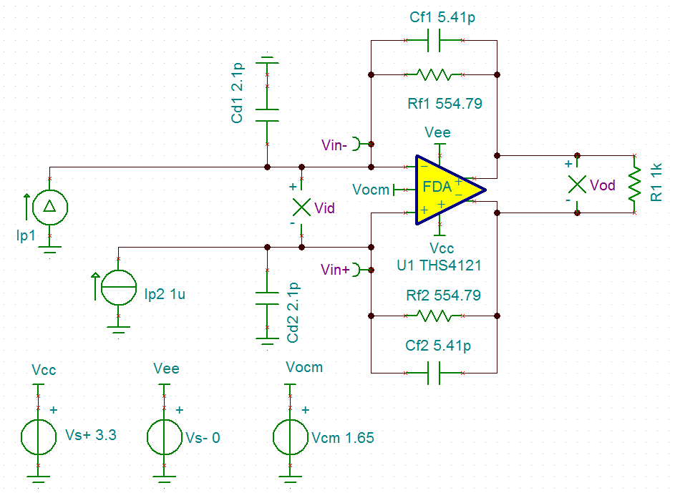figure 1
Ip1 setting：DC 1uA，Pulse signal，amplitude 1nA，Pulse width 20nS。
Ip2setting：DC 1uA。
Transient simulation setting as below:：
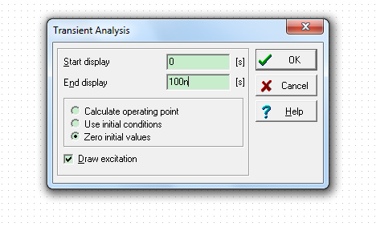

The instantaneous simulation results are shown in Figure 2 as below：
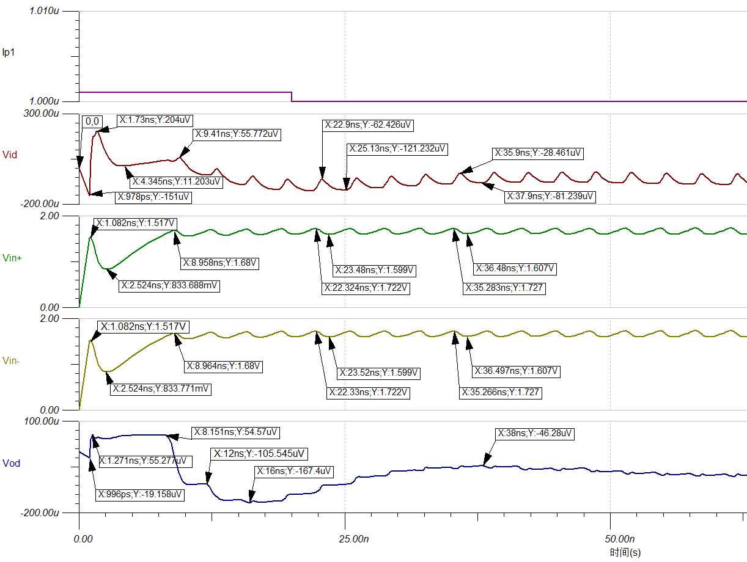Figure（2）
From the figure 2, Vid is in shock，The shock frequency is about 307MHz. The amplitude is about 60uVpp.
For Vod, the max value is about 54uV and the time is about 8.151ns. The min value is about -167.4uV. The time is about 16ns.

②、Cd=4pF，Cf=2pF，Rf=5.69k ohm Fiugure（3）： Ip1 and Ip2 are the same as Figure（1）.
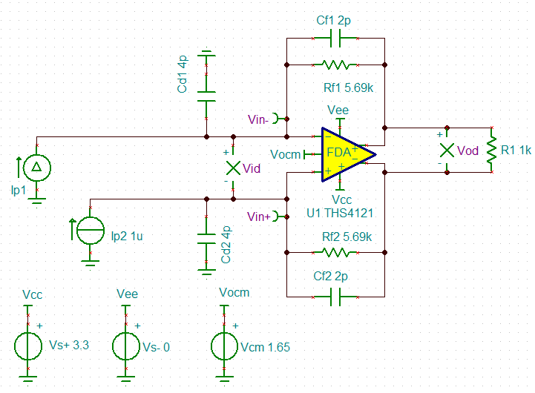
Figure（3）
The instantaneous simulation results are shown in Figure 4 as below：
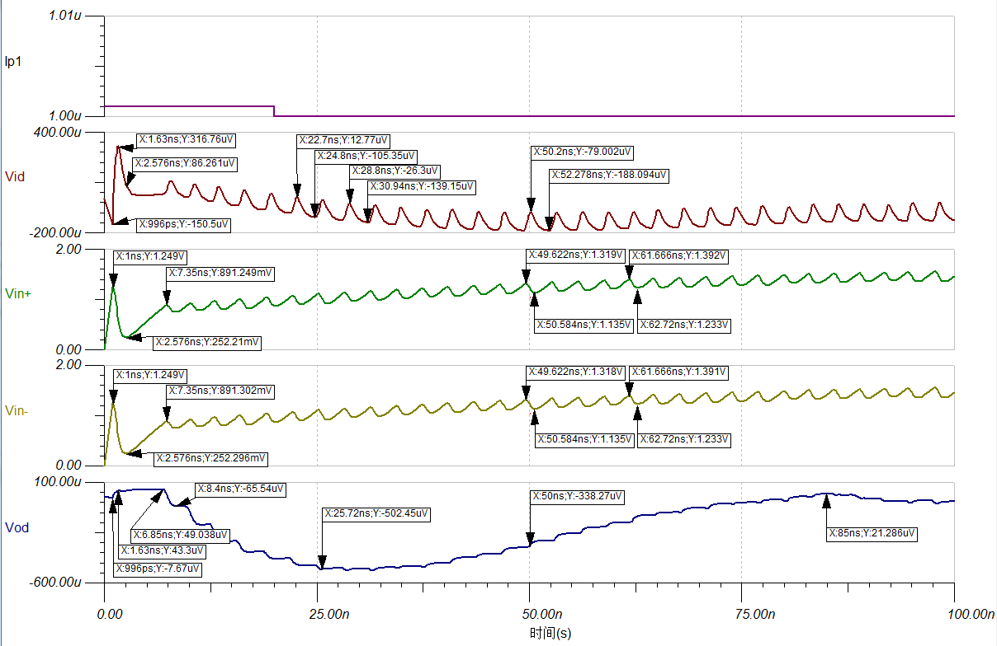Figure（4）
For the Figure（4）result, when the customer changes the different Cd、Cf and Rf values,
Vid is still in shock. For Vod, the max value is about 49uV and the time is about 6.85ns. The min value is about -500uV. The time is about 30ns.
- Remove the current source:
①、Cd=2.1pF，Cf=5.41pF，Rf=554.79ohm Figure（5）
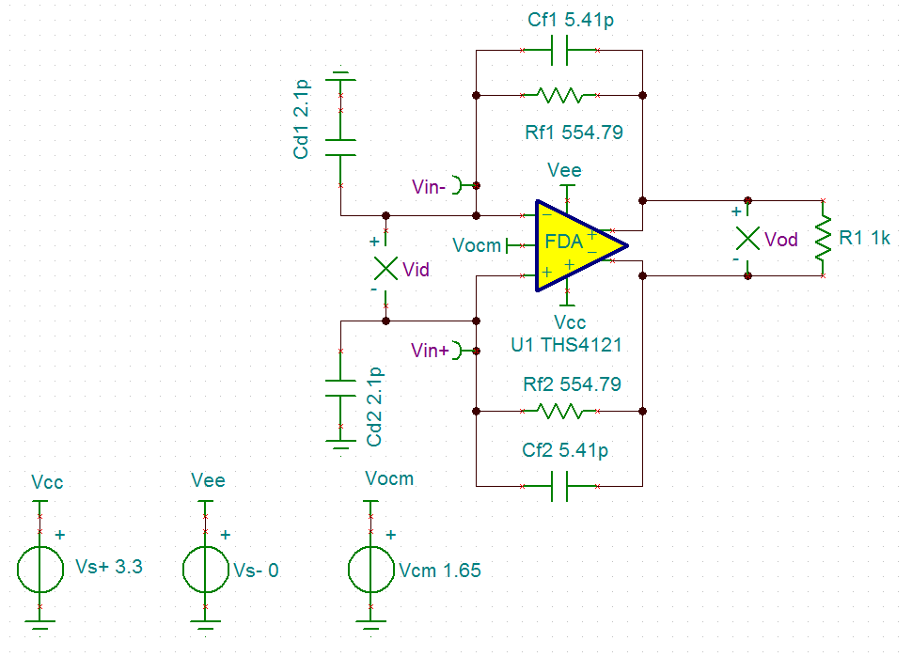Fogure 5
Transient simulation setting as below:：

The instantaneous simulation results are shown in Figure 6 and Figure7 as below：
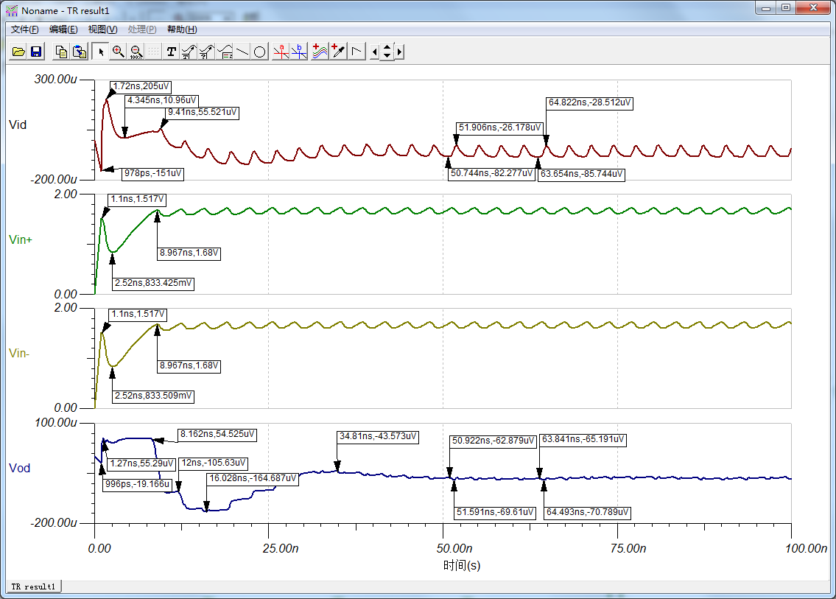Figure（6）
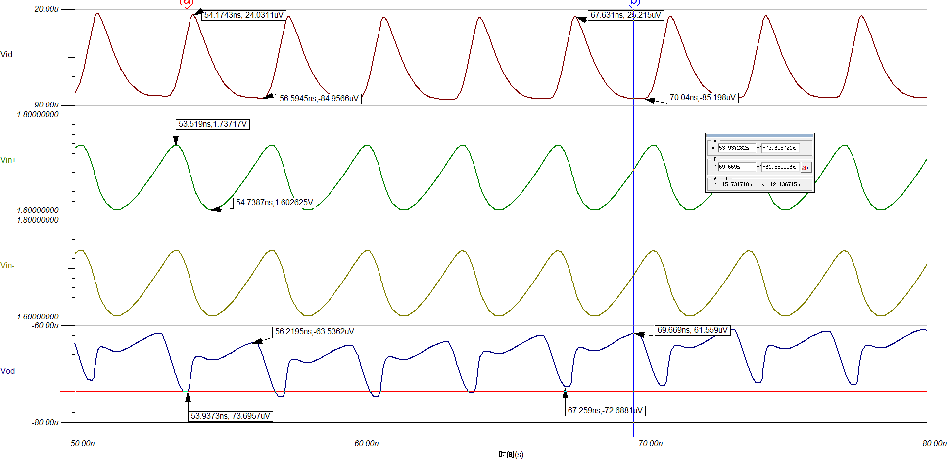Figure（7）
For the figure7, the Vid amplitude is about 60.45uVpp and the shock frequency is
about 297MHz. The Vod amplitude is about 10.64uVpp and the shock frequency is
about 297MHz. The phase shift between Vod and Vid is about 0.372ns. The Vin+ amplitude and the Vin- amplitude is about 134.5mVpp. Their frequency is about 297MHz.
② Remove Cd and Cf , Figure（8）
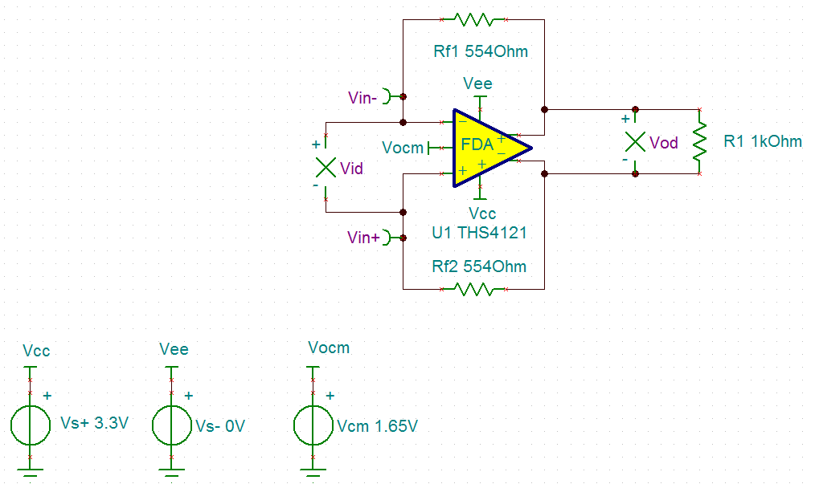Figure（8）
The instantaneous simulation results are shown in Figure 9 as below：
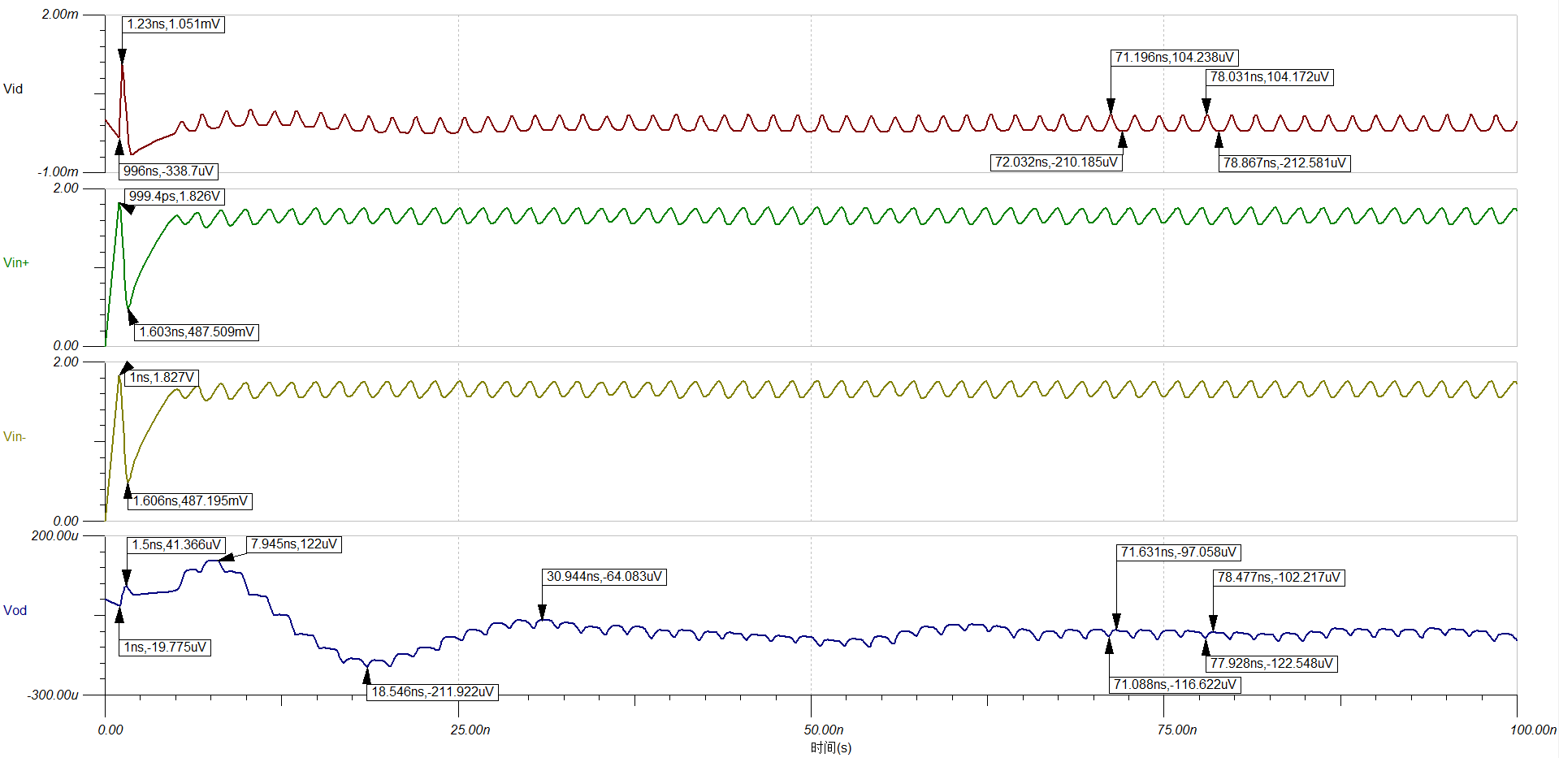Figure（9）

