THS4531 single to diff. 1kHz design

Simplified original design and went to single +5V supply and Vocm = 1.5V

Here is the input signal – odd way to generate it, but 0 to 3V input

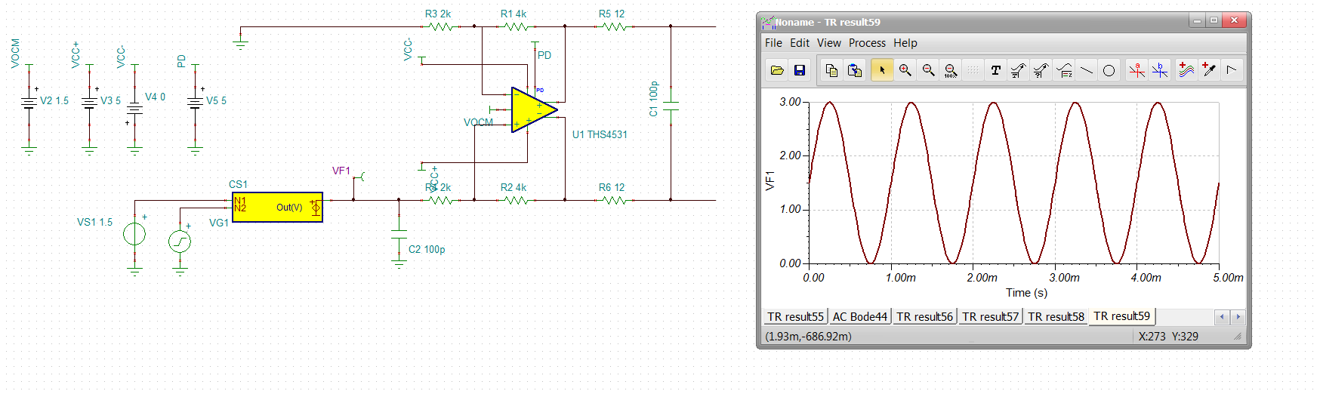

So the output is sitting at 1.5Vcm. That +/-1.5 signal is set up for a gain of 2 to the diff out. Or +/-3V differential, divide that by 2 and you should be getting +/-1.5V 180deg out of phase on each output.plot that next removing input probe, this looks wrong, checking the macro, 2011 model,

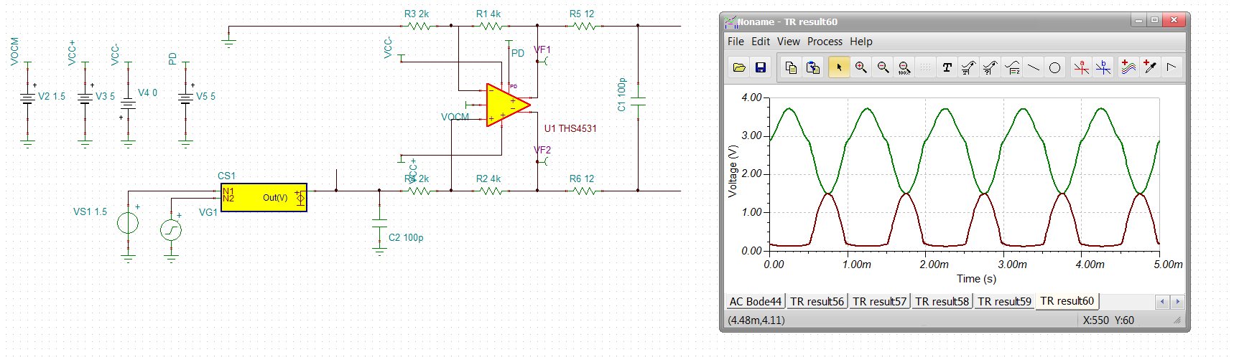

Check DC operating points

This look odd, looks like the input diff V is way too high,

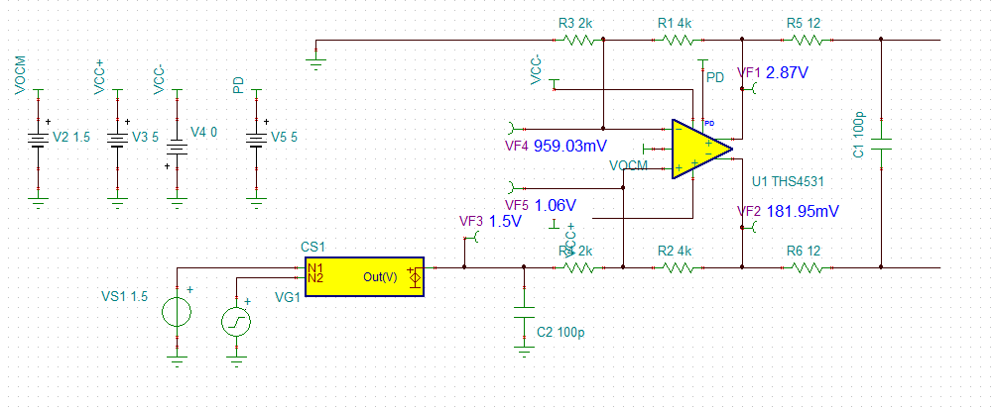

This very old 2011 model has not been updated, try the THS4551 for functionality, had to reverse supplies and PD, looks better, but at mid 1.5V input, the ouput pin is near 0V on the negative side, so positive swing to +3V will clip it – note the input voltages are better (closer to zero delta).

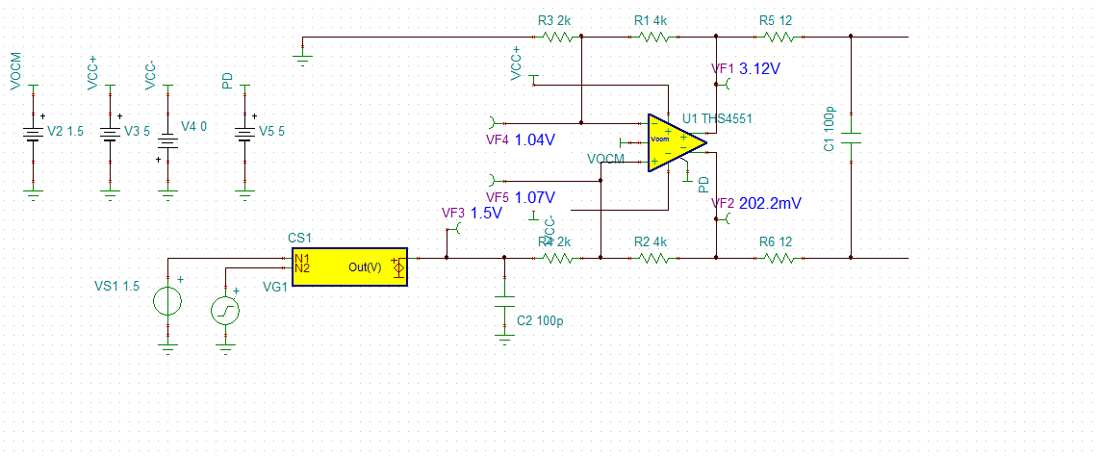

If I run that 0 to 3V input transient, should clip, yea, it bombs as it clips in sim,

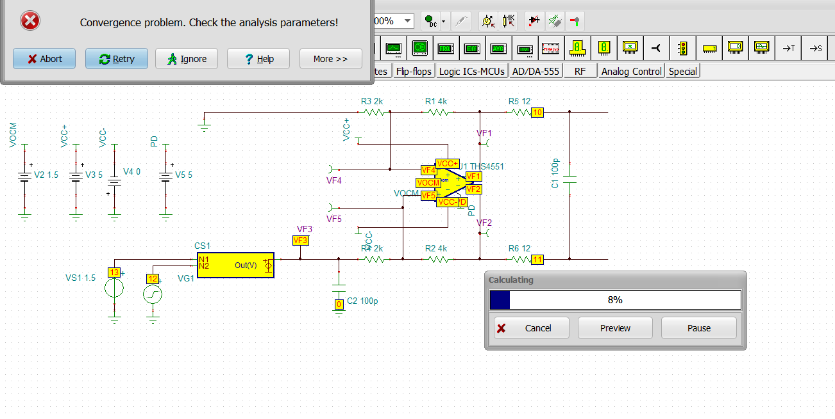

Move the Vocm control to midsupply 2.5V – and re-run, having a lot of problems running for some reason.

Ok, reduced the gain to ½ and everything ran, the input is 0V to 3V single ended, so yes, the differential output hits an odd 0V diff out (each output each at Vocm) and then 1.5V differential,

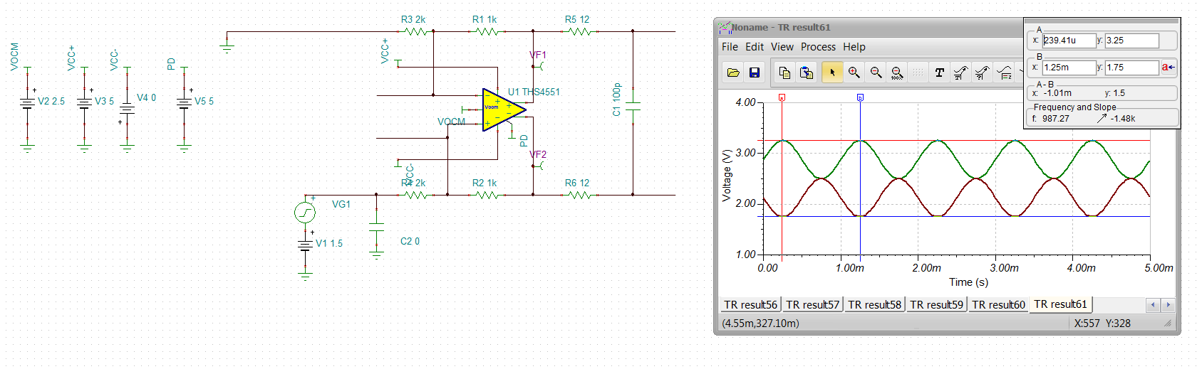

So the original design with 0 to 3V input is hitting a 0V diff out then 6V diff out in one polarity, that is +3V from vocm and -3V from Vocm – clipping likely,

Go back to original ckt. Not really using the Vocm voltage, just floating input which will put the output Vocm at 0V, and that is what the individual output swings look like – changed the gain to 0.5V to stay in range for this 0 to 3V input,

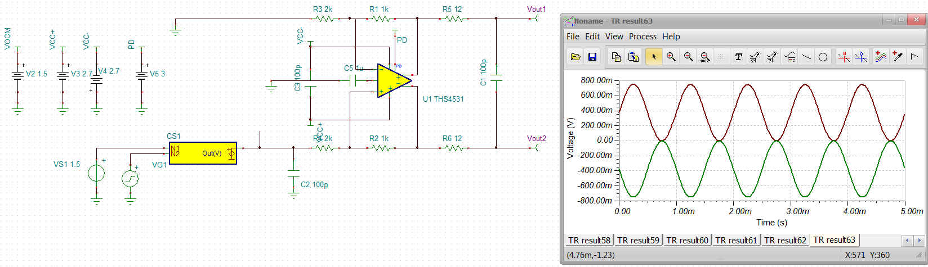  
Connecting the Vocm to Vocm control, with shift this to 1.5Vcm which is where the two outputs come together for a 0V input signal, so yes, each output is 1.5V +0.75V on one side, -0.75V on the other, running gain of 2 will clip for sure at the outupts,

