1. Below is a 100KHz filter, is there a document or speadsheet to guide customer how to calculate out the R, C value to achieve the bandwidth that customer want? Not publicly available

[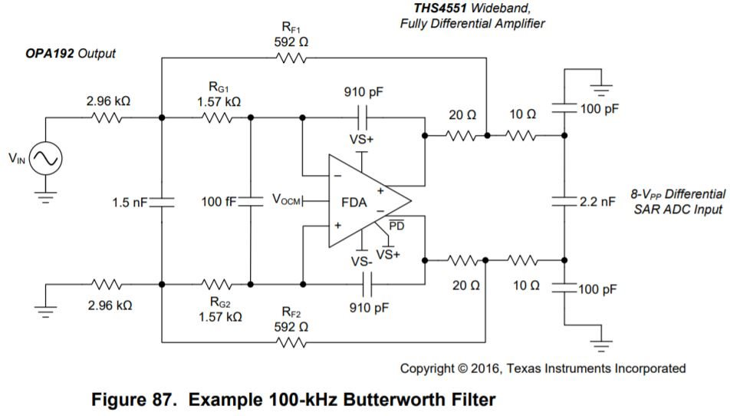](https://e2e.ti.com/cfs-file/__key/communityserver-discussions-components-files/14/THS4551-figure-87.JPG)

2. Below is customer's circuit, R&D would like to form a 25KHz butterworth filter, so is the R, C value of black line area correct? if not, please provide the recommendation. So the FDA is not a 2nd order MFB anymore with C278 a NC. The feedback pole at 48kHz is not right either – so I don’t know what they are thinking? The question below is not bad – I normally try to do 3rd order things if you have a place for a real pole like right there – Normally at the OPA192 inputs I would use an R value that does not increase its noise too much (5.5nV for the OPA192, target 2nV R noise or 250ohm input R). Using 250ohm there, a Butterworth 25kHz is all poles on a circle in the s-plane so the real pole is 25kHz or an input C of 25.5nF – use 24nF).

Then the active filter stage needs an Fo of 25kHz and a Q of 1 – use the original release model as the new 2019 one is off on noise (at least). Using this very detailed tool I work on occasionally, there is the design targeting a 2.5kohm kind of input R. (takes about 2minutes as I have those design files open all the time for articles and consulting). So here is a solution, hits the targets pretty well,

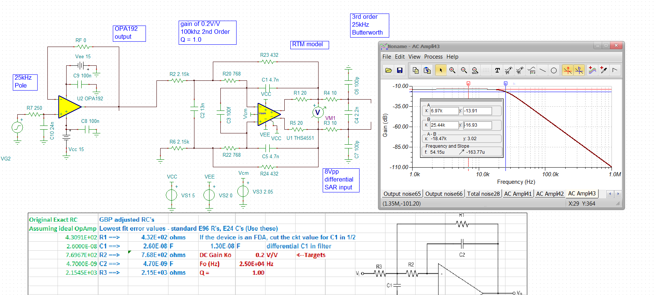

3. Why need a differential and common mode filter in blue line area? So this is optional, most SAR just want a differential, but we found in some cases the CM caps helped – we put those in, but if testing shows they are not needed, make them DNC. [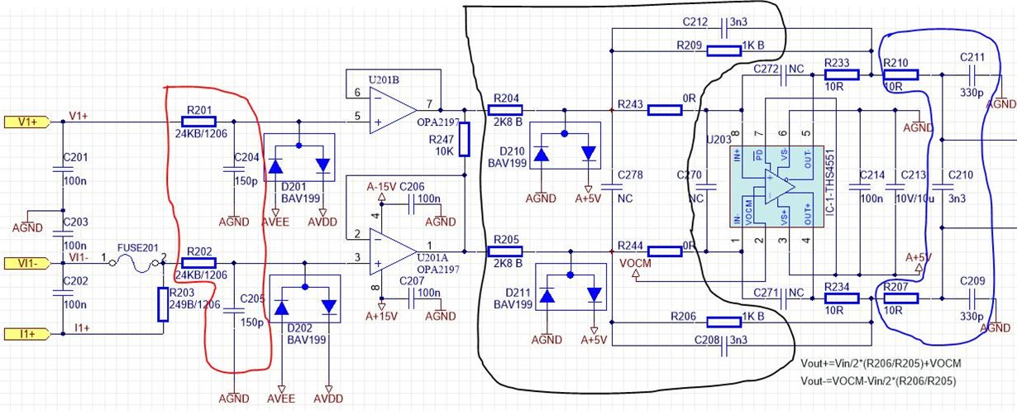](https://e2e.ti.com/cfs-file/__key/communityserver-discussions-components-files/14/THS4551-customer-circuit.JPG)

4. Can customer large the R, C value in blue line area to form a main filter(like to build a 25KHz filter)? If it is not recommended, why? Already answered in schematic

5. Customer try to change C210 from 3.3nF to 470nF, the -3dB should be at 1/(2*3.14*20*470n)=16.9KHz but his test result is about 8.9KHz, why? And he also found the total power consumption increase about 1W, does it make sense? So you probably put the FDA into oscillations – that is a pretty high value for that cap.

Thanks very much.

Vincent Chen