THS4551 Video interface and filter to ADC
Michael Steffes, 12/24/2019
First set up the input range and DC bias on the other side as shown here – will get to a 3rd order eventually, but here is just the FDA stage with single feedback pole at 11Mhz – the diff input C is only for NG shaping to reduce resonance out at higher F. 2nd order RLC after this will flatten it out. ADC need max 1.8Vpp (-1dBFS) on a 1Vcm here. Eventually, that is 1.8Vcm +/- 0.45V on each output.
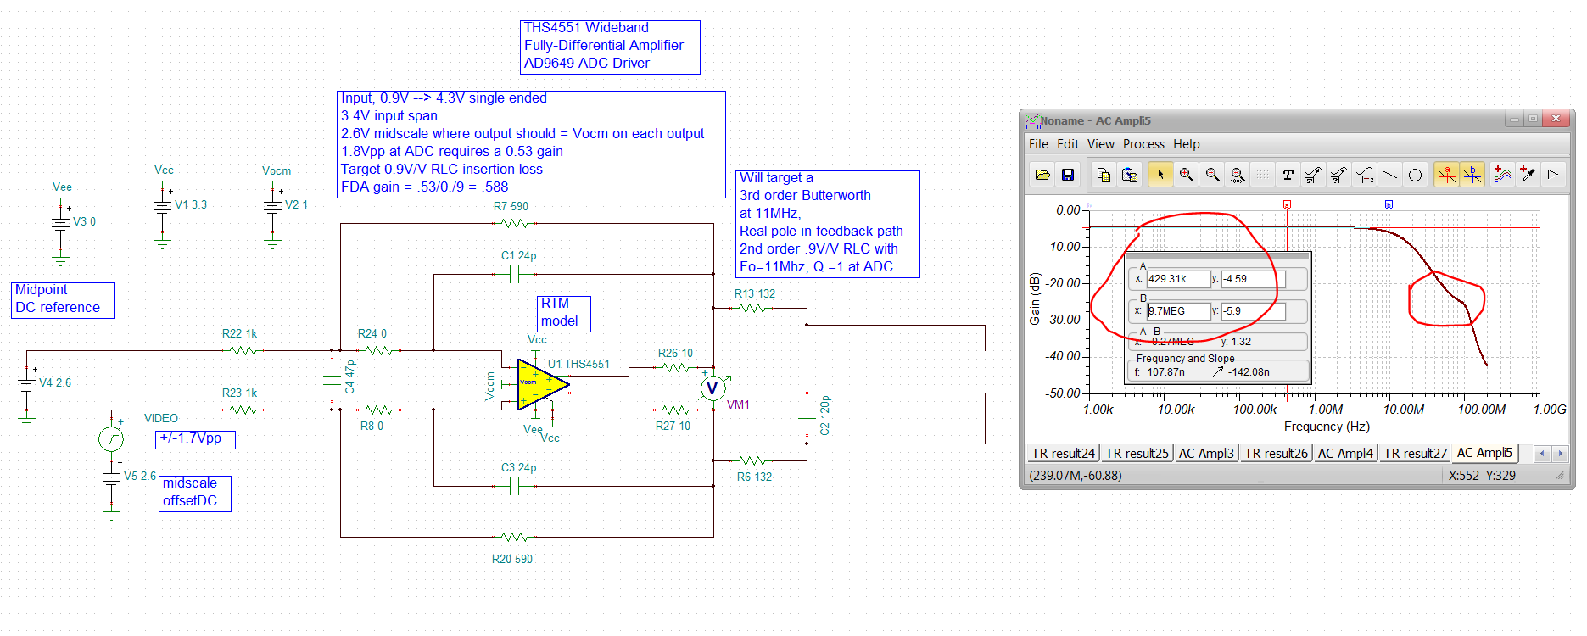
Now add the RLC filter at the ADC,
Alpha = 0.9V/V
Rload = 500ohm
Fo = 11Mhz
Q =1
It would be better noise wise to put a 2nd order MFB into the FDA stage and single post RC, but here is one option for reversing those –
This is a single ended design, need to double the shunt R take ½ the shunt C values and include the ADC input Z effects – had some real stability issues adding this filter, increasing the inside the loop R fixed that, go to 50ohm there, some headroom loss but plenty of room there.

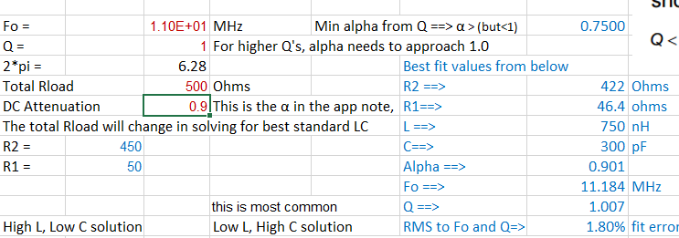

Looking at the diff output and final ADC inputs, good response shape,
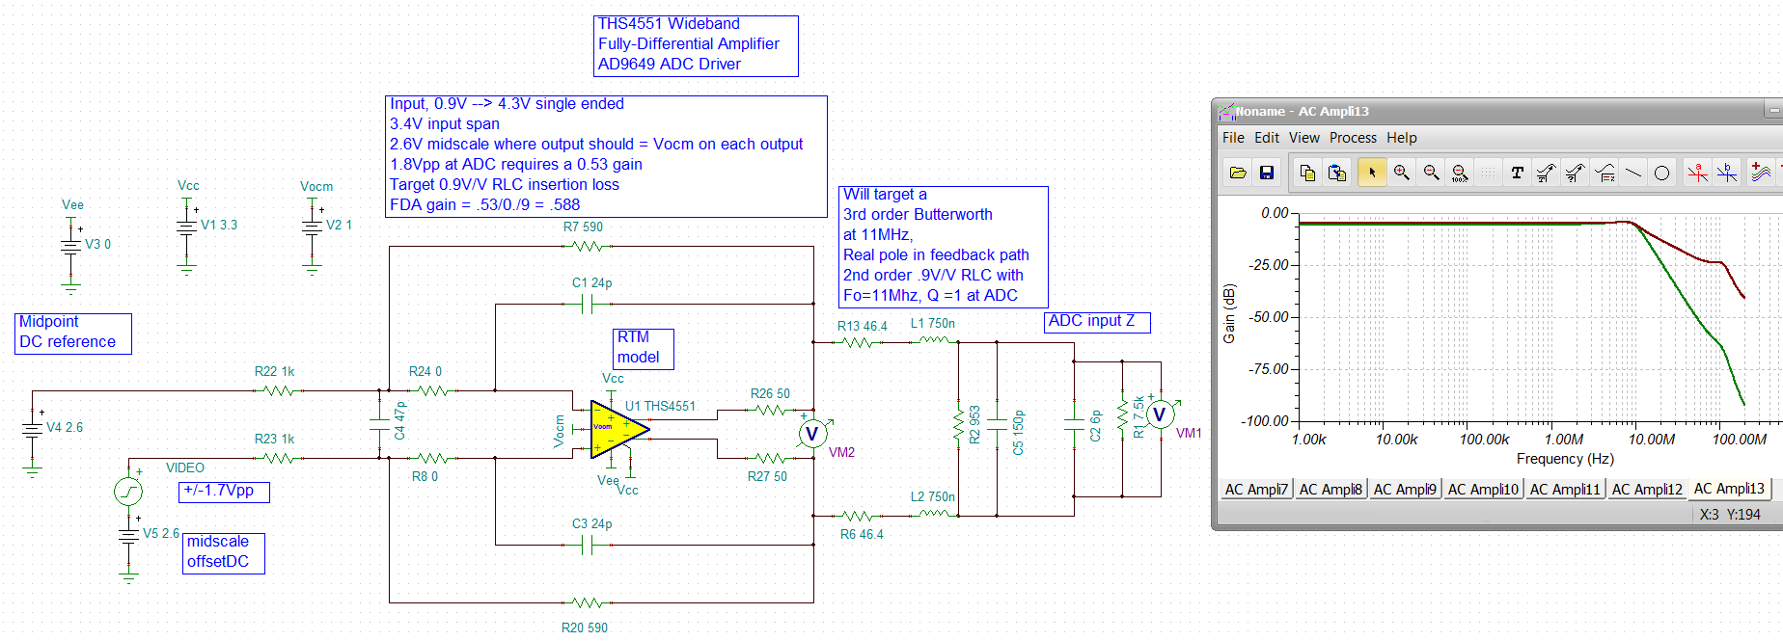
Then running that test input of +/-1.7V around 2.6Vdc as a sinusoid at 100Hz looking at each ADC input pin separately, this also still had the differential FDA output, so there is your 2Vpp then attenuated by 0.9V/V and set to a 1Vcm point for the differential input,
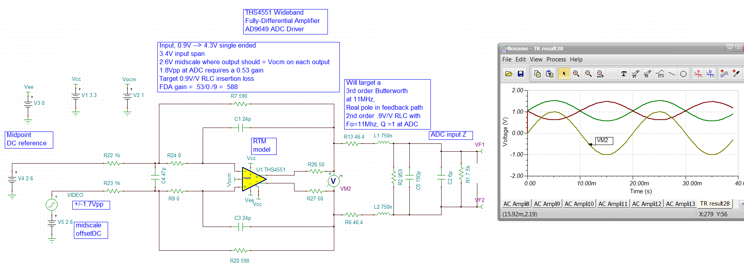
This circuit had a slew rate problem at full scale 9.7MHz associated with the higher swing due to inside the loop 50ohm used for phase margin improvement, I moved the 50ohm out of the output line and it works now,
