4th order low F chebychev,
Michael Steffes 11/24/2022
Putting your requirements into FilterPro shows this, the chebychev will work,
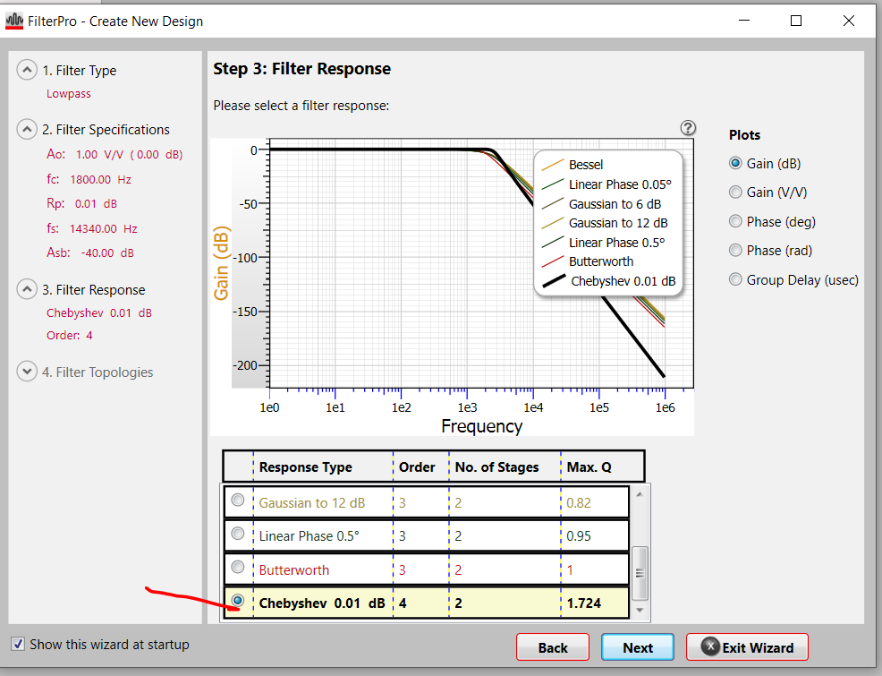
Next step will show stage Q and Fo,
So this is what I would need to do the stages, I would put the higher Q first,
Also, the required GBP are quite low, you do not need the THS4500, something more like the THS4551 would be fine (or THS4561)
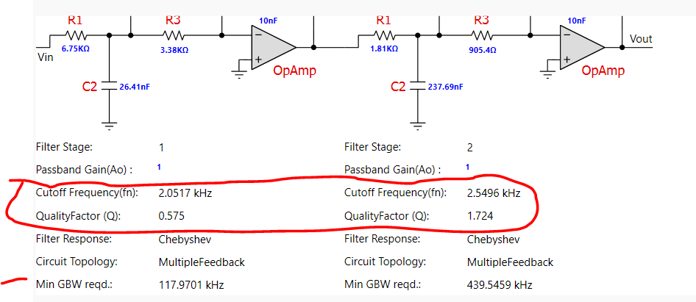

I will use the THS4551 for now, I am putting in a few extra elements to improve the phase margin – that is something I think we have discussed in other e2e before,
Oh wait, you said +/-3V supply, so I will use the THS4561,
Then going through the higher Q design flow using the Intersil online tool flow I developed,
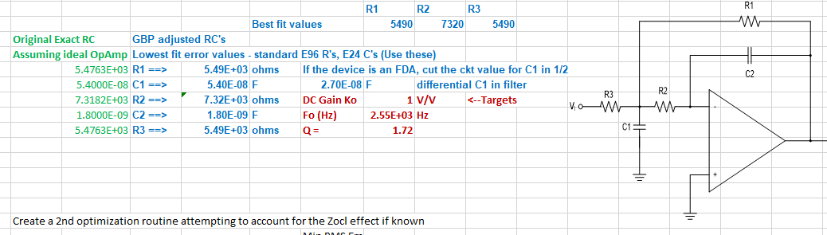
Ok, now lets find a existing THS4561 MFB file, I use the original model since it has a more accurate Zol showing the physical output Z resonance that is more accurate, and important in MFB filter phase margin,
Ok, this looks pretty good without adding that C across the inputs or the inside the loop R values.
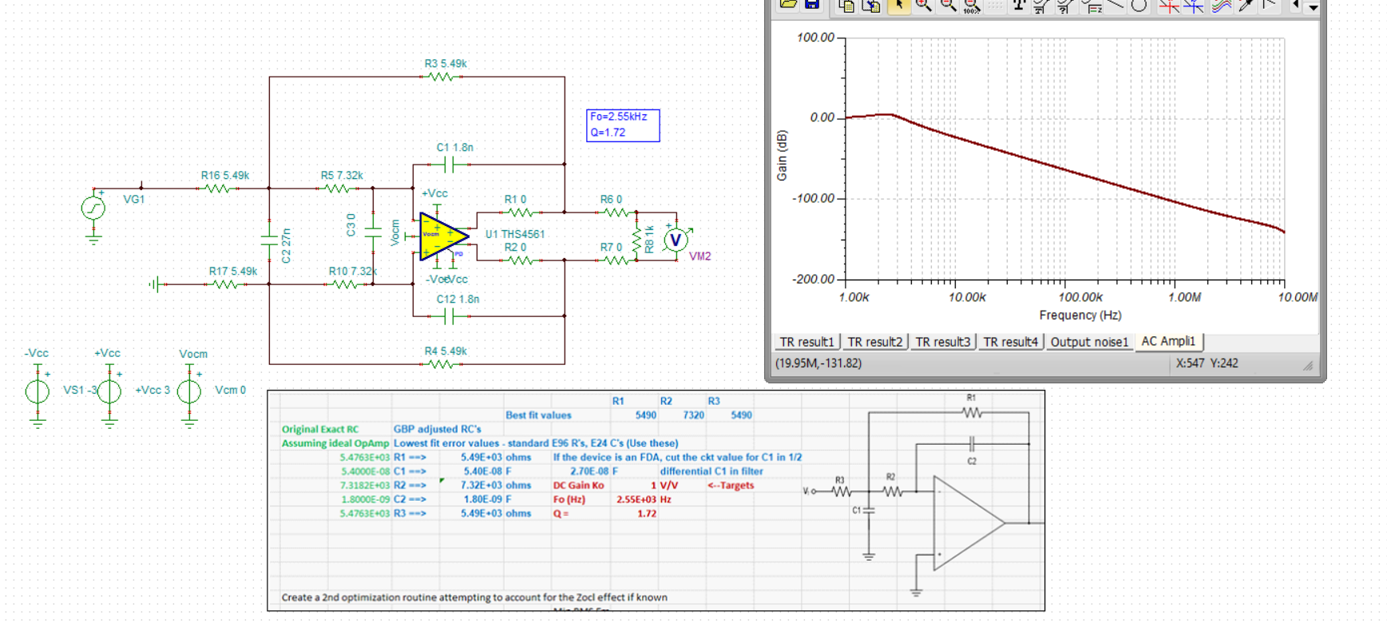
One quick way to check stability is spot noise out through 500MHz, nope there it is a little over 100MHz,
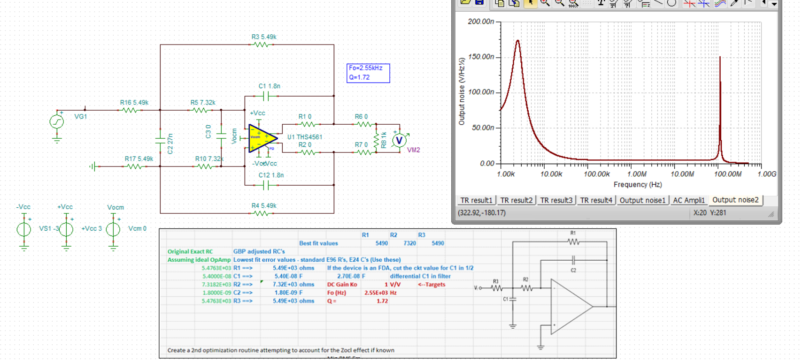
So lets add those elements, won’t effect the filter shape, yes, that should take care if it, wideness of the noise peak tells me the phase margin is >20deg which enough,
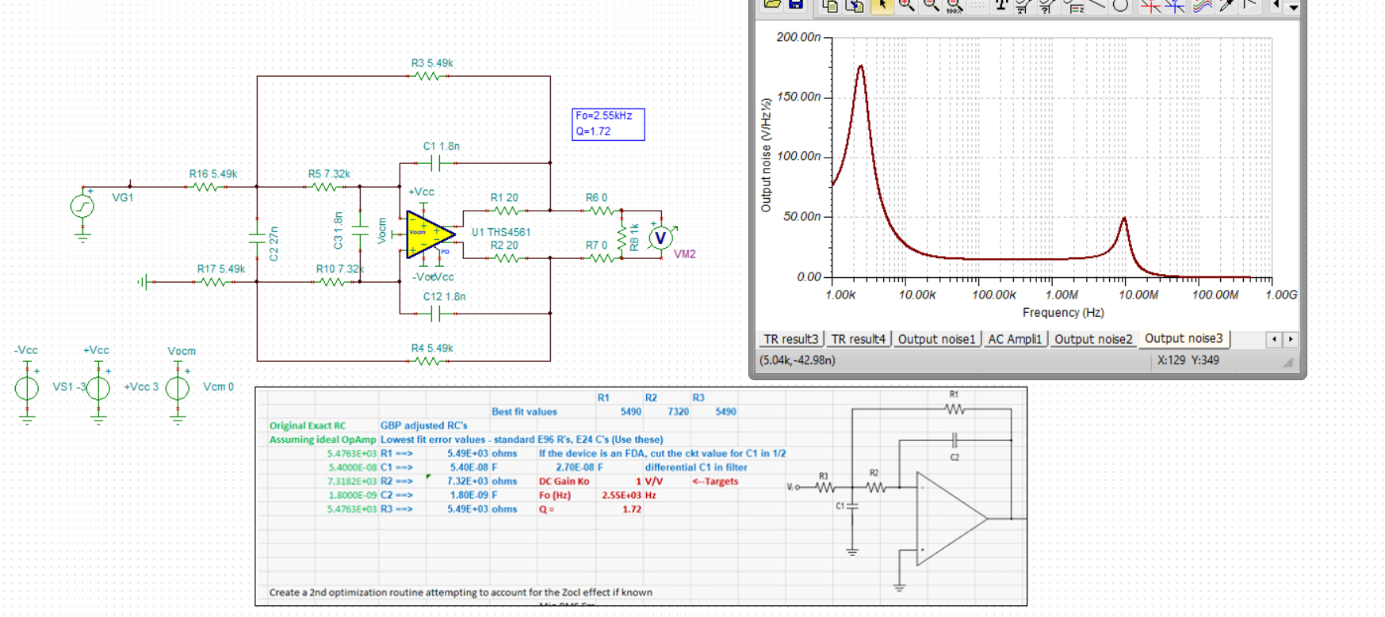
Ok, save this stage and modify to lower Q stage, here that AC response is, that little bump, maybe a higher than 20ohm in the output legs.
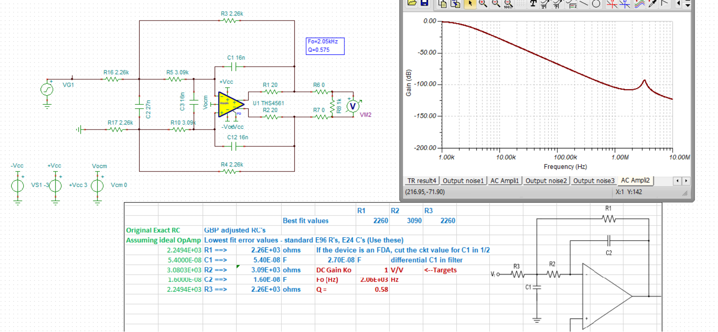
Looking at spot noise through 100Mhz now, yea, that needs some work,
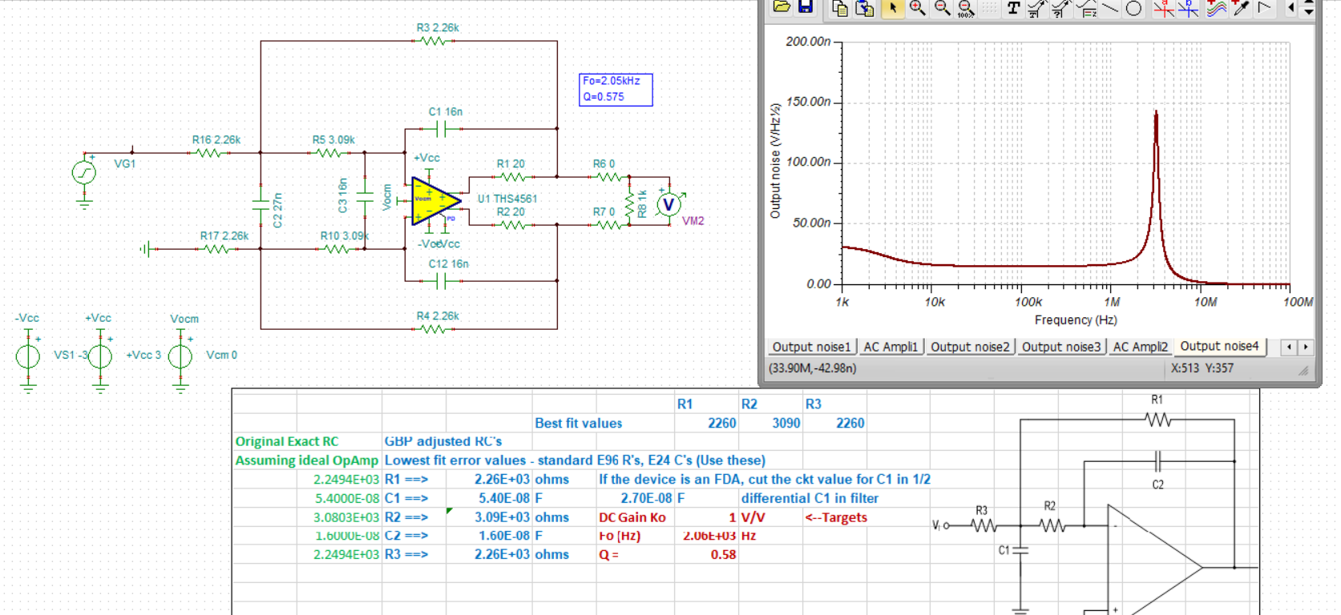
So here I got it a little better,
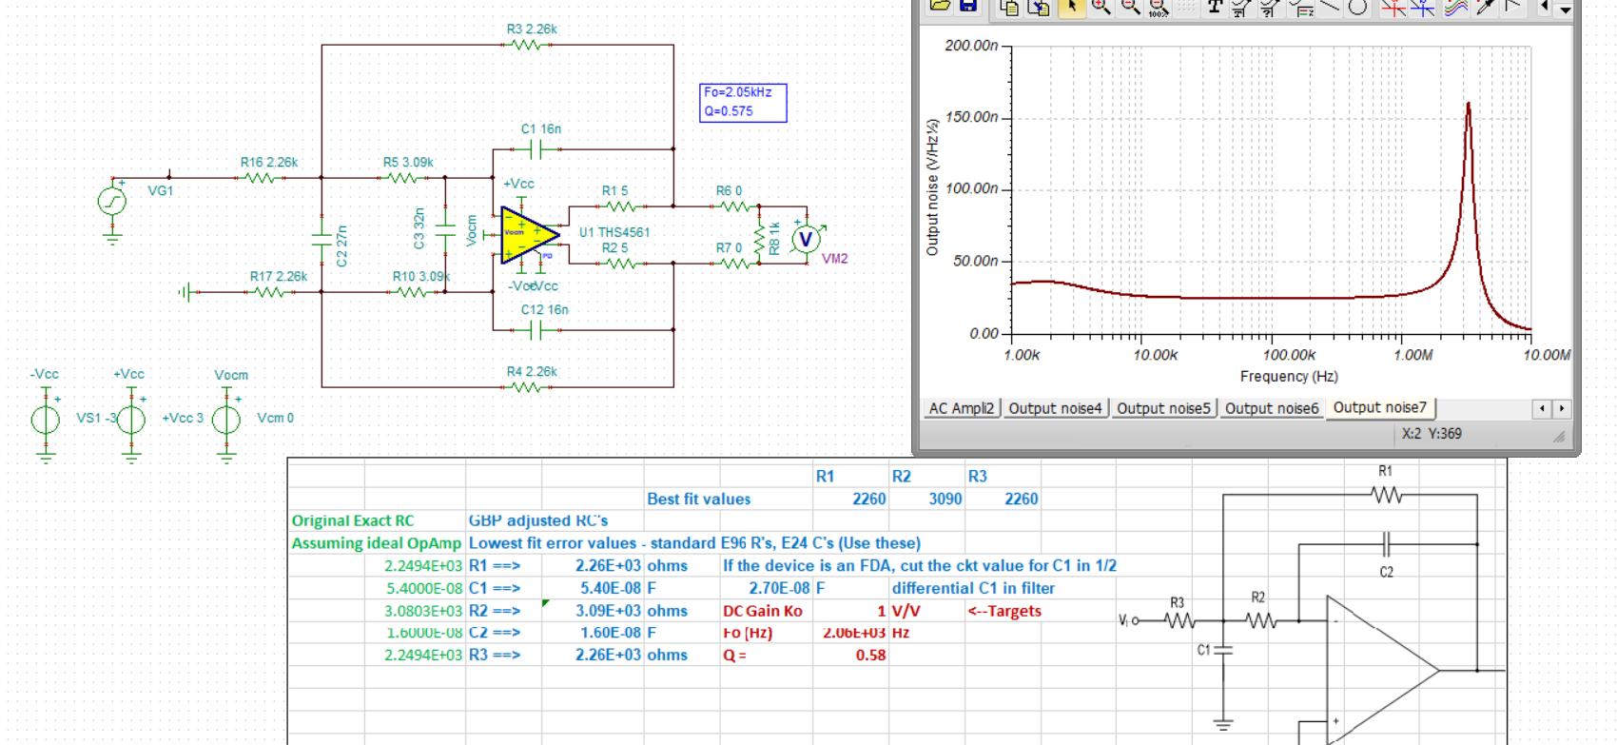
In theory that large C across the inputs would get into my filter response, I can test that, it gets into the RC solutions through the GBP adjust routine, but, we have so much margin here no change in RC solutions,
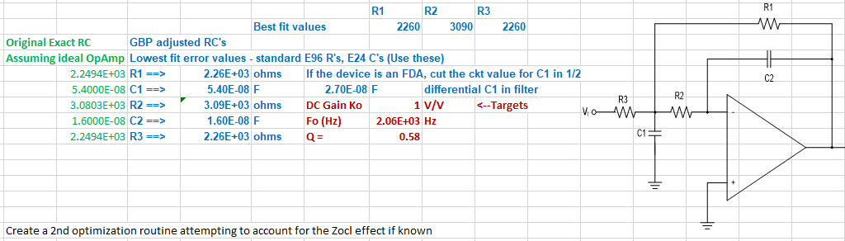
Ok, lets put them together – broadband looks pretty good,
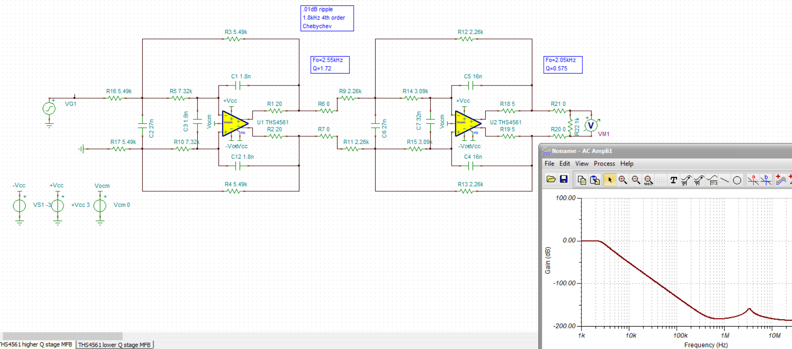
Zoom in, only about .02dB shift to 1.8kHz, you will never get that in practice due to component tolerances, but a good start,
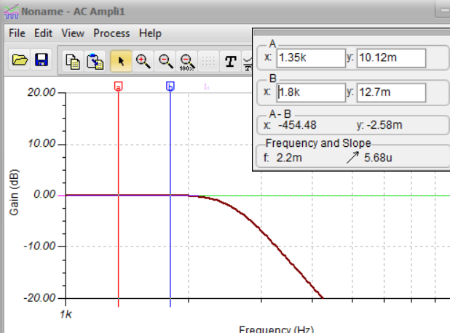
Now the integrated noise through 100MHz,
Looks pretty good, 145uVrms, or about 870uVpp.
I will leave as an exercise to the interested to reverse the stages, the integrated noise will go way up – the academic lit focused on higher Q overdrive concerns if at the 1st stage – a real concern but usually we are small signal in this stages and noise is more important,
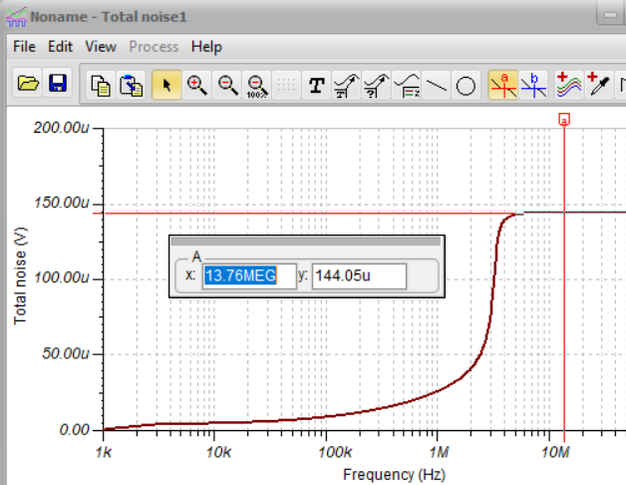

This should give you something to start with, off to other things now.

