THS4561 front page MFB stability issues
So a lot of this is all about the horribly resonant open loop output impedance, which means it is very load dependent. If I start out with 1kohm diff load, it is indeed unstable, at 117MHz, 192deg around the loop.

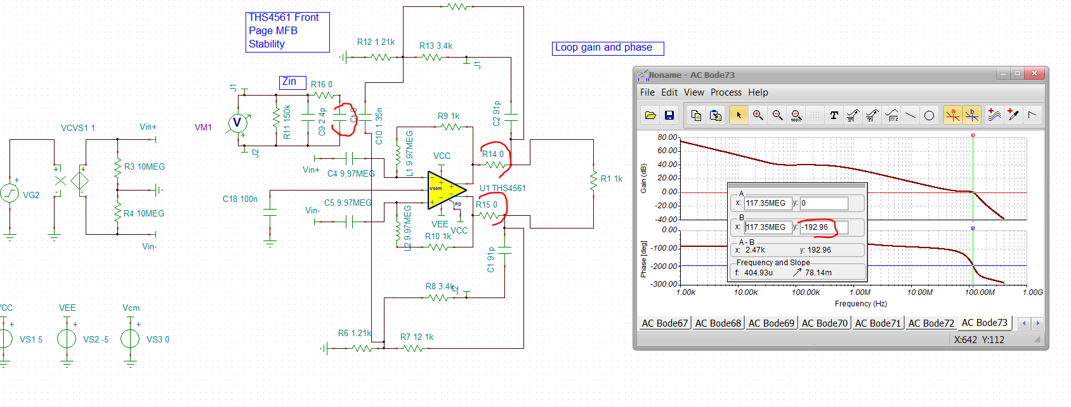

This circuit looks odd, but is in fact a valid LG set up, as per this.
https://www.planetanalog.com/author.asp?section_id=434&doc_id=564934&
So that is pretty bad, but first try a heavier load. Note the tuning elements are in here, just not used yet. Yea, that does it with about 57deg phase margin now, but lets get is stable with 1kohm load.
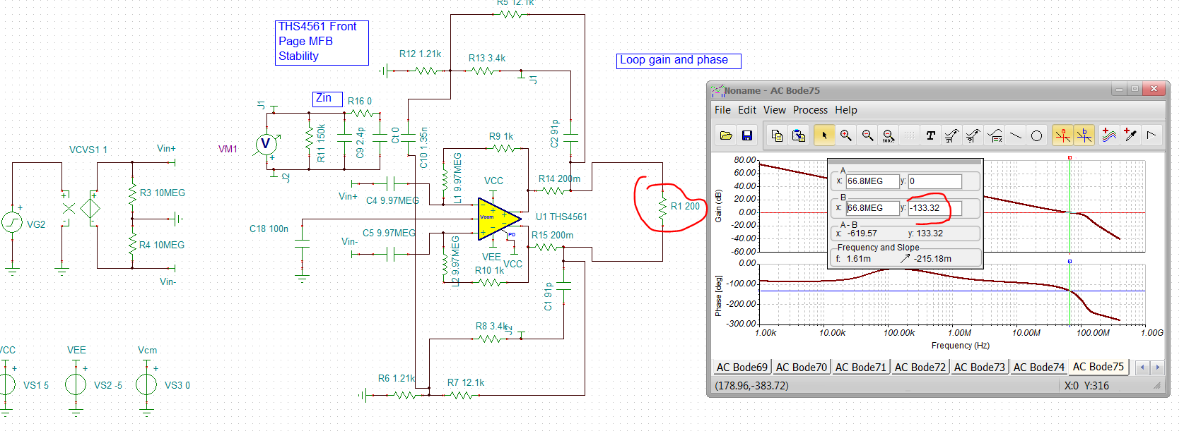

So this is the open loop output Zout – not sure I need those -0.6pF across the I/O – that was for the THS4551, but not making much difference I don’t think.
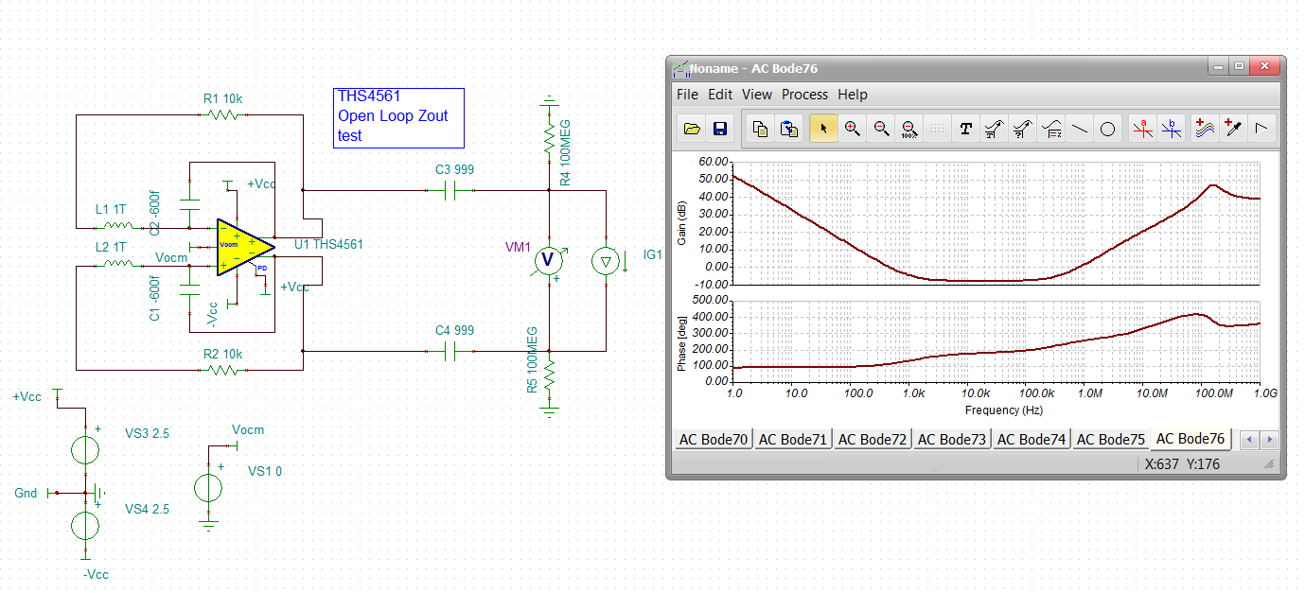

This was a lot worse earlier, but at the last minute I got Chi to add 5ohm in each output line, here was an earlier match to Cadence data. We did not have any of this when I did that front page circuit.
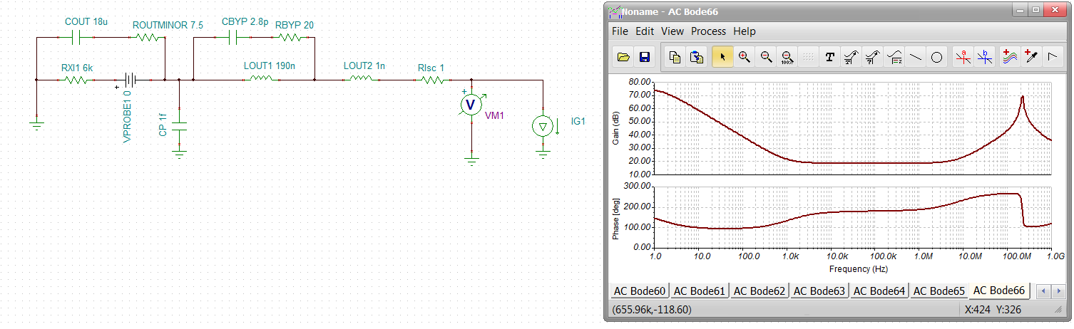
Ok, so lets fix this for a light load, will only get better if the load is heavy. First add 20ohm inside the loop in the output legs. Did not seem to help, but I know when we start adding diff input C this will help to have those resistors
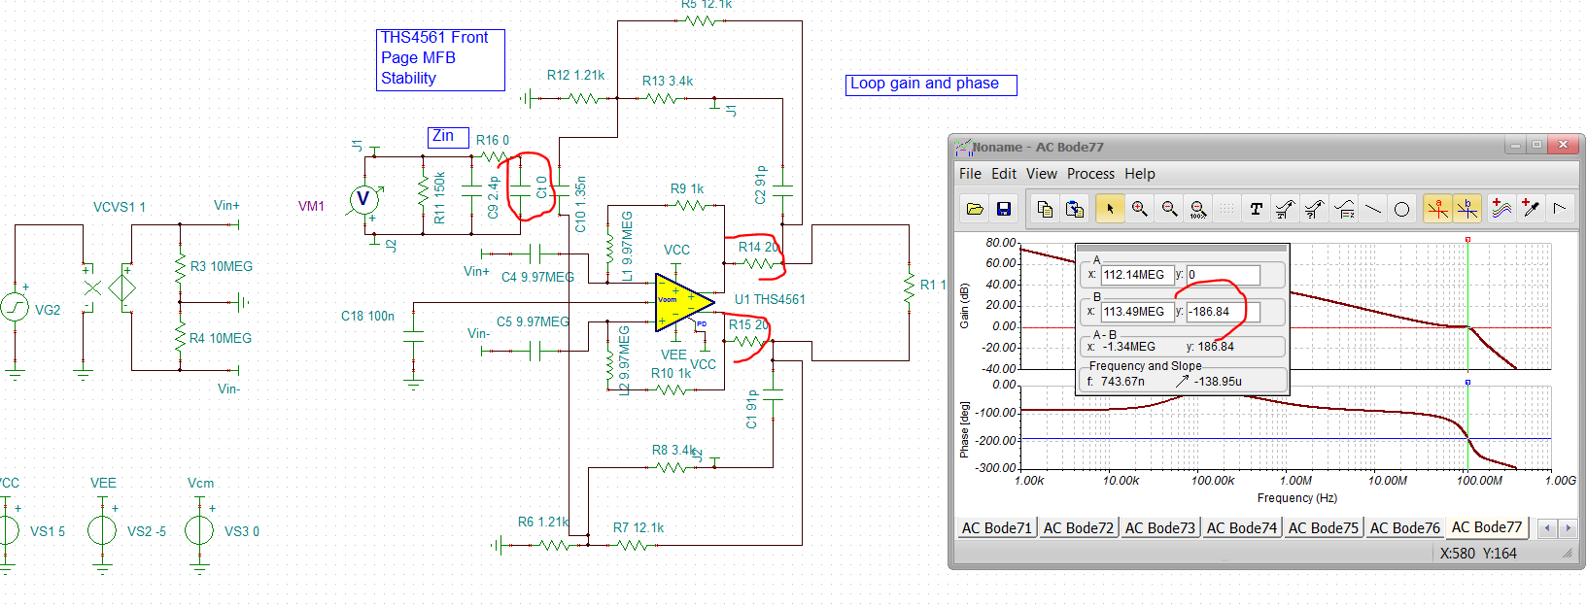

Now try shaping the noise gain up with input diff C, yes, 47pF diff input C is about 1+94/91 = 2.03V/V high frequency noise gain and gives 62deg phase margin.
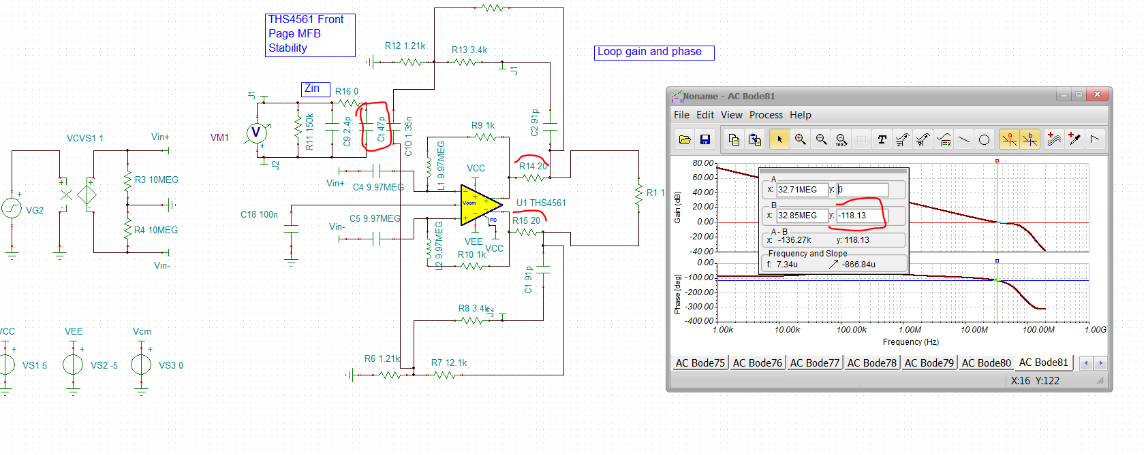

Now take those 20ohms inside the loop to zero, I would expect to see that peaking at higher F to come back. This is that resonant open loop Zo interacting with the Cap load in the feedback. So you need both. This sim is not very happy, numerical chatter sometimes I can fix that with low output R, not here, but you can kind of see the LG goes backup above 0dB out around 80Mhz. That is bad.
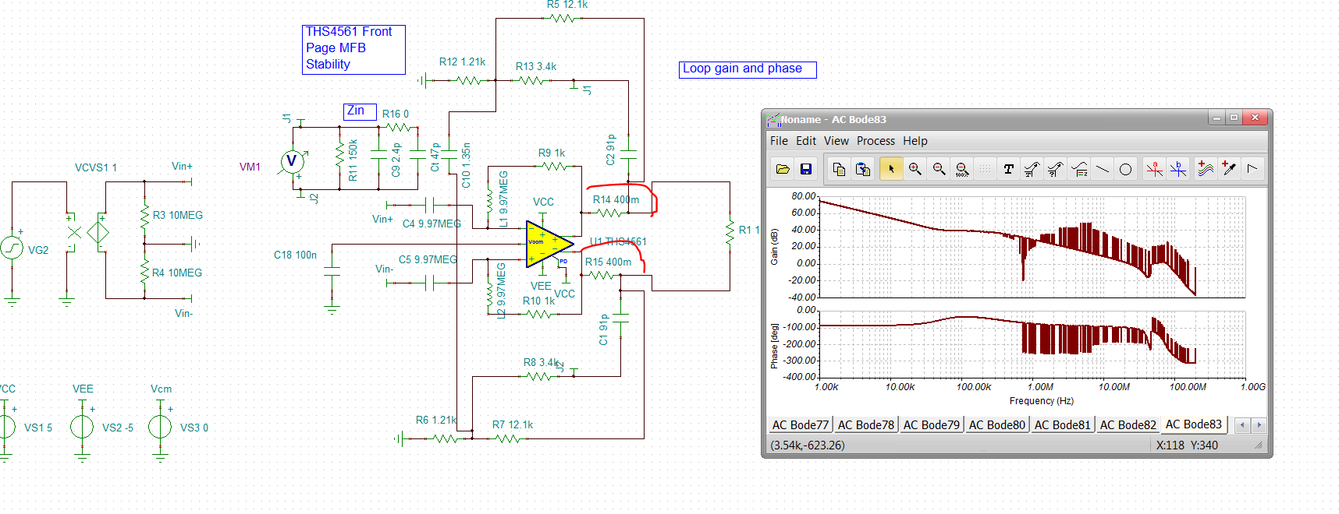
Sometimes people add a series R with the diff input C, I don’t think that is super good idea, but may be wrong as it does seem to help the SNR. Ok, so lets run some swept input C with different inside the loop output R. Here is 20ohm with 0pF to 100pF in 20pF steps. First couple of steps are clearly oscillating
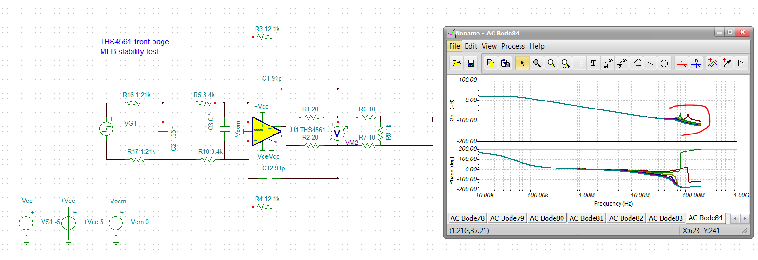
Zooming in and labeling these.
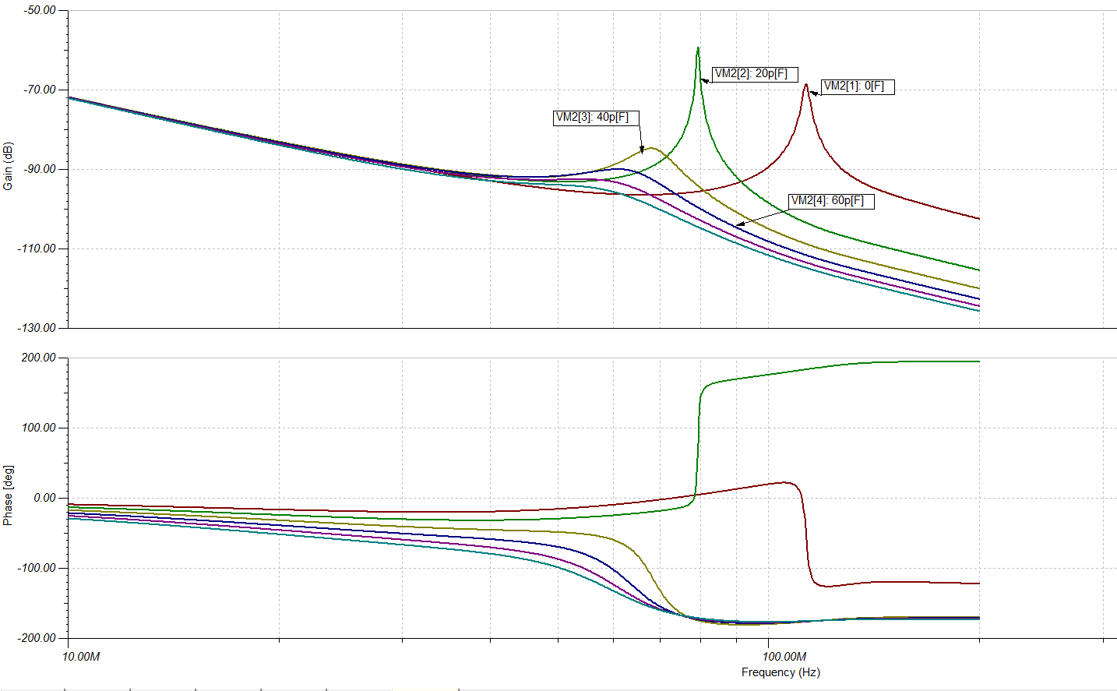

Now repeat this with 0ohms inside the loop, probably will not work, Actually has a region where is looks ok, but I prefer the R being there as well.
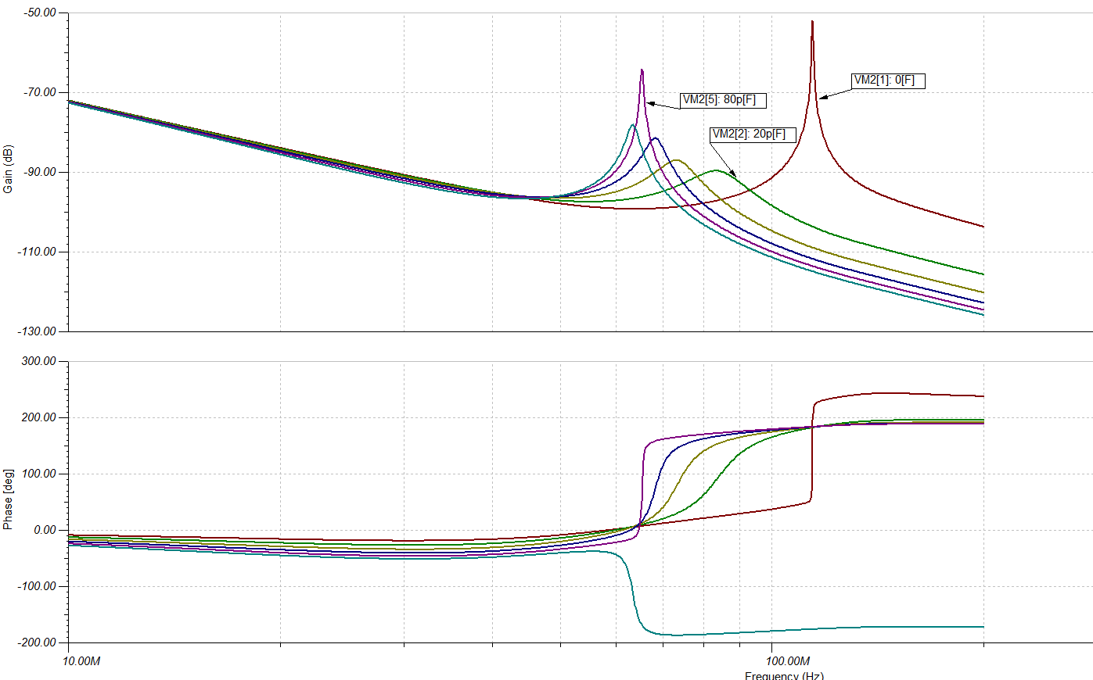

Now lets update this design to lower noise and adequate phase margin. To limit the loading looking in, keep each input resistor >350ohm. Also, plan on some diff input C that will be part of the RC filter solutions. So the updated filter values are shown, where I am sweeping the diff input C from 0 to 300pF,
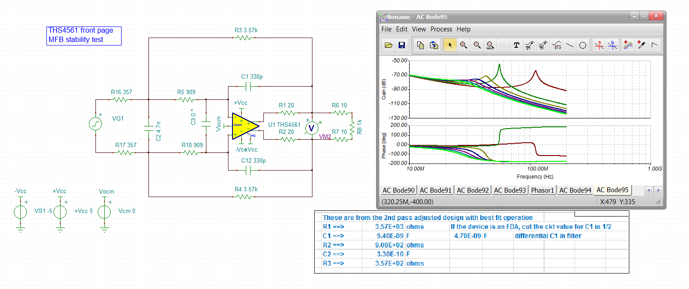
Zooming in on the response curves shows 150pF across the inputs is adequate, 0pF is not. You want to use as low a diff input C as possible to limit SNR degradation.
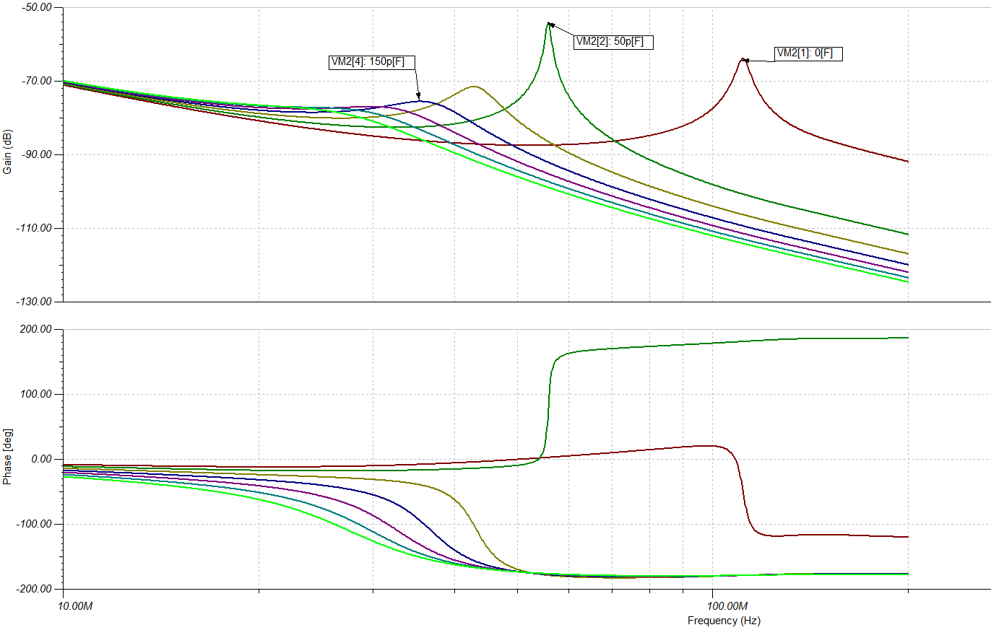

Now checking phase margin for the proposed design, looks like about 32deg. This will change with different loading, but hopefully not much
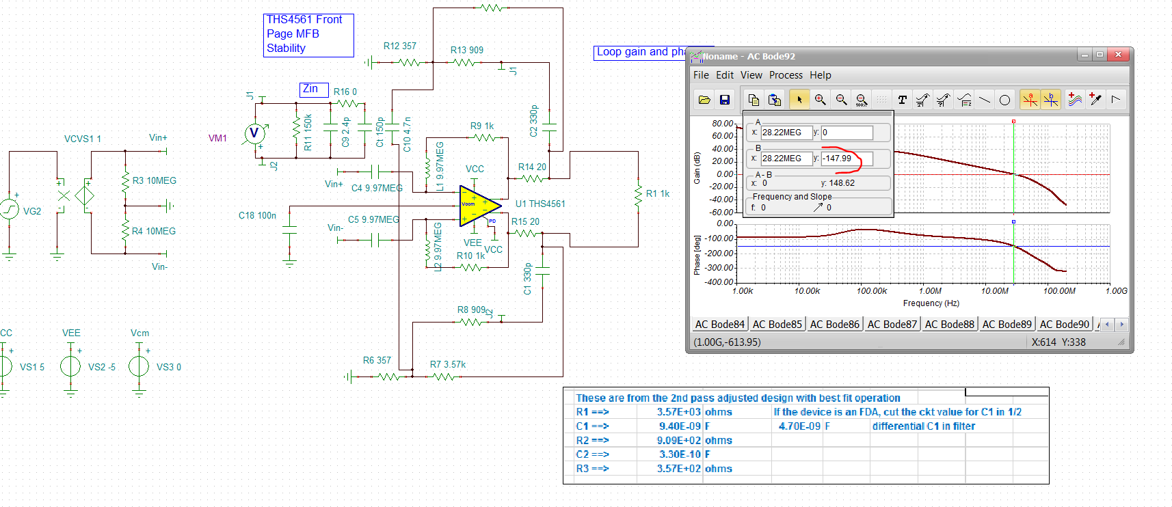
Just to be sure, go to open load then an RC load to see how robust this is. At 100kohm load, goes down to 23deg, still ok actually,
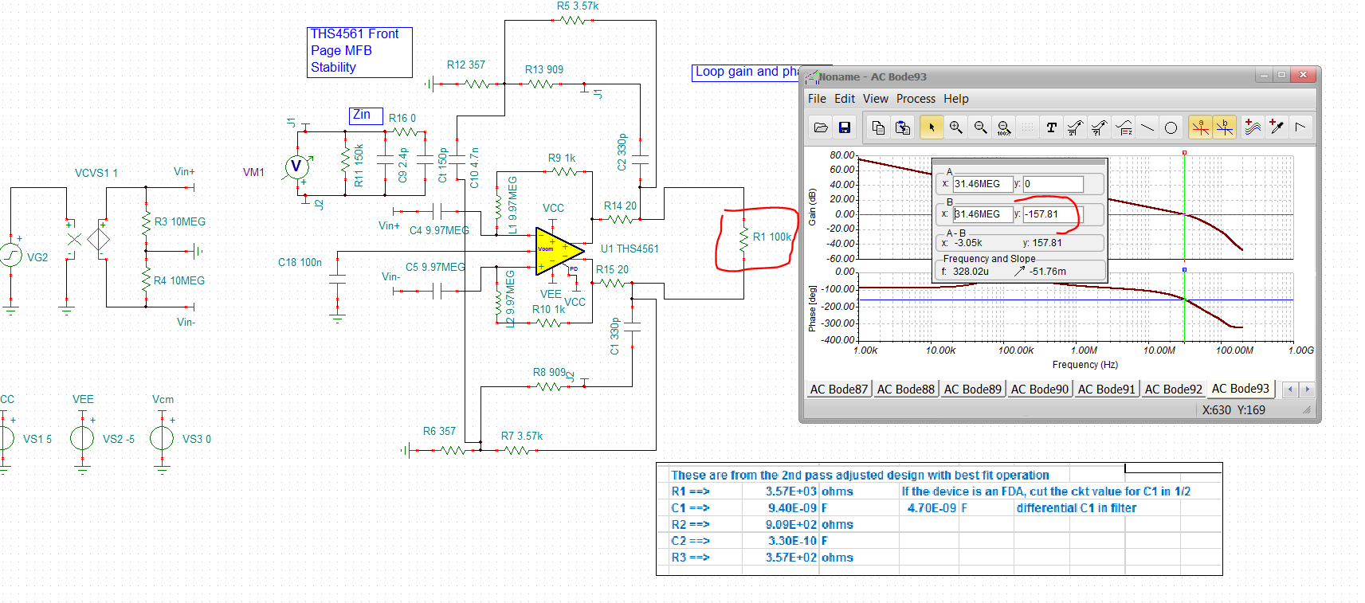
An RC load pulls the crossover way back with Zol effect, actually the improves the phase margin quite a bit.
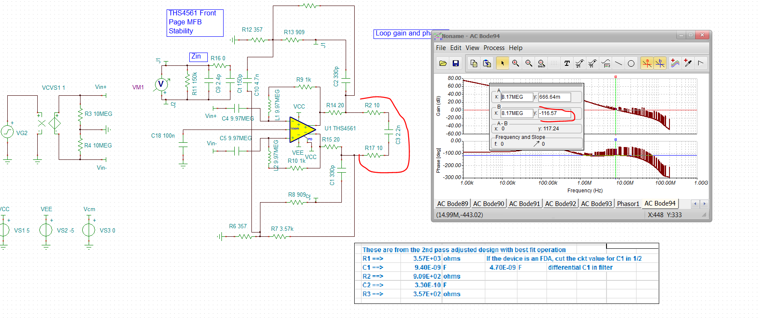
And then going back to where the 50kHz cutoff is supposed to be closed loop with 150pF diff input C, pretty much right on 20dB DC gain and 50.27kHz F-3dB
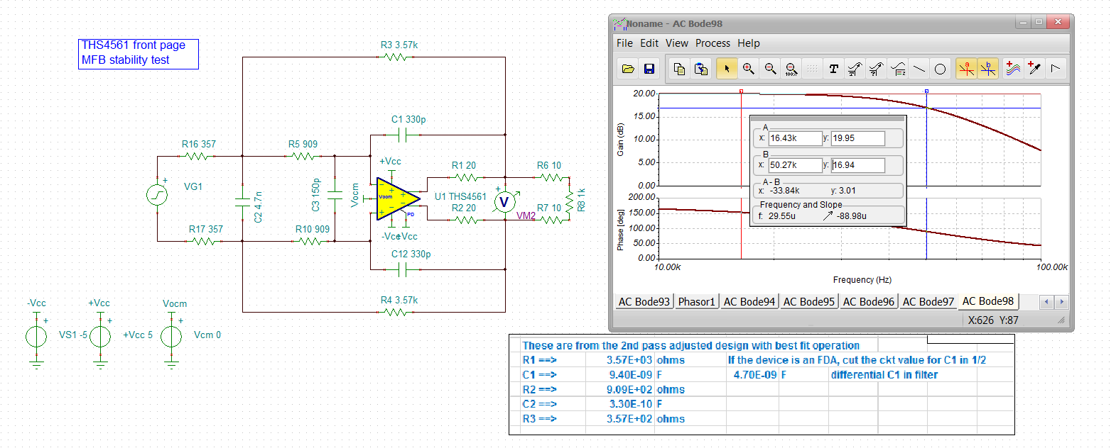
It turns out, it is easy to run monte carlo with the purchase version of TINA, here that is with the R’s at 1% and the C’s at 2% for the filter, but 5% for the diff input C. This is Guassian distribution, 200cases. Here is the -3dB spread around 50kHz, This is really pretty good.
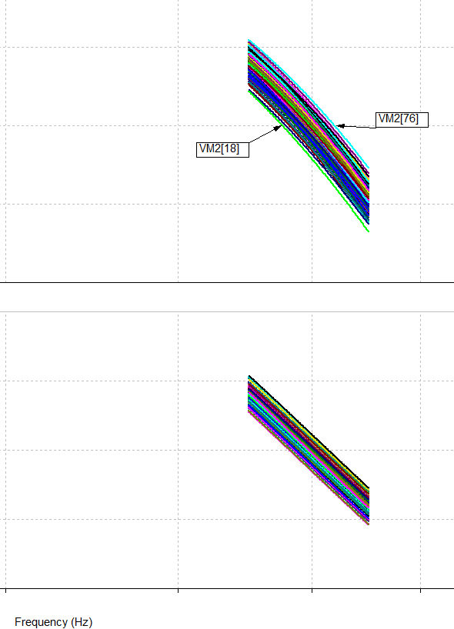

And Finally, as long as I am set up, here is the differential output spot noise. Filters always have some noise peaking around Fo, but here we also see that 32deg phase margin noise peaking out there at 36MHz.
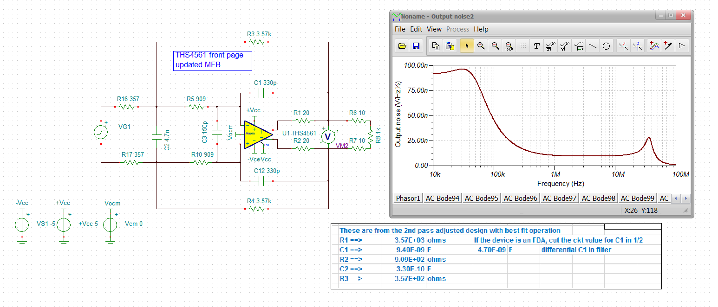
Running an SNR using a 10Vpp max assumption, 3.55Vrms. Not super broadband, but if add a typical RC pole and measure there, it will get a lot better.
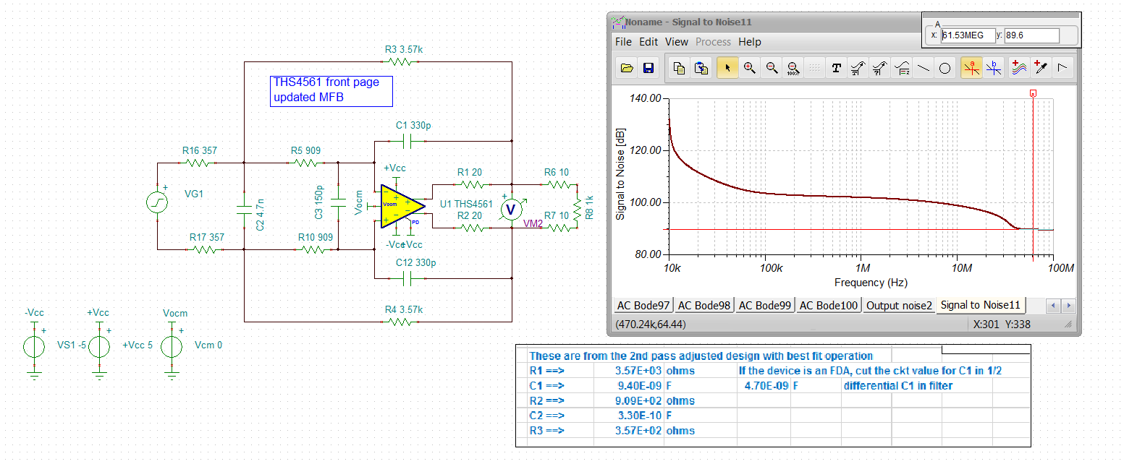
Yea it went from 89 to 100dB SNR.
