- OK TL074CDR output 7.622V NG TL074CDR output 9.215V
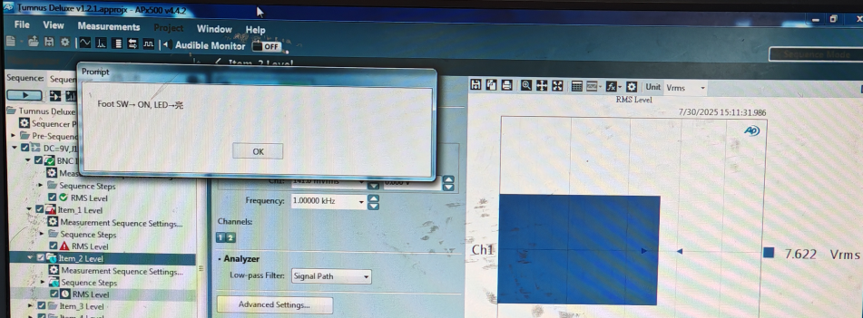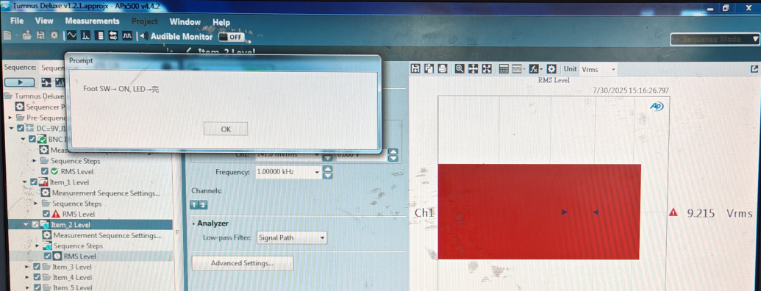
2：OK TL074CDR 054U-TE15RR-00740(TL074CDR)Pin1 NG TL074CDR 054U-TE15RR-00740(TL074CDR)Pin1
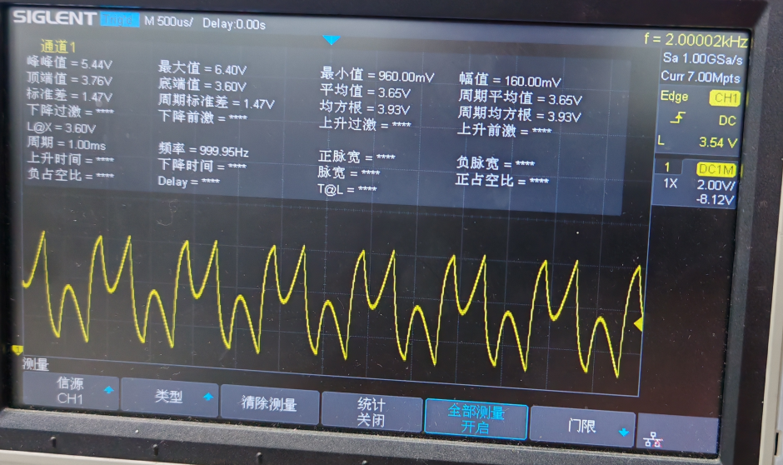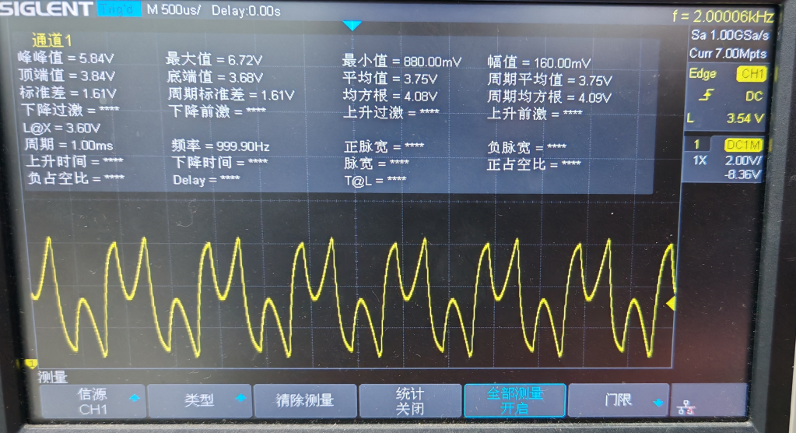

3：OK TL074CDR 054U-TE15RR-00740(TL074CDR)Pin7 NG TL074CDR 054U-TE15RR-00740(TL074CDR)Pin7
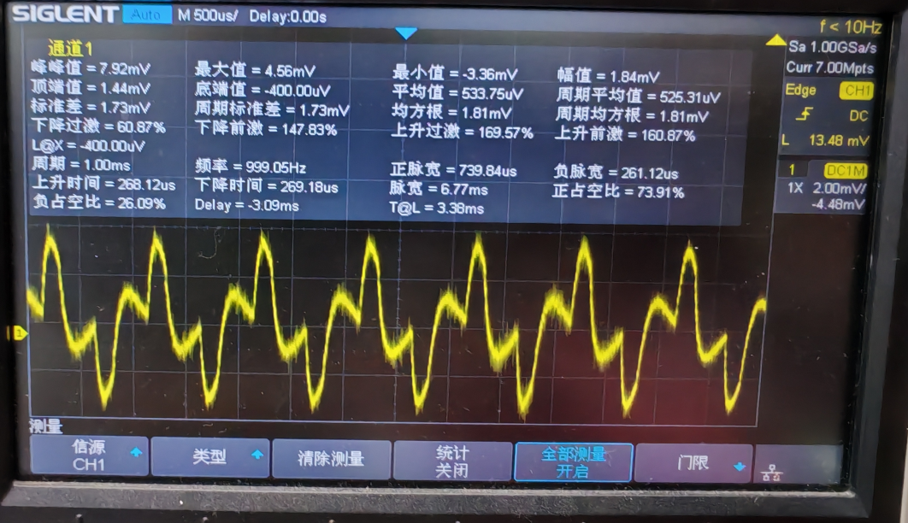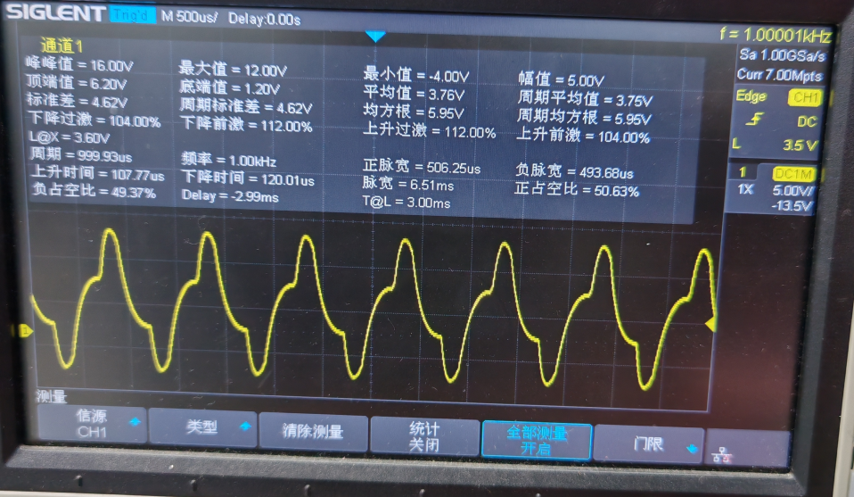
4：OK TL074CDR 054U-TE15RR-00740(TL074CDR)Pin:8 NG TL074CDR 054U-TE15RR-00740(TL074CDR)Pin8
