**Marking for NG unit:**

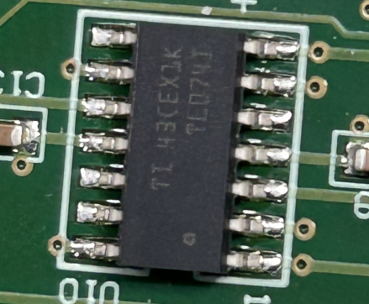

**Circuit Diagram:**

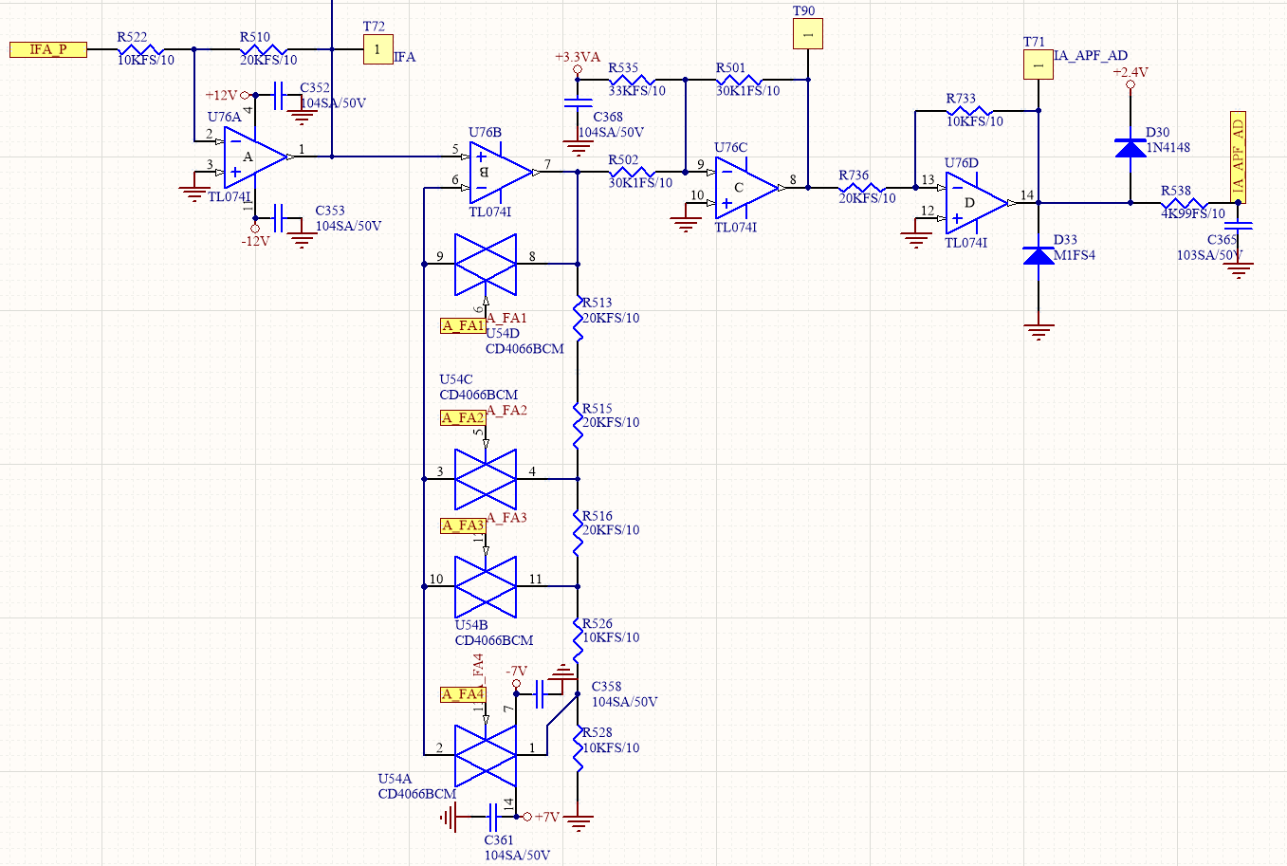

**Waveform Measurement:**

T69 abnormal

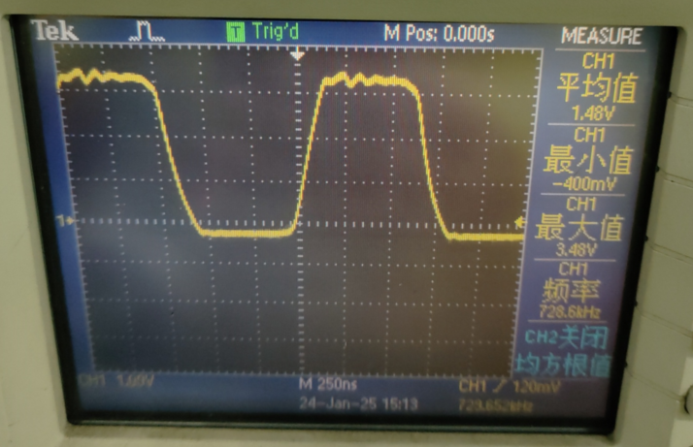

After replacing U108 TL074

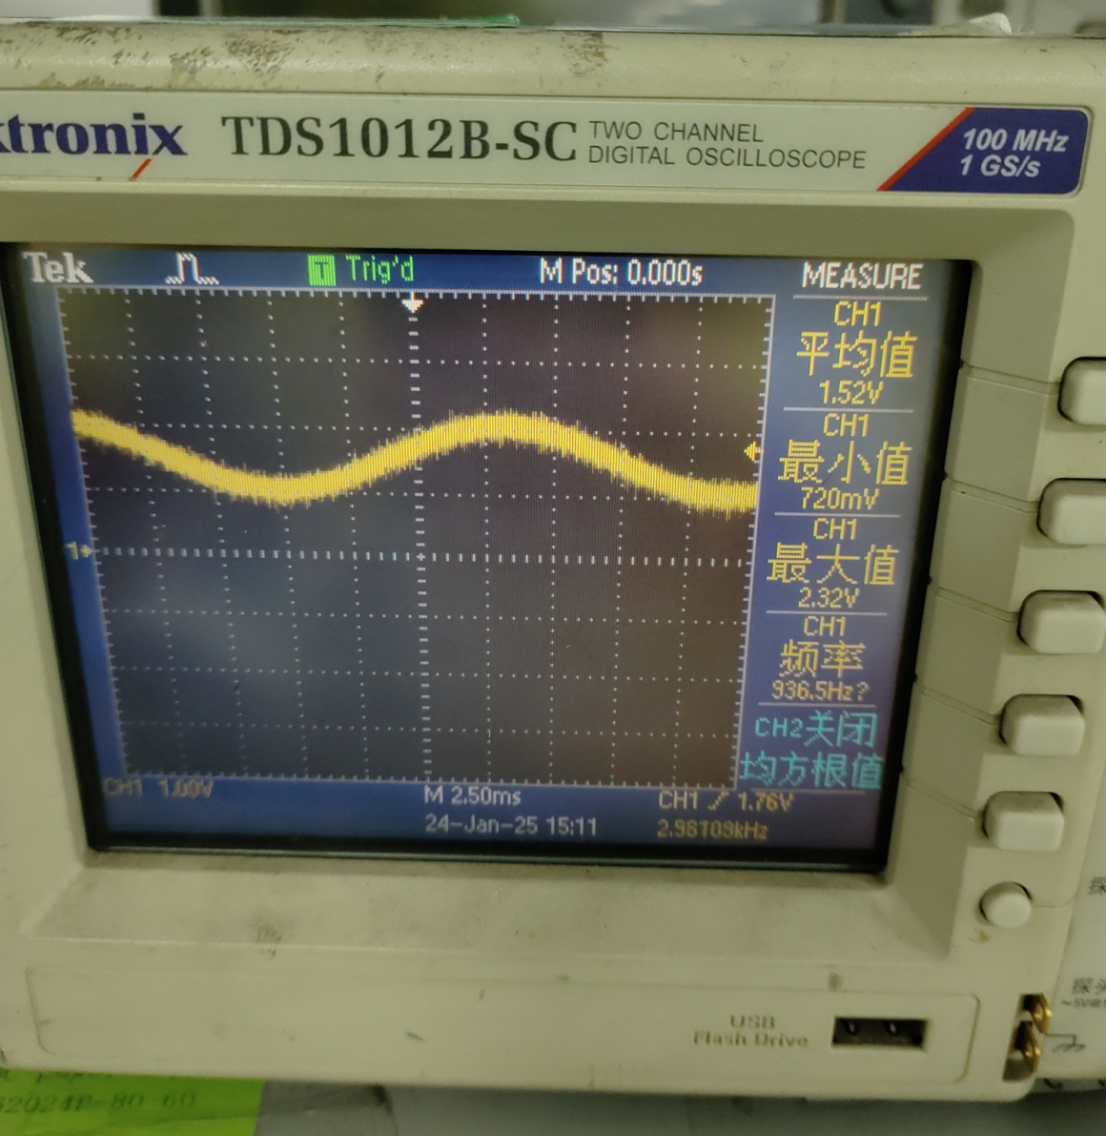

**U54 CD4066 working status when abnormality occurs:**



**TURN ON**

Only U54B is turn on, Others is turn off.