Current Sense resistor location in PV side.
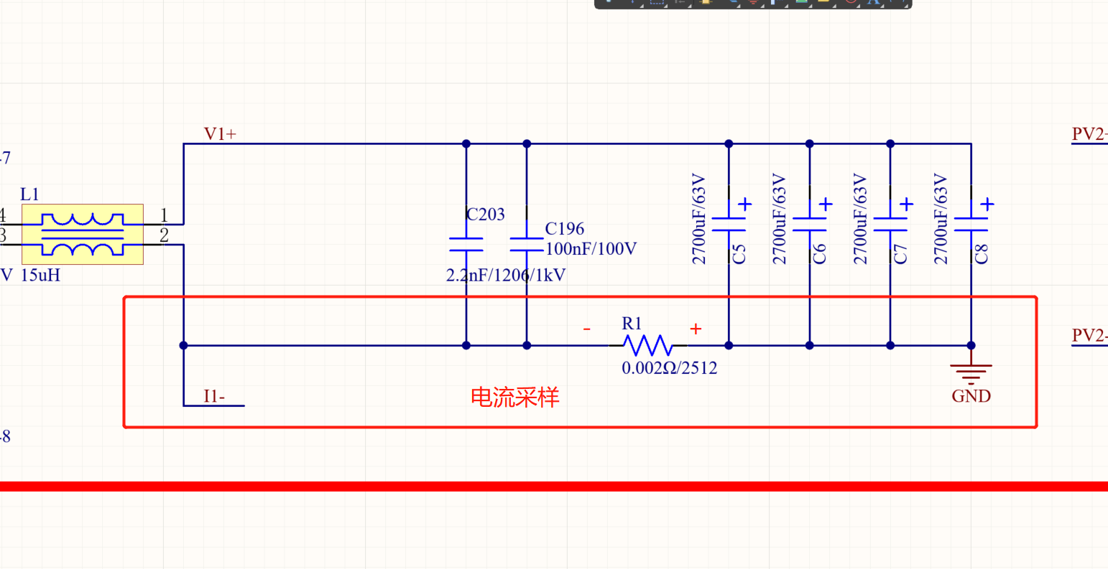
Current Sense- Differential OPA- amplifier factor=62
In static status( without load), the TP18 (output of U13B) is about 0.01Vdc normally.
In suspicious status, the TP18 is 0.5Vdc.
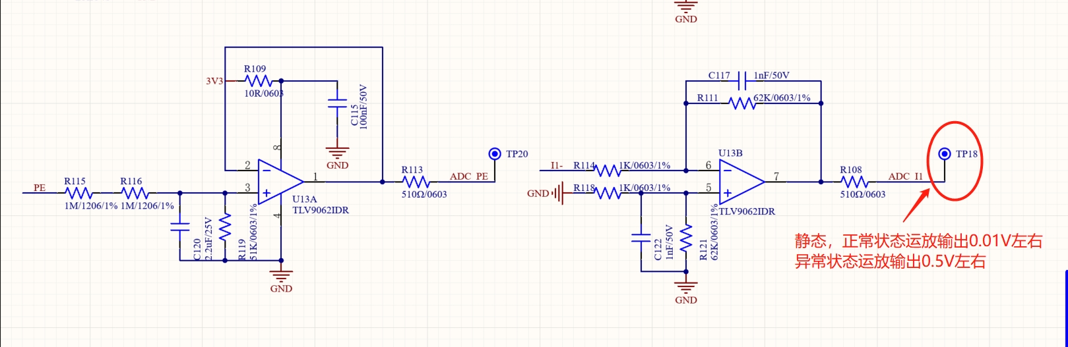
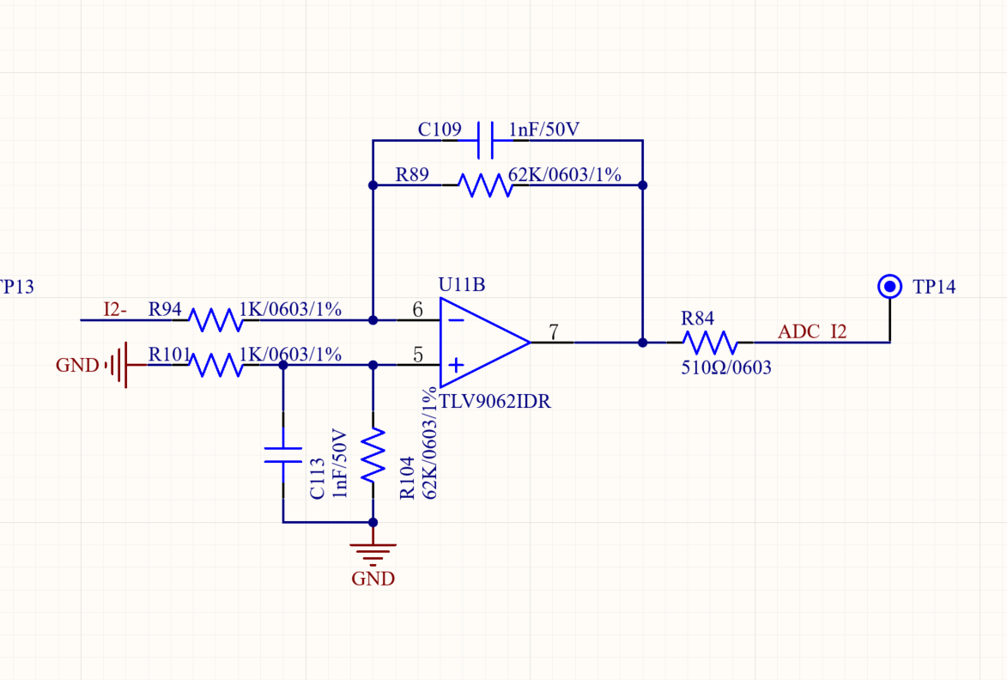

AC line voltate detection- differential OPA
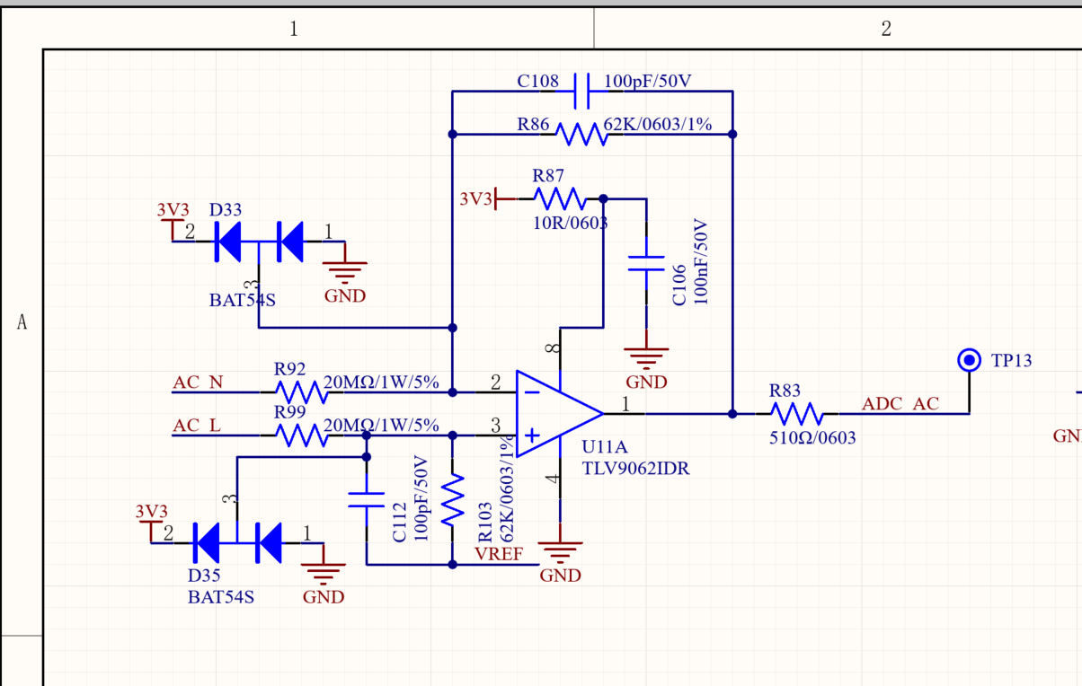

The above two circuits have more anomalies, and they are normal after replacing new devices. We use a multimeter to measure the impedance to the ground at each pins of chip and find no difference. The abnormal problems are basically the same;

