Testing the MFB ckt in the THP210 data sheet, Figure 53 for various things
Michael Steffes, 9/5/2020
I had these files set up to test the THS4561 front page ckt, just adapted them to this new PA FDA,
Phase margin is good, right around 52deg,
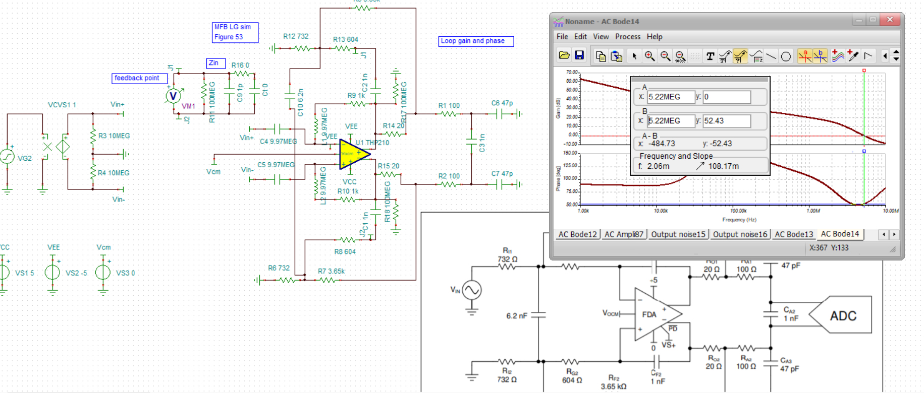
If I move the feedback cap outside those 20ohm (that helped a lot for the THS4561), we get,
Actually just a little worse, 51deg so no benefit here,
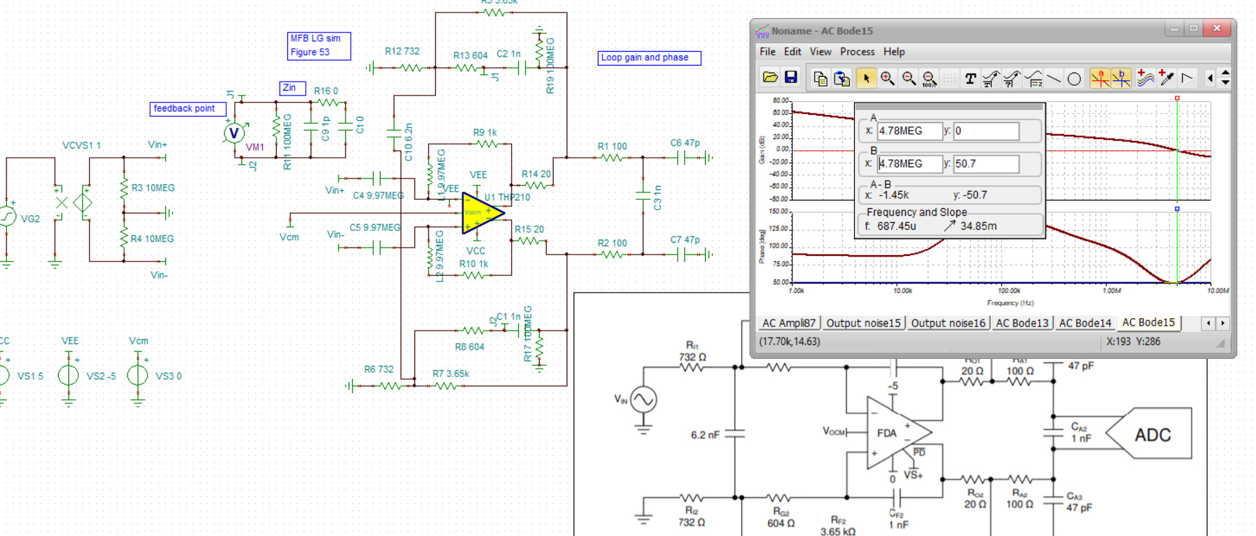
Now back to the closed loop ckt.

Here is the response curve, that little flattening aroud 5MHz is the LG crossover peaking slightly, 30.58kHz cutoff
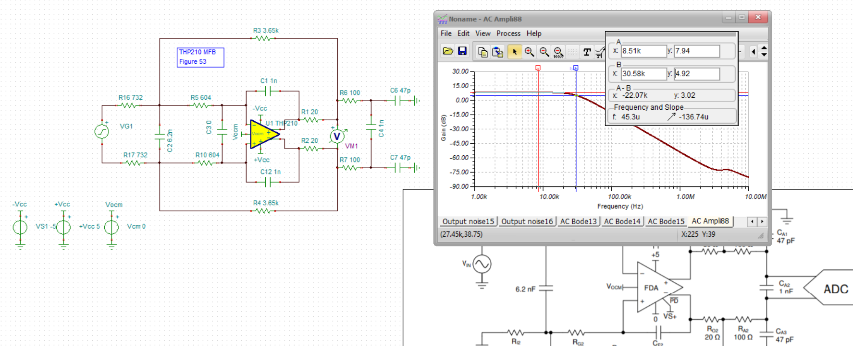
Looks good, lets try an SNR using say 9Vpp max into a SAR, or 3.18Vrms for the SNR sim
108dB SNR is really good,
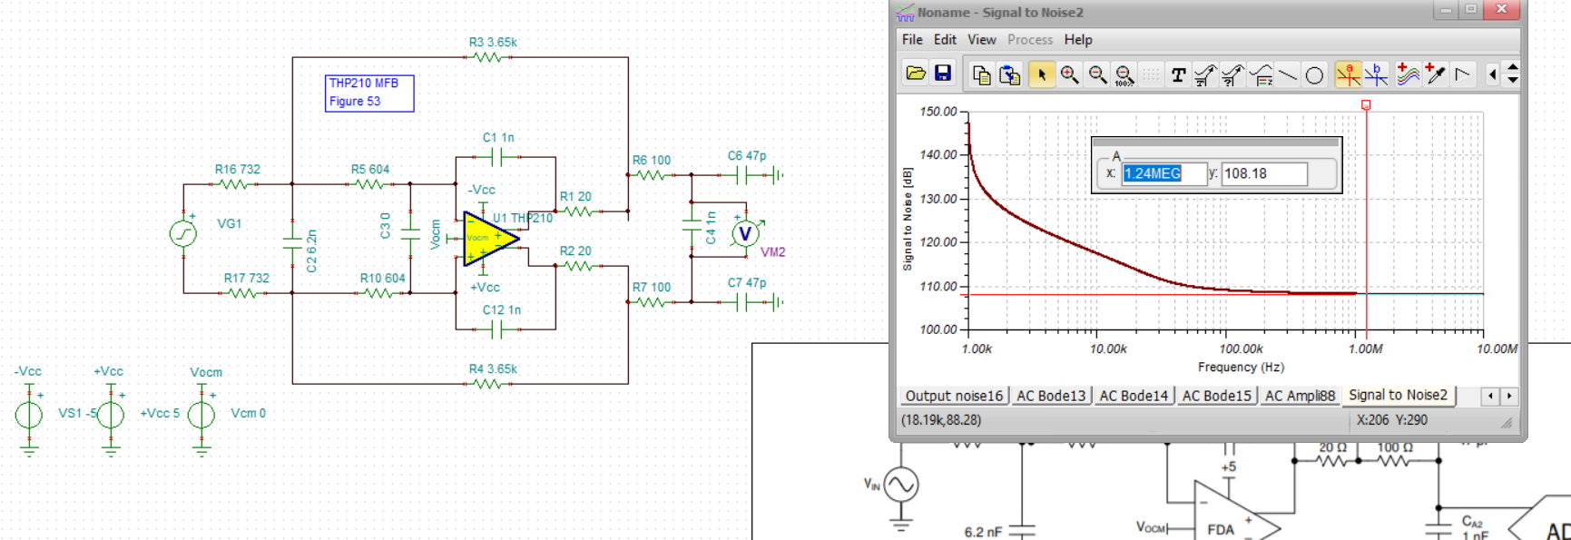
Alright, so lets dig under the covers of the MFB design, Here is what this filter is producing, So the nominal F-3dB is a little higher than 30kHz. Pretty close to flat,
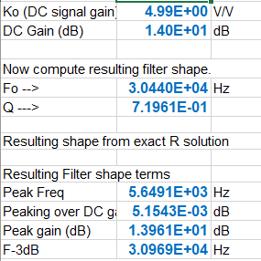
And then plotting the NG on the Aol to get the LG, this 33dB min is pretty good,
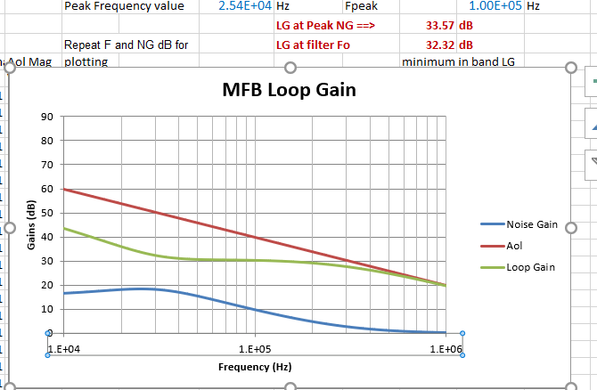
Now let’s rerun the design trying to slightly reduce the NG peaking,
Here I was trying to hold the sum of the two input resistors about the same, about a 0.4dB degradation in SNR, not much
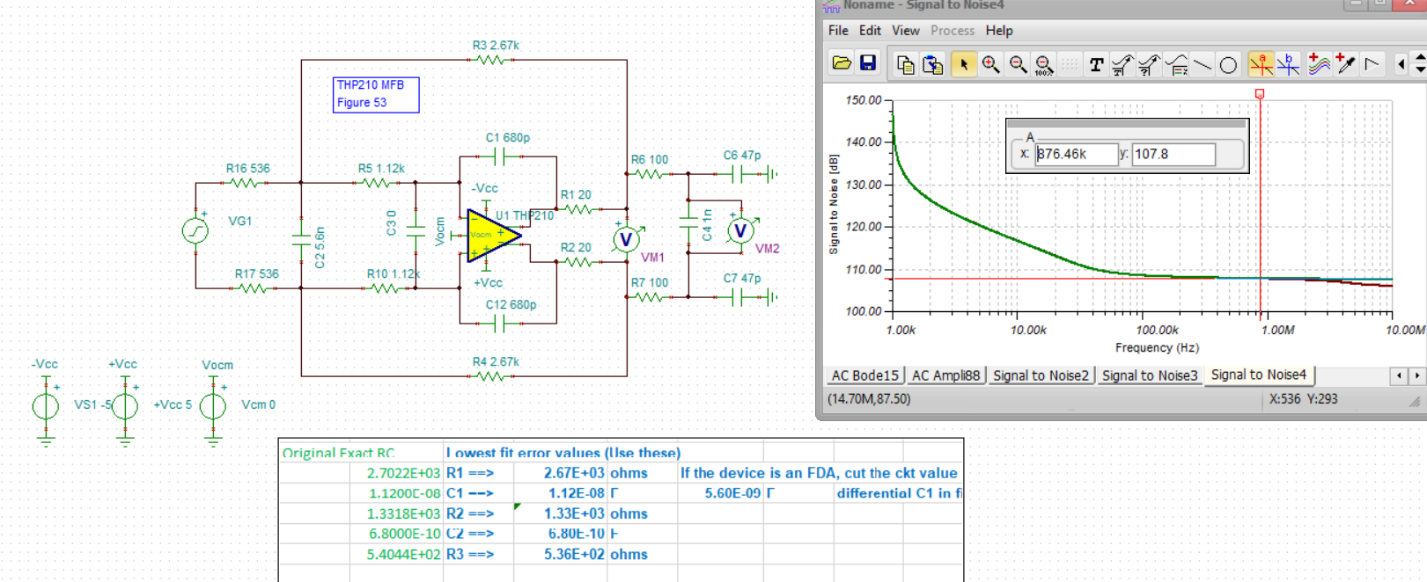
And then the LG plot did get a little better,

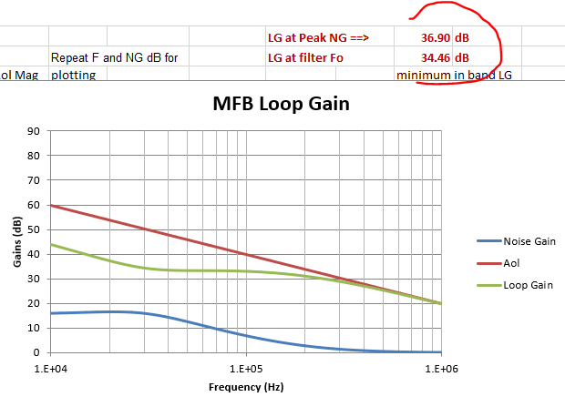
Got about 2 to 3dB better, should feed straight into slightly improved HD up towards the cuttoff F.
Not much difference but free LG improvement with the same filter shape, little higher cutoff, not sure why
