E2E Forum Questions:
Question 1:
When injecting a signal into power line using AFE031 and a coupling circuit, the output of the power amplifier reduces to 3Vpp from 6Vpp (after LVCAP ). The transformer used is 1:1 ferrite cored having primary and secondary inductance of 300uH.
When tried to drive a inductive or resistive load directly from output of power amplifier, the amplifier is driving the current in order to maintain the voltage. But why is it not driving the current into power line?
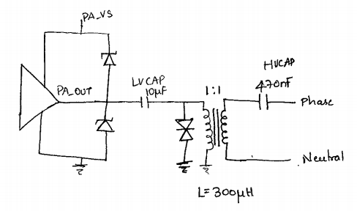
PLC Transformer Specification Information:
https://www.we-online.com/web/en/passive_components_custom_magnetics/products_pbcm/product_spotlight/texasinstruments_750510476.php
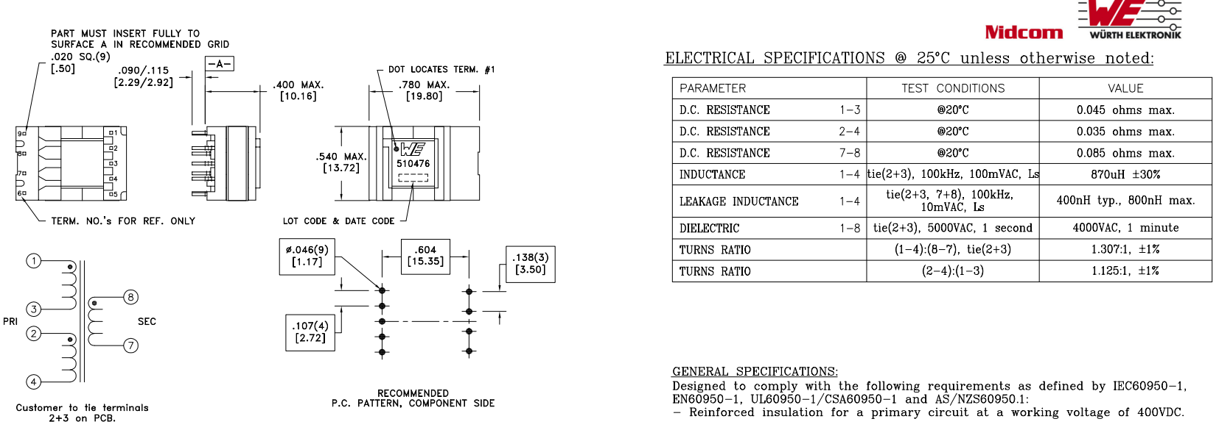

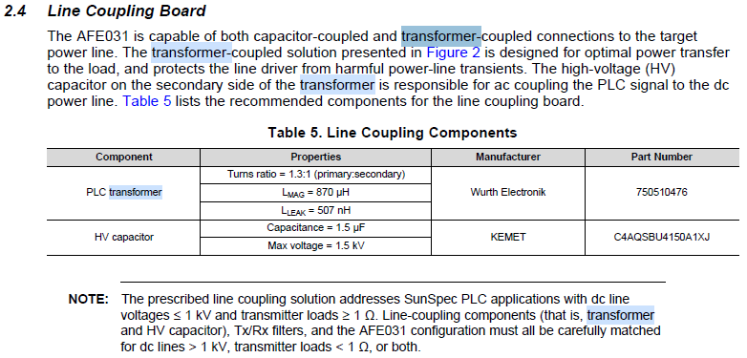
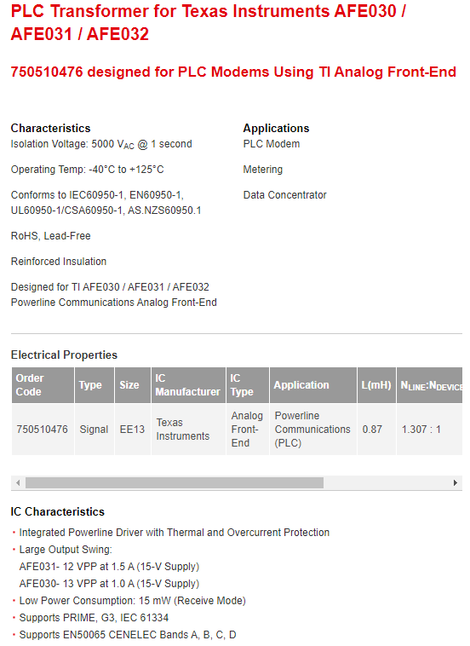
I am listing the PLC transformer specification from the application note. Since you have customized magnetic design (Ferrite core) in the transformer, I will assume that you know what you are doing. The transformer does not work with DC power, since the magnetic core will be resulted in core saturation.
I assumed that your transformer coupling and losses are optimized. Per AFE03x PLC Transformer, here is what is specified in Application Note:
Primary: Secondary coils: 2 primary windings: 1 secondary winding, Turns Ratio 1307:1000 (pin 1-4, tie 2-3): (pin 8-7)
Turns Ratio: (pin 2-4) : (pin 1-3) = 1125: 1000 with $R=$0.045Ω (Pin 1-3), $R=$0.035Ω (Pin 2-4) and $R=$0.085Ω (Pin 7-8)
This particular transformer is designed for the AFE03x’s application note with ${12V}_{pp} at 1.5A$ for AFE031.
Answer to your questions:
AC Line 50Hz, $I_{PLC_load}<50mA$ , LVCAP$=10μF,$ Tx communication frequency 135kHz - 145kHz
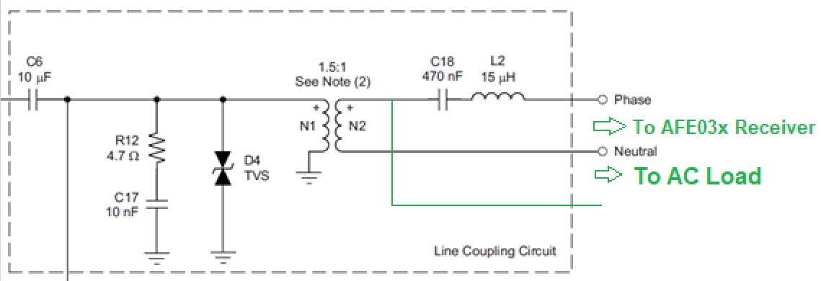
The above schematic is the AC line coupling circuit for AFE03x. When PA’s output is connected to C6, 10uF capacitor, its signals consists of DC and AC components. C6 or 10uF is used to block DC, and pass the AC signal or transmitting PLC communication frequency. In terms of impedances, here is the calculation.
Near low frequency, say 100Hz, $Z_{100Hz}=$ $\frac{1}{sC}=\frac{1}{2πfC}=\frac{1}{2π∙100∙10×{10}^{-6}}$ $=15.9Ω$
Near PLC communication frequency, say 140kHz, $Z_{140kHz}=$ $\frac{1}{sC}=\frac{1}{2πfC}=\frac{1}{2π∙140×{10}^{3}∙10×{10}^{-6}}$ $=0.114Ω$
So if you measure the voltage from peak to peak after LVCAP, the voltage swing will be reduced due to voltage divider (LVCAP and Impedance of Transformer), since the scope measurements consist of both DC and AC signals. If you look at the signal strength with spectrum analyzer, say at 140kHz, there should be very little IR losses across the LVCAP.
In addition, PLC transformer has two input windings. One winding is to couple AC transmission signals into the AC power line. Other winding is to couple AC power line (50Hz in your case) to the secondary. This is why C18 has to be HVCAP.
The above Line Coupling Circuit is only shown how PLC communication should be configured. The HVCAP in above schematic is shown 470nF in value. At 50Hz, the impedance value of 470nF will be 6.77kΩ; 470nF at 140kHz has impedance of 2.42Ω. So 50Hz AC frequency will be mainly dissipated across the HVCAP for PLC communication. Since the PLC communication current is low, the power loss will be relative small.
If you want drive load from the PLC transformer on the secondary winding, you have to get parallel AC line, see the above schematic.
Please remember: input power has to equal to output power $P_{input}=P_{output}$.

Question 2:
We connected a 100 ohms resistive load and then reduced it gradually to 12 ohms. As the load increased, the voltage across the secondary reduced and even the voltage at the primary also reduced slowly.
This issue has to do with the property with transformer. As you may remember, the following equations are from transformer’s primary to secondary.
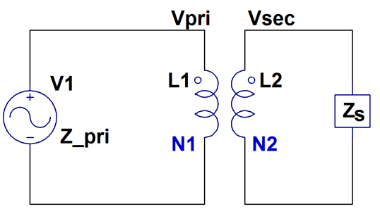

Since $\frac{V_{1}}{V_{2}}= \frac{N_{1}}{N_{2}}$ and $\frac{I_{2}}{I_{1}}= \frac{N_{1}}{N_{2}}$
$\frac{V_{1}}{V_{2}} ∙\frac{I_{2}}{I_{1}}$ = $\frac{N_{1}}{N_{2}}∙\frac{N_{1}}{N_{2}}= {\left(\frac{N_{1}}{N_{2}}\right)}^{2}$
But $\frac{V_{1}}{I_{1}}=$ $Z_{primary}=Z_{pri}$ and $\frac{V_{2}}{I_{2}}=$ $Z_{secondary}= Z_{sec}$
Hence $\frac{Z_{pri}}{Z_{sec}}= {\left(\frac{N_{1}}{N_{2}}\right)}^{2}$ $\boxed{Z_{pri} = {\left(\frac{N_{1}}{N_{2}}\right)}^{2}{∙Z}_{sec}}$
The reflected impedance from secondary to primary is a function of the turns ratio of the transform. The ratio of the primary impedance to the secondary impedance is increased or decreased through turns ratio square.
Per your observation, the changing of output load will affect the input impedance of the transformer through the relationship above ($Z_{pri} ={ Z}_{sec}$, since your N1:N2=1:1). Since you change the load at transformer’s secondary winding, it will change the PA’s voltage swing at the primary.

