A 1 kHz, 18 mV differential signal from a signal generator is currently applied to MIC1+ and MIC1-. The supply voltage VDD is set to 3.3 V with SD=VDD. The MODE is set to "MIC 1 ON", and Mute is set to "MIC 2 mute".
The signal generator is connected across R1 (M1+) and R5 (M1-). The MIC_BIAS potential is currently 1.96 V, and VDD is independently powered by an external power supply at 3.3 V. The measured voltages at MIC_P and MIC_N are 0.98 V.
The measured waveforms are shown below:
- In AC mode, with Pre-amp = 36 dB and Post-amp = 18 dB, CH1 / CH2 / CH3 are: MIC+ / OUT+ / OUT-.
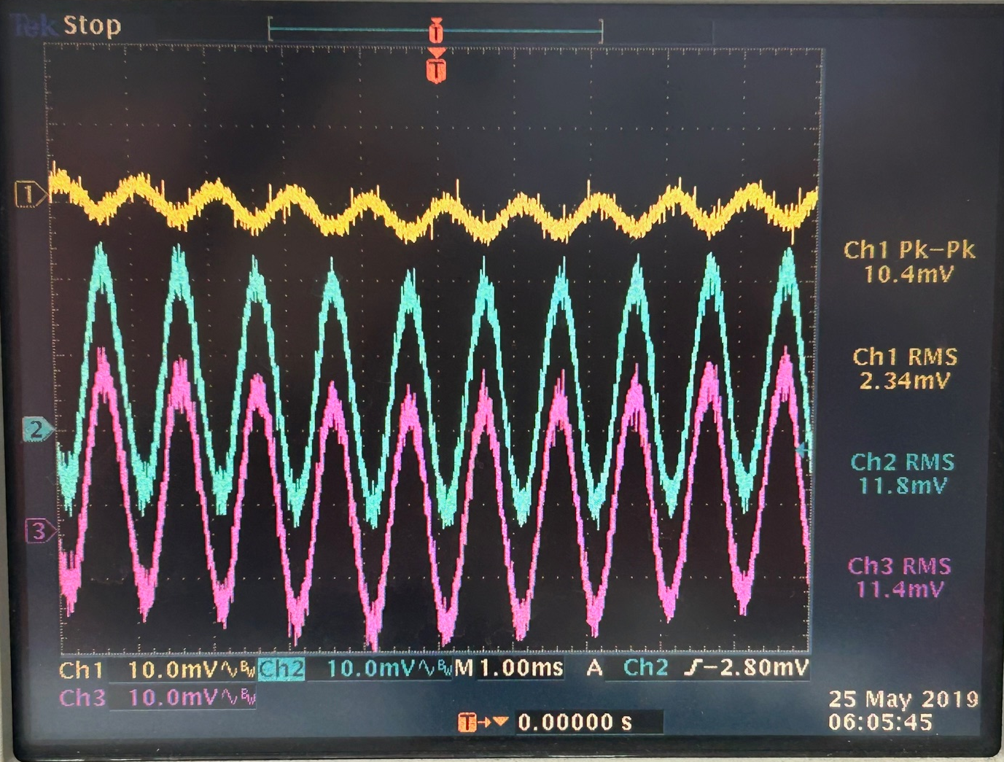

2. DC mode，Pre-amp=36dB,Post-amp=18dB，CH1/CH2/CH3: MIC+/OUT+/OUT-
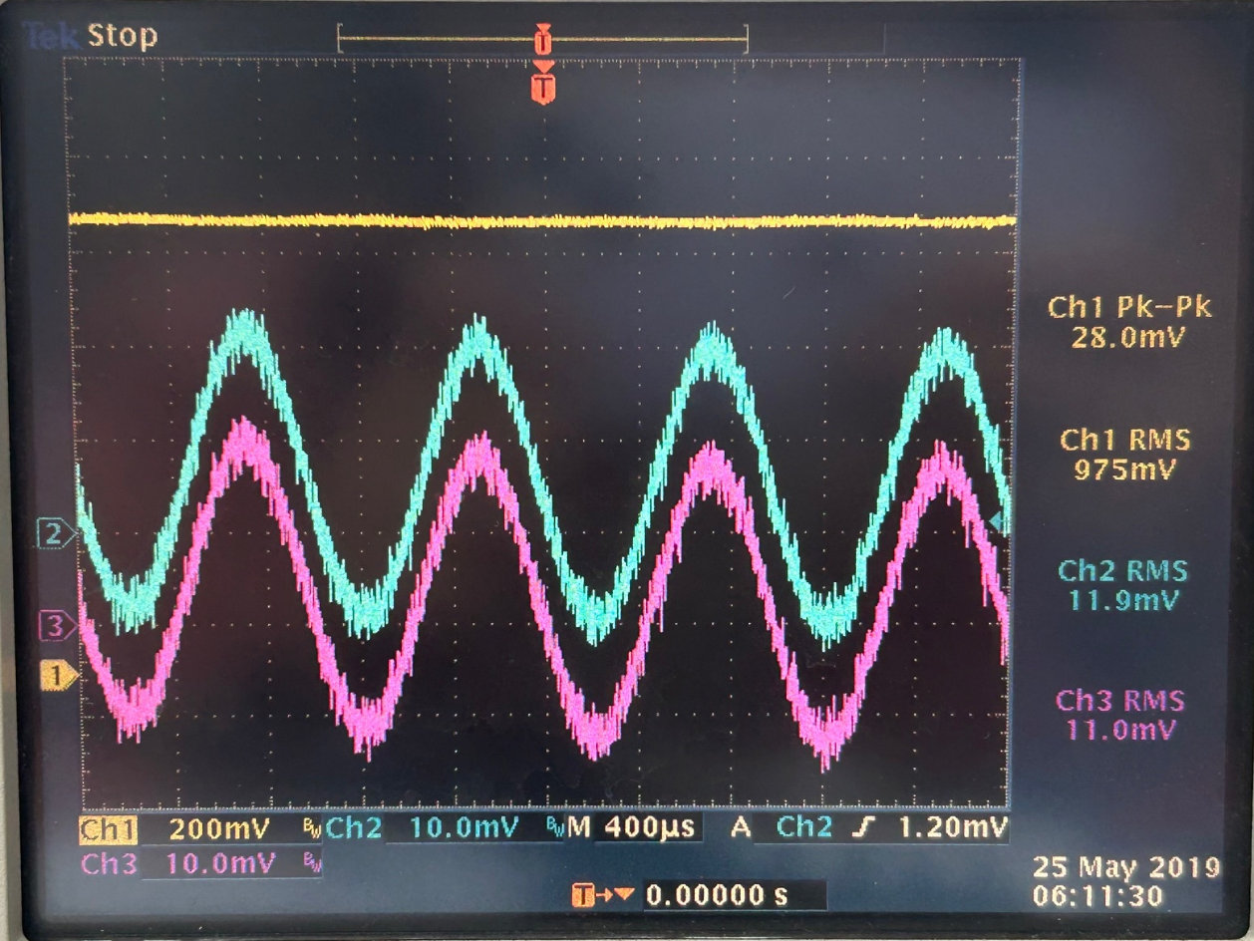
Even with the pre-amp set to 36 dB, there is still no signal amplification.
Could you please help check what the potential issue might be? I look forward to your reply. Thank you!
Additionally, attached below is the block diagram showing how the signal generator is connected to the circuit:



