We have grounded the front-end capacitors (C7 & C8) of Mic2+ and Mic2-, and set MODE1 = 0 and MODE0 = 1, but the pre-amplifier still fails to amplify properly. GA0-GA3 and GB0-GB2 are 3.3V (=VDD), when set to HIGH= 3.3V and set to LOW=0V. Currently, we are using a signal generator to supply a 1kHz, 18mV differential signal to MIC1+ and MIC1-, with VDD supplied at 3.3V and SD = VDD."
Below waveform still function fail
1. AC mode，Pre-amp=36dB,Post-amp=18dB，CH1/CH2/CH3: MIC+/OUT+/OUT-
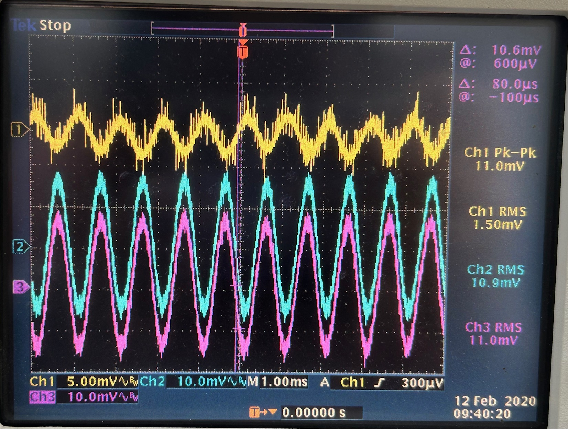

2. In AC mode，Pre-amp=6dB,Post-amp=18dB，CH1/CH2/CH3: MIC+/OUT+/OUT-
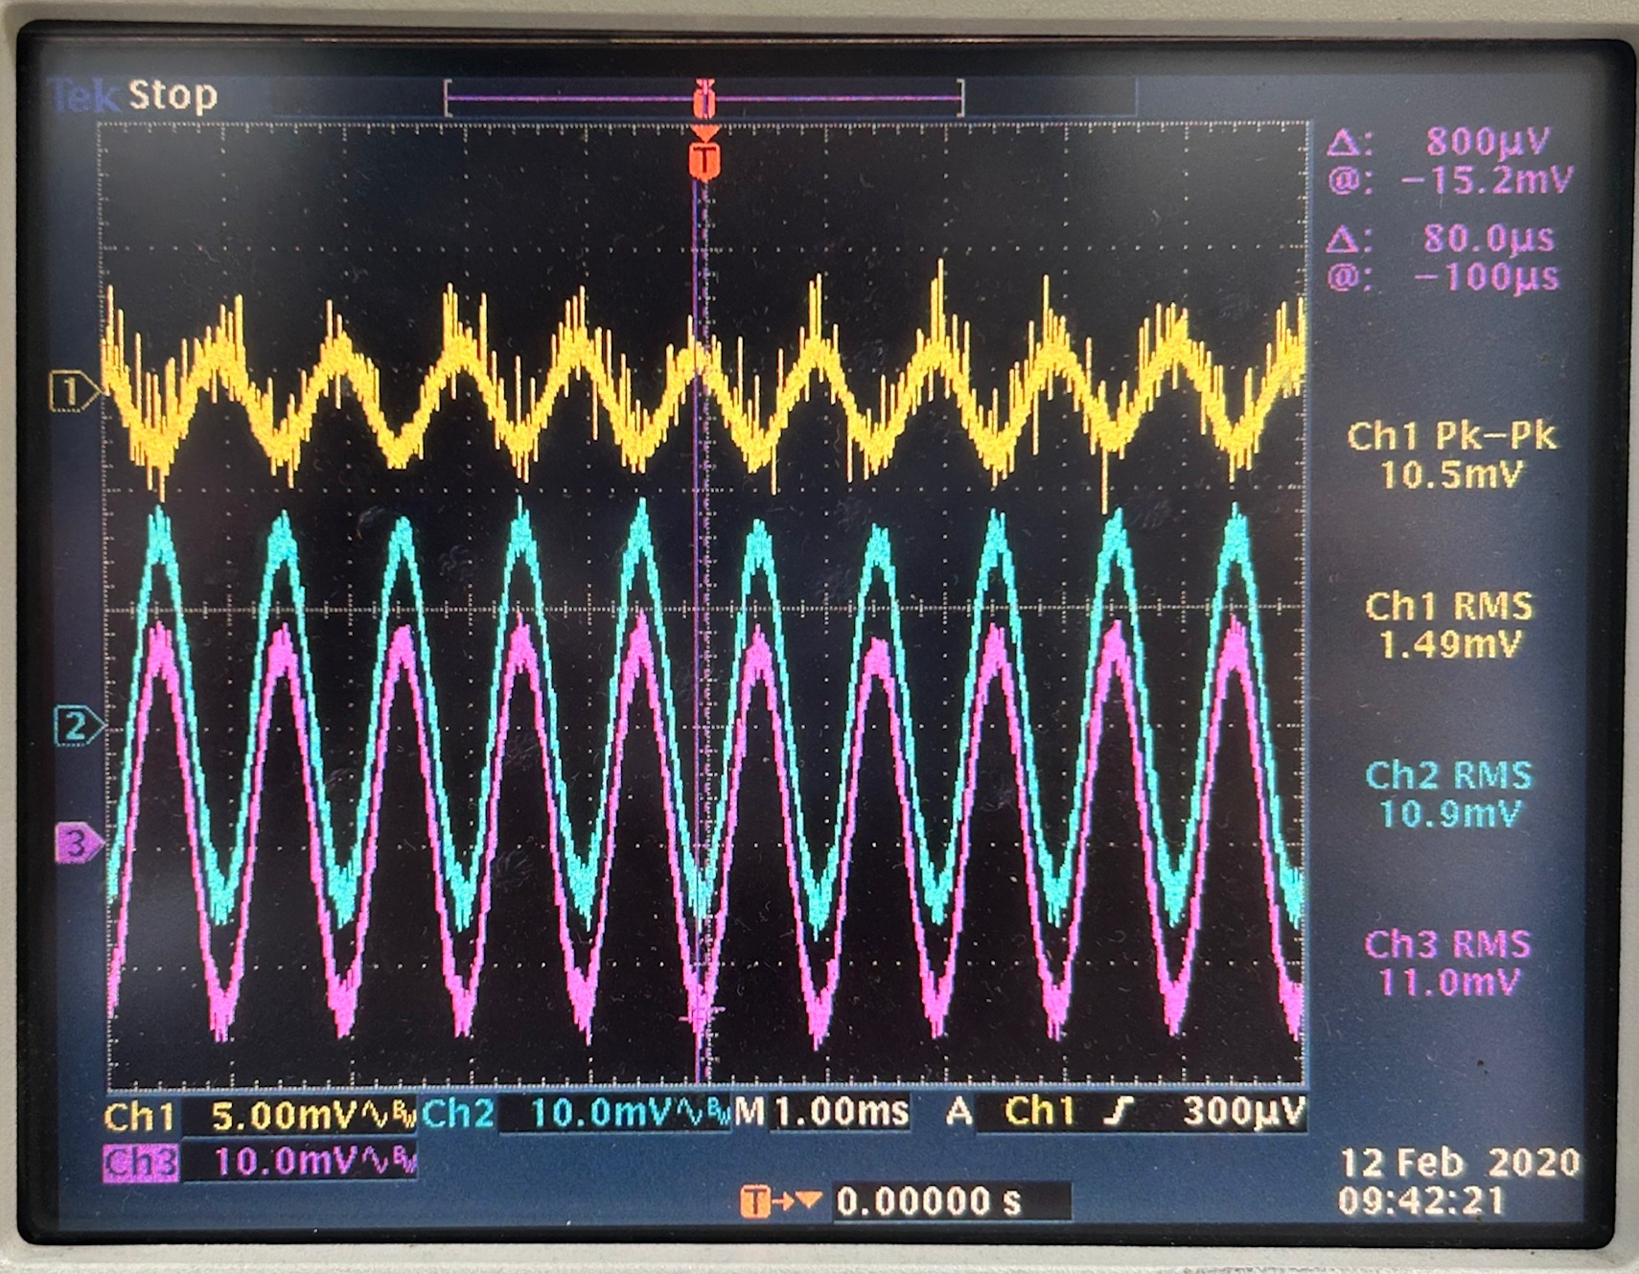

3. in AC mode，Pre-amp=36dB,Post-amp=6dB，CH1/CH2/CH3: MIC+/OUT+/OUT-
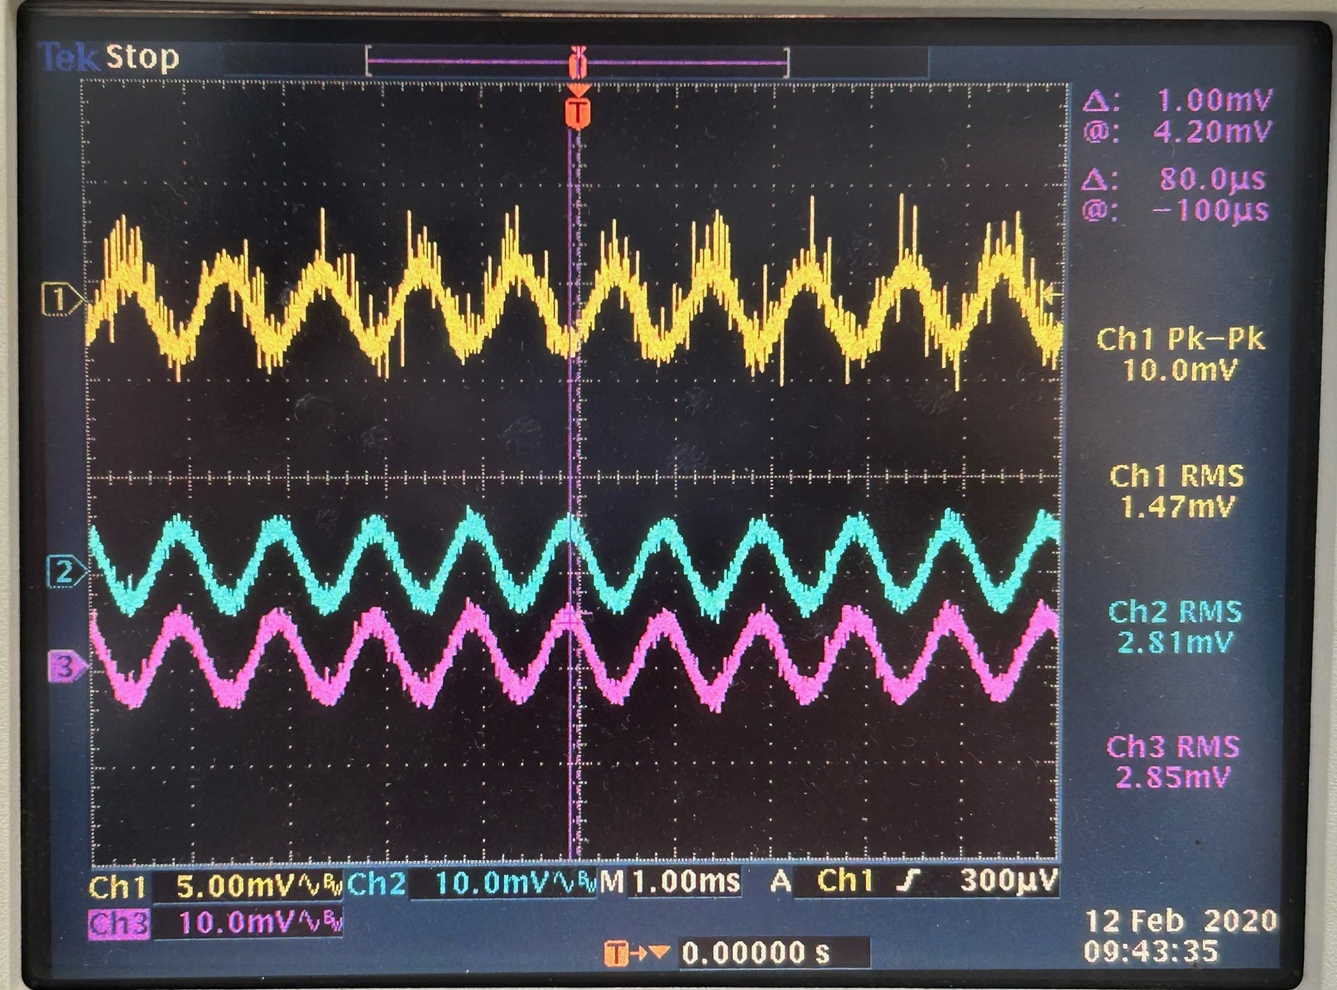

4. in AC Mode，Pre-amp=6dB,Post-amp=6dB，CH1/CH2/CH3: MIC+/OUT+/OUT-
