Currently supplying a 1 kHz, 18 mV differential signal to MIC1+ and MIC1- using a signal generator. VDD is maintained at 3.3V, SD = VDD, MODE is set to MIC 1 ON, and Mute is set to Mic 2 mute (as there is no signal when both Mic 1 and Mic 2 are muted)如
1. Pre-amp=20dB,Post-amp=6dB，CH1/CH2/CH3: MIC+/OUT+/OUT-
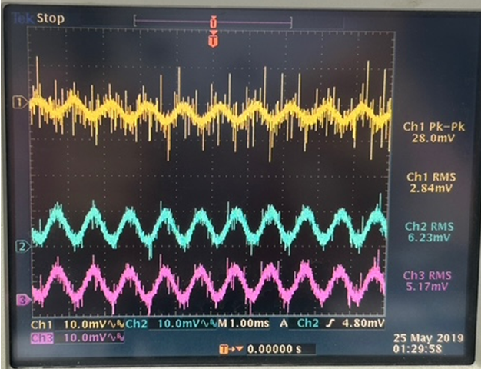

2. Pre-amp=6dB,Post-amp=6dB，CH1/CH2/CH3: MIC+/OUT+/OUT-
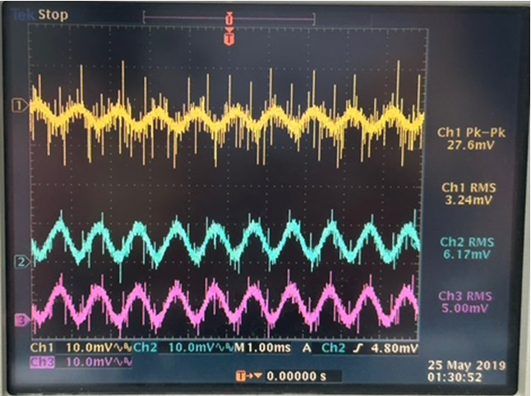

3. Pre-amp=36dB,Post-amp=6dB，CH1/CH2/CH3: MIC+/OUT+/OUT-
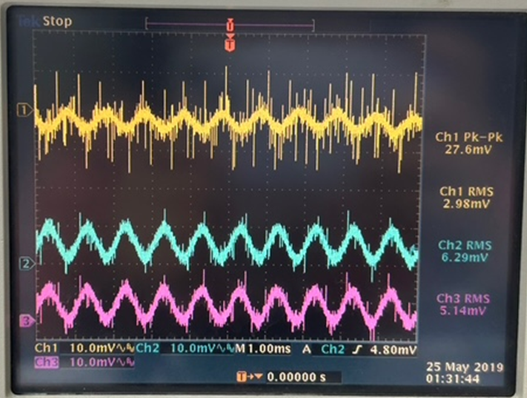

4. Pre-amp=36dB,Post-amp=18dB，CH1/CH2/CH3: MIC+/OUT+/OUT-
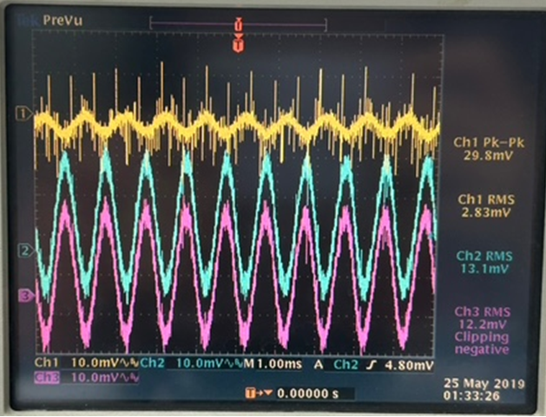

5. Pre-amp=6dB,Post-amp=18dB，CH1/CH2/CH3: MIC+/OUT+/OUT-
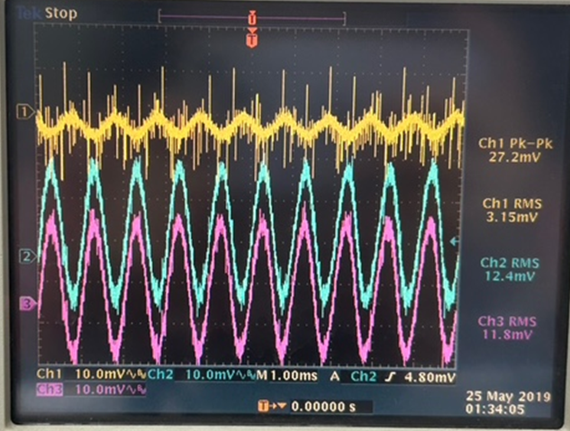

6. Pre-amp=20dB,Post-amp=18dB，CH1/CH2/CH3: MIC+/OUT+/OUT-
