1st check the AC response, since the output amplifier is a CFA, that 4.7kohm is way to high, will bandlimit badly, And, that output DC is at 151mV nominal,
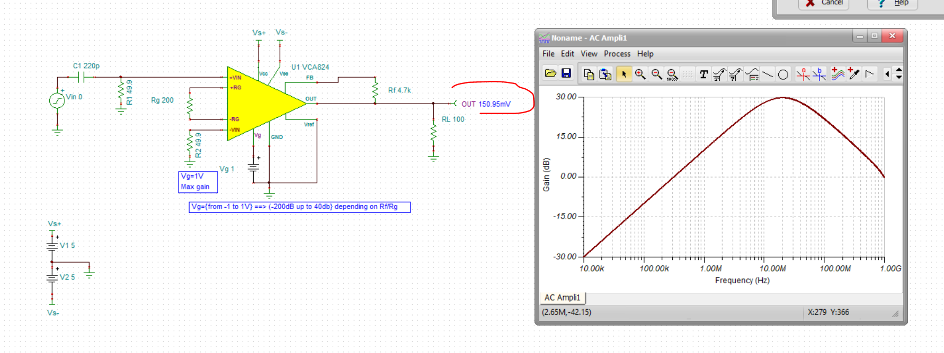
Fix the bandwidth problem first, Can’t make the Rg resistor too low or the buffers will bandlimit at the input, but here it got better and the output offset shifted a lot – this is the inverting current error at the output CFA op amp having less gain with the much lower Rf,
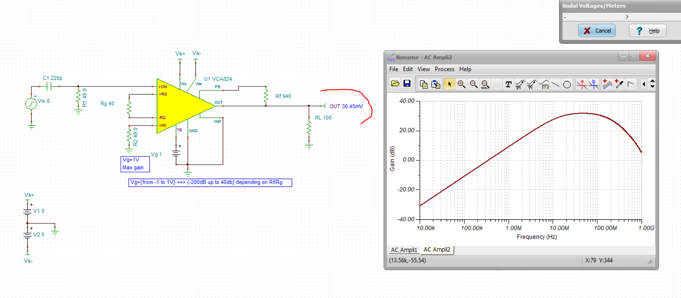
Now, since the path is AC coupled anyway, lets add a servo op amp to set the output at 0V (but could be a reference voltage also). I just picked a low cost >10V max supply op amp, the model is a dual part number but if you only need a single use the TLV9151 or something like it – unity gain stable
And yes, here the output DC is servo’ld below 1mV error – you could just apply a target output DC level at the V+ input of this op amp if need be.
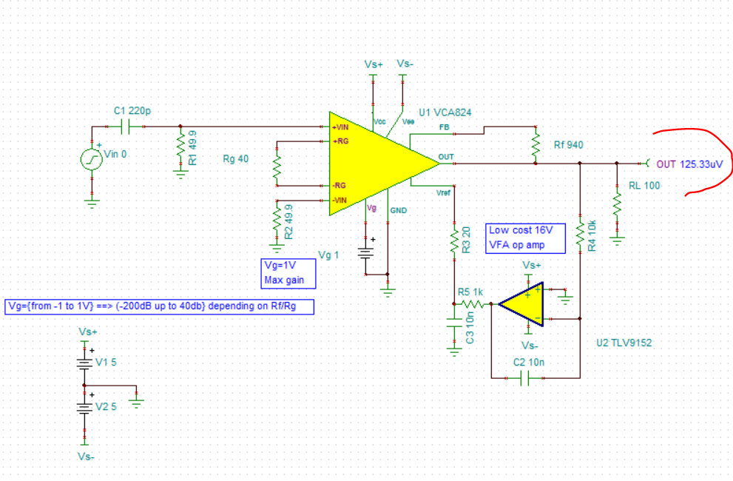
Always interested in the noise, here that is,
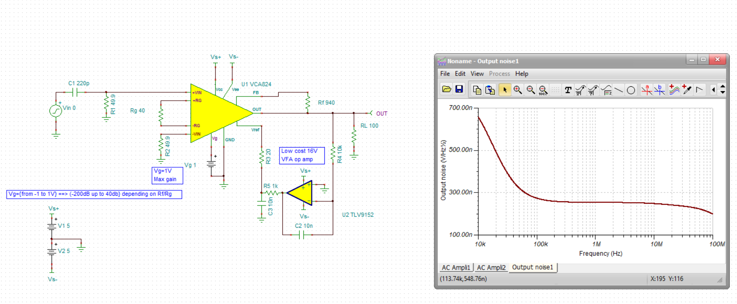
The high pass is being set by the input cap, but the servo is also a high pass, let’s short that input cap and show that, so that servo is gone by about 10kHz,
