Waveform captured for Common Mode Voltage and Current Amp Ouput

Ch1 Red : Current Amp INA199A1 Output (OUT)
Ch2 Yellow : Current Amp INA199A1 Input (IN-) (~ Common Mode Voltage)

10 Ohm Load

Motor Driver Input Signal Configuration : IN1 = PWM, IN2 = LOW
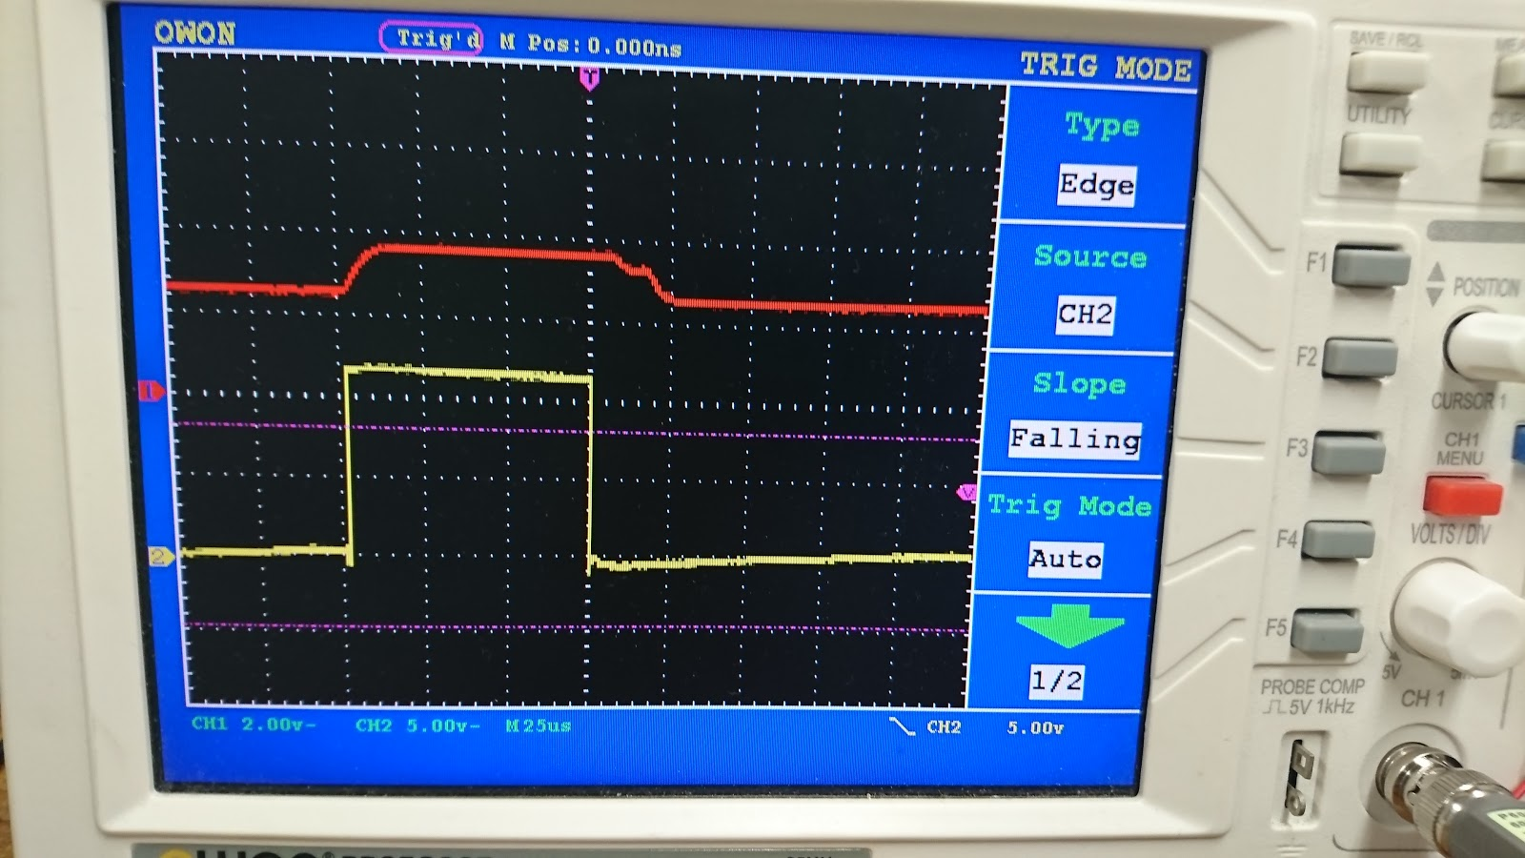

Motor Driver Input Signal Configuration : IN1 = LOW, IN2 = PWM
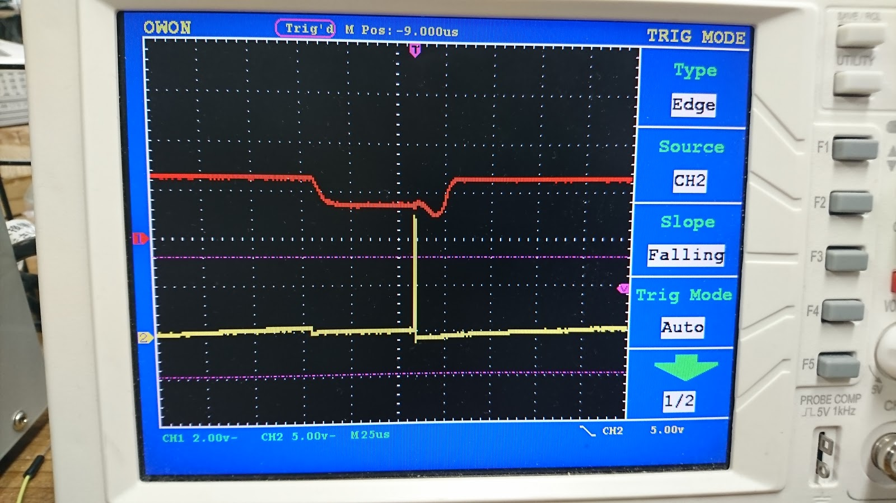
Ch1 Red : Current Amp INA199A1 Output (OUT)
Ch2 Yellow : Current Amp INA199A1 Input (IN-) (~ Common Mode Voltage)

100 Ohm Load

Motor Driver Input Signal Configuration : IN1 = PWM , IN2 = LOW
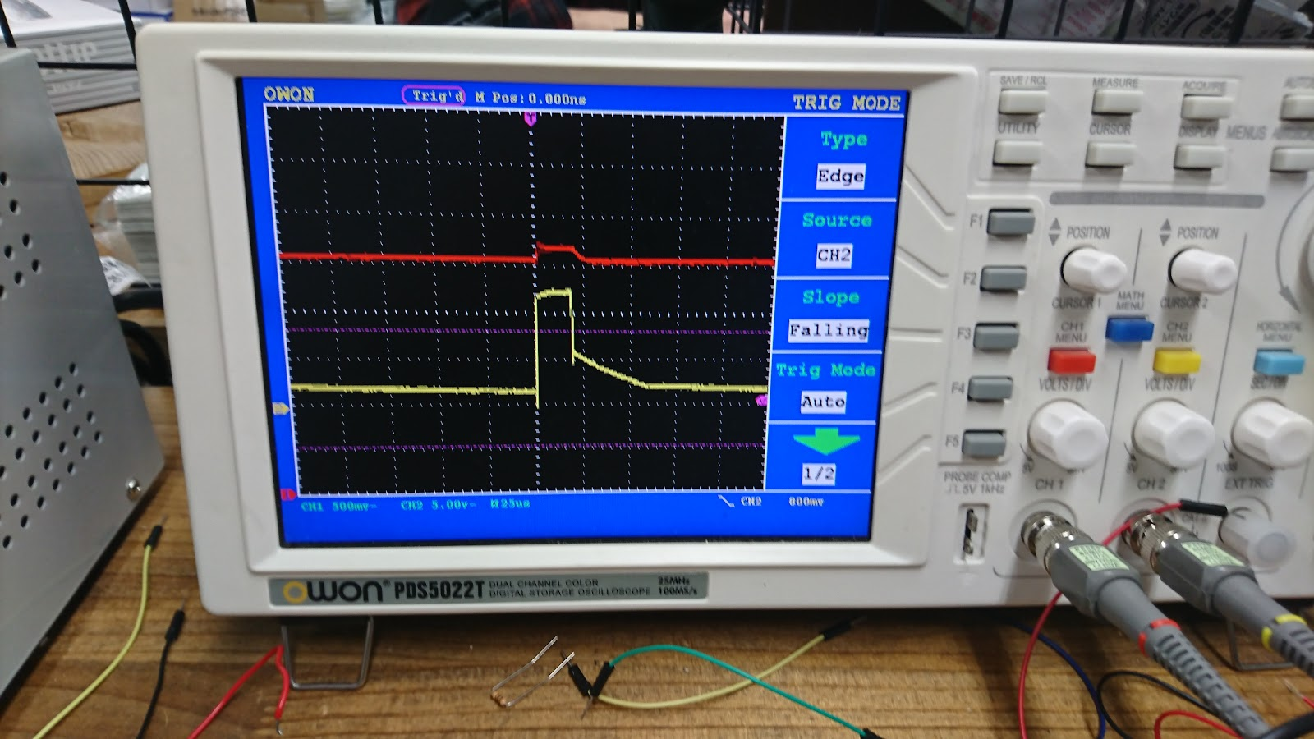

Motor Driver Input Signal Configuration : IN1 = LOW , IN2 = PWM
