1. **Waveform captured at 25C, near PGA PRG pin**

(in this condition, we could read data from PGA registers, Read Data : 13E4)

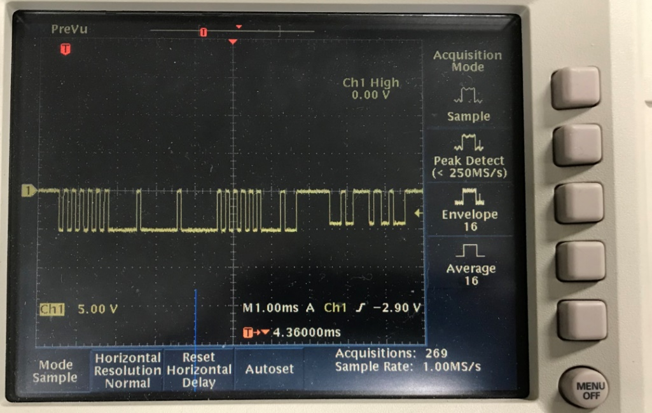

Response zero bit is not reaching Level 0

Peak to peak of response was 4.2V

What could be the reason for this?

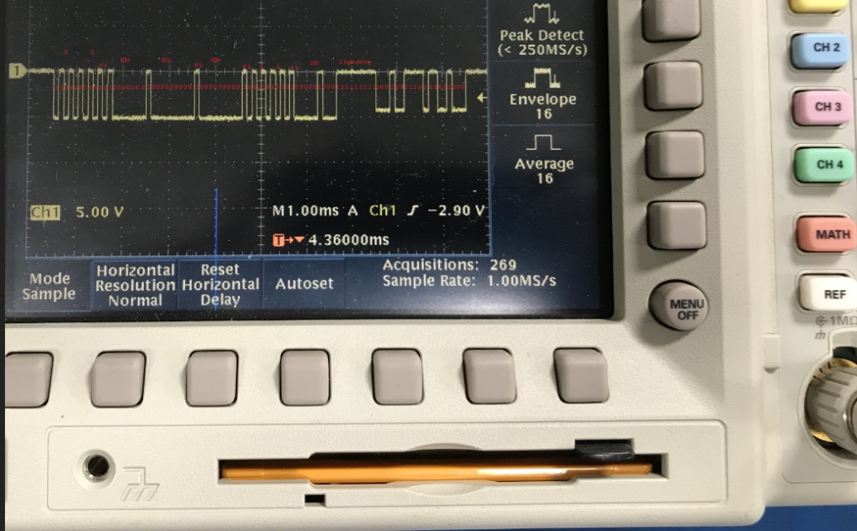

Approximate bit values done by hand after capture

Considering the 5K bridge and 200-ohm resistor used in the Temperature sense circuit, 13E4 value is representation of 25C. ( temp adc gain is 4)

2.Waveform captured at 125C

(in this condition, we were not able to read PGA registers, register read 000, But we can see the response from the PGA, response Zero level is not at zero on both cases (working & not working)

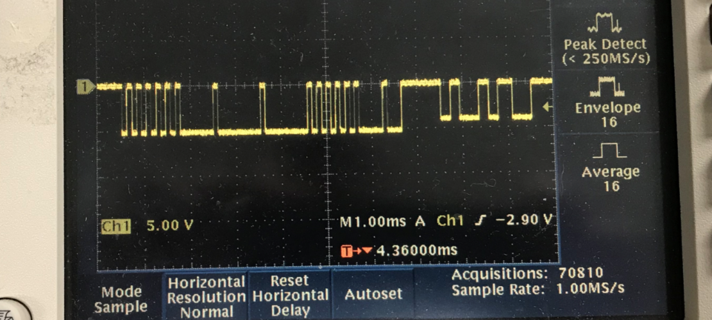

Response zero bit is not reaching Level.

Peak to peak of response bits was 4.V

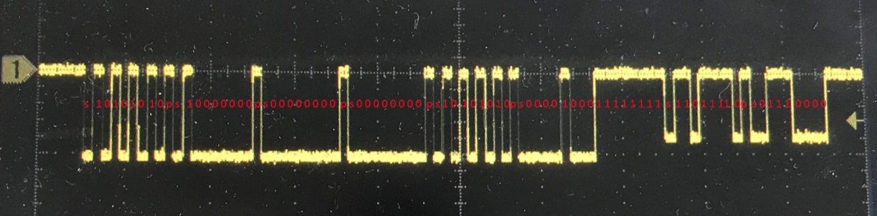

I noticed as per the analysis, command was proper even at 125C and from the response I could analyze the response was 0E7B at 125C which is correct value considering the 5k Bridge and 200-ohm series resistor in temp adc circuit.

**Low(zero) Level of the response byte was at 0.8V at 25C and it was at 1.0V at 125C.**

**What could be the reason for this?**