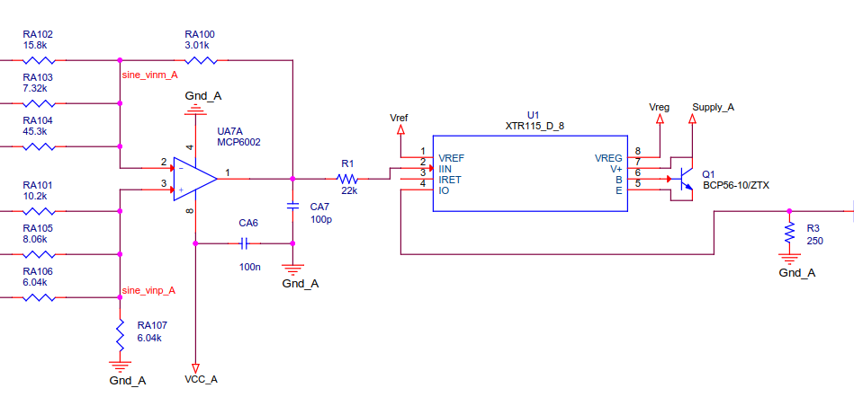

Input Voltage is a sine between 0.85V and 4.3V
Input load R1 is 22kohms
When testing, amplitude of output current starts to decrease by 3Khz and our target is 13khz

